Pre-op

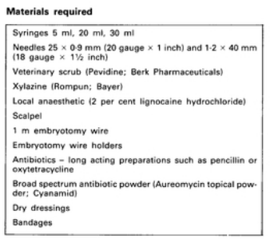

- Restraint using a stanchion and foot crush
- Sedation using xylazine
- A tourniquet can be applied to the metatarsus or metacarpus
- Anaesthesia- Local IV of lidocaine
- Ideally, the operation area should be washed, shaved and disinfected.

