Intra Op method and considerations

Wooden/Rubber Blocks application technique.

- Cow should be properly restrained in a standing position with the lame leg firmly secured held up so that the plantar surface of the foot can be examined thoroughly. If fractious, the cow may be sedated with ketamine-stun.
- Clean and trim the hoof properly at the level the surface of the sole of the claw which does NOT have the lesion, using a hoof knife or electric sander. The block should fit at 90 degrees to the metatarsals
- Select the correct size block: It should go past the heel, be at least ¾ inch thick, 5 ¼ inches long
- To prepare the hoof for glue it should be roughened used a grinder or hoof rasp and shallow grooves into the sole surface can be done to improve glue attachment.
- Spray methylated spirits onto the claw or dry the hoof using an electric dryer or heat gun and allow the foot to dry.
- Using a spatula, mix the methylmethacrylate powder and liquid in the appropriate proportions as instructed by the manufacturer, to produce a putty-like mixture (usually 2:1). Some glue is already pre-mixed.
- Using a spatula, apply about 1/8th if an inch of glue to the block focusing on the area on the block where the toe triangle and hoof wall will be attached, and press the block and claw together. Ensure the tip of the block is level with or slightly caudal to the toe to avoid tilting the cow back on her heels.
- If the block extends too much past the heel, it may be grinded and trimmed to the appropriate length,
- Mould the glue, spreading excess glue up from the sides of the block up over the hoof wall to ensure that the block is attached to the foot squarely and securely. Check that excess glue does not cover the interdigital skin.
- Roll over can be done to improve how the cow walks on the block by grinding the toe end of the block to a 45-degree angle.
- The block should be checked that it’s at an appropriate length to ensure that the angle (thickness) of the block is improved and more weight is taken off the unhealthy claw.
- Keep the foot restrained for about ten minutes.
- Release the cow, ensure the block is attached properly and is landing on the ground and recheck in 4-6 weeks.

Other Considerations
Ensure the block is applied to the HEALTHY, unaffected claw
Glue should be applied more to the wall and toe triangle, sparing the area of the sole ulcer location of the medial claw.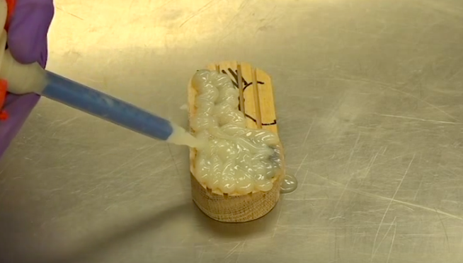
For rubberized boot /shoe, the glue should be mixed inside of the area of the shoe and then spread along the length of the boot/shoe.
For thin sole shoe, it should be trimmed and shaped to the actual shape of the affected claw and not extend past the heel as done with the blocks.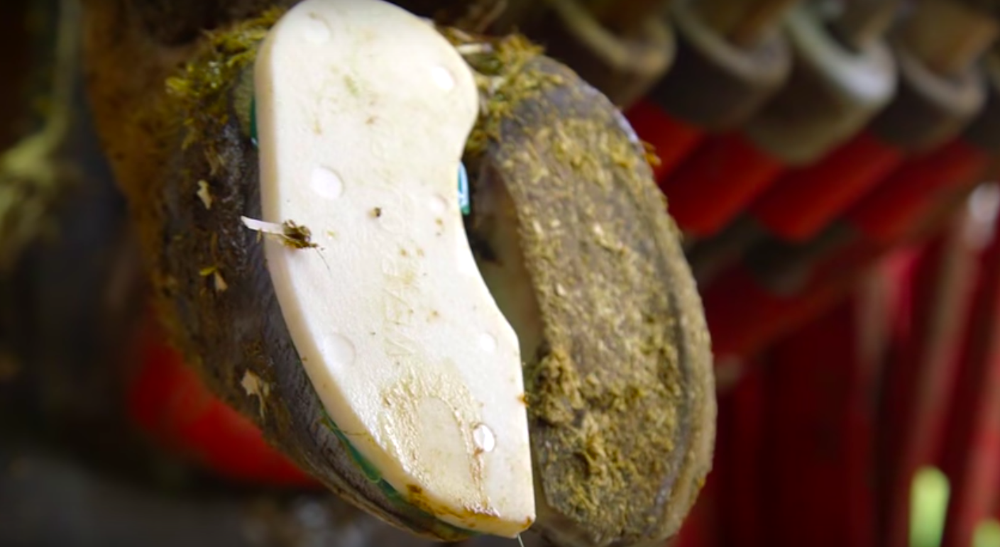

For nailed on rubber shoes, With the foot held firmly, place the block against the claw and hammer the nails, bevelled edge innermost, through the sole of the hoof, immediately lateral to the white line. Due to the bevel the nail should pass outwards through the side of the hoof. Place the first nail towards the toe, the second at the heel, and the remainder of the holes should then be in the correct position. And the nails should then be clenched.

