Drug name | Category | Use | MOA | Dose | Method of administration | Side Effects | Withdrawal times | Precautions
Tetanus toxoid  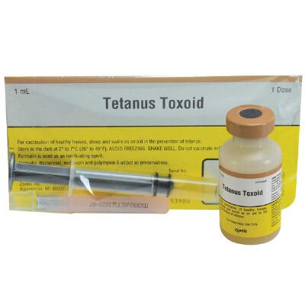 | Vaccine | For vaccination of healthy horses,sheep and swine to aid in the prevention of tetanu | Establish an active immunity for prevention against tetanus. Protective antibody levels occur about two weeks after the second injection of the primary immunization series | For primary immunization; two doses SC/IM 30 days apart. Horses or Cattle: 1 mL dose  Sheep, Goats, Swine: 0.5 mL dose | IM/SC | Anaphylactoid reaction may occur following administration of products of this nature. If noted, administer adrenaline or equivalent. | Do not vaccinate within 21 days before slaughter | Use intramuscularly for horses as local reactions are more likely to occur if injected subcutaneously.

