Drug name | Category | Use | MOA | Dose | Method of administration | Side Effects | Withdrawal times | Precautions
TranquiVed Injection  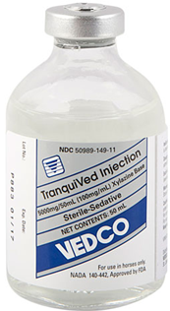 | Xylazine HCl  ALPHA2 ADRENERGIC AGONIST | Used in horses when it is desirable to produce a state of sedation.  For conducting various diagnostic, orthopedic and dental procedures minor surgical procedures of short duration  preanesthetic to local or general a  Nesthesia  . | Dose dependant sedation and analgesia  With muscle relaxant properties | Horses IV: 0.5 mL/100 lbs b.w. (0.5 mg/lb).  IM: 1.0 mL/100 lbs b.w. (1.0 mg/lb). | IV/IM  In horses | Arrhythmias, resulting in partial AV blocks, and bradycardia are transient changes which may occur, but that can be counteracted to a large degree by the administration of atropine prior to or following xylazine injection. | No withdrawal with meat and milk | should not be used in conjunction with neuroleptics or tranquilizers.  Intracarotid Arterial Injection Should be Avoided.  care should be taken to assure that the needle is in the jugular vein rather than the carotid artery.  Despite sedation, the practitioner should proceed with caution since defense reactions may not be diminished

