Drug name | Category | Use | MOA | Dose | Method of administration | Side Effects | Withdrawal times | Precautions
Tolazine injection  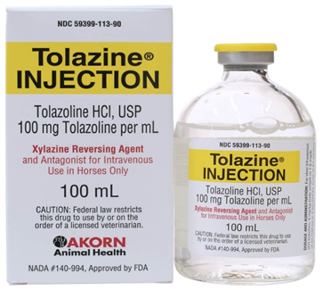 | Reversal agents ( alpha- adrenergic blocker | Tolazoline is approved and indicated for the reversal of effects associated with xylazine in horse. In humans, the primary uses for tolazoline are: treatment of persistent pulmonary hypertension in newborns, adjunctive treatment and diagnosis of peripheral vasospastic disorders, and as a provocative test for glaucoma after subconjunctival injection. | By directly relaxing vascular smooth muscle, tolazoline has peripheral vasodilating effects and decrease total peripheral resistance.  Tolazoline also is a competitive alpha1 and alpha2- adrenergic blocking agent, explaining its mechanism for reversing the effects of xylazine. Tolazoline is rapid acting (usually within 5 minutes of IV administration), but has a short duration of action and repeat doses may be required. | Horses, dogs, cats, cattle and goat-4mL/220lb of body weight  550 lb / 10ml  1100lb: 20 mL | IV | Hoses: transient tachycardia; peripheral vasodilatation presenting as sweating & injected mucous membranes of the gingiva & conjunctiva; hyperalgesia of the lips(licking, flipping of lips); piloerection; clear lacrimal & nasal discharge; muscle fasciculations; apprehensiveness. |  | The manufacturer does not recommend use in horses exhibiting signs of stress, debilitation, cardiac disease, sympathetic blockage, hypovolemia, or shock. Safe use for foals has not been established and some believe it should not be used in foals as adverse reactions and fatalities have been reported.  Approved for horses; not to be used in food -producing animals.

