Drug name | Category | Use | MOA | Dose | Method of administration | Side Effects | Withdrawal times | Precautions
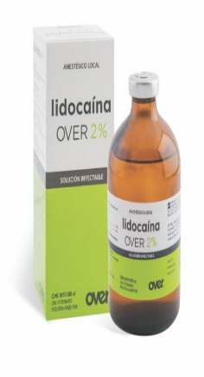  Lidocaina 2% | Antiarrhythmic drugs | Besides its use as a local and topical anesthetic agent, lidocaina is used to treat ventricular arrhythmias, principally ventricular tachycardia and ventricular premature complex in all species. Cats may be more sensitive to the drug and some clinicians feel that it should not be used in this species as an antiarrhythmic, but this remains controversial. In the horses, lidocaine may be useful to prevent pot- operative ileus and reperfusion injury. | Local anesthetic; It blocks the spread of the nerve impulse preventing the entry of Na ⁺ ions through the nerve membrane | Cattle and Horses- 5 to 15 mL.  Dogs and Cats- 1 mL per 10 pounds of body weight. | 1.Epidural  2.Nerve Block | Lidocaine hydrochloride 2%.Fresenius Kabi are rare and usually result from excessively high concentrations in the blood, usually by rapid absorption or allergic reactions.  Possible sides effects include dizziness, numbness of the tongue and lips, failure to listen, tinnitus, dysarthria, disorientation and occasionally drowsiness. In extreme cases, there is tremor, nervous movements and tremors initially in the facial muscles and in the distal parts of the extremities. There may also be effects on the cardiovascular system, such as a drop in blood pressure and bradycardia.  Allergic reactions are very rare. Theycan occur asskin reactions, paleness, swelling of the lips, itching, weakness, dizziness, a feeling of tightness in the chest, chest pains, rapid pulse and shortness of breath (anaphylactoid reaction). |  | Lidocaine is usually well tolerated. Nevertheless, as with all local anesthetics, untoward effects may occur due to hypersensitivity, faulty technique, overdosage and inadvertent intravascular or subarachnoid injection. In case of respiratory arrest, immediate resuscitation with oxygen is indicated

