**COFFIN JOINT ARTHRODESIS**

Sequelae to an infection e.g. hoof rot.

In the case of valuable animals, arthrodesis is done to fuse the distal and middle phalanges.

Infection enters the distal interphalangeal joint via three possible main sites:

1) The dorsal commissure of the interdigital space, via penetrating trauma or complicated foot rot (interdigital phlegmon);

2) sand cracks

3) white line disease or retroarticular abscess.

A 1-cm canal is drilled through the abaxial wall into the joint, and a second canal is drilled from the causal lesion into the joint. The joint cavity is enlarged by curettage, and a drainage tube drawn through. Continuous irrigation with sterile saline should be performed for 2–3 days.

A wooden block is then applied to the sound claw and the affected digit immobilized by fixing it to the block with methyl methacrylate. Immobilization is further facilitated by encasing the digital region in a cast. The cast is removed after 4 weeks.

DISTAL INTERPHALANGEAL JOINT INFECTION Sepsis of the distal interphalageal (DIP) joint is caused mainly by extension of sole diseases, such as sole abscesses and white-line disease. A penetrating foreign body in the interdigital space or foot-rot is also often implicated in sepsis of the DIP joint.

In dairy cattle, the origin of DIP sepsis is most likely sole ulcers, while in beef cattle the cause is often unknown. The distal sesamoid bone and its bursa, the tendinous portion of the deep digital flexor (DDF) muscle, the tendon sheath of the DDF muscle, and the superficial digital flexor muscles are in close relationship and solar infection can rapidly spread to these structures.

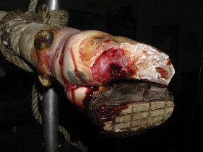Holstein adult cow suffering of a chronic infected sole ulcer. The coronary band and the heel are swollen.

The history of affected cattle is often typical: they have history of chronic lameness being treated unsuccessfully for foot-rot or sole ulcer. Severity of the lameness is quite variable, depending of the extent of infection and the chronicity of the disease.

The hallmarks of DIP infection are a swollen and painful coronary band with a draining tract, either at the proximal aspect of the coronary band or under the sole.

A swollen heel suggests infection of the distal sesamoid bone and its bursa and the digital cushion pad, and a fistula tract may be present at the heel skin junction. Cattle with deep sepsis of the digit show sign of pain when the heel is palpated or the digit is extended. The tendinous portion of the DDF tendon might rupture if the necrotic process is severe, and the digit affected will tilt upward

Radiographic evaluation of the DIP joint is helpful to determine the extent and duration of the process. Usually the lesions are not subtle because of the chronicity of the infection.

The distal sesamoid bone may show lysis of its articular surface or may be destroyed completely. The proximal interphalangeal (PIP) joint might also be involved in the process.

If a fistula tract is present, communication with the DIP joint is confirmed with the insertion of a sterile probe into the tract.

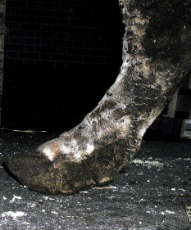Adult Charolais bull presented for chronic lameness of the left hind limb. The lateral digit of the left foot is tilted upward, indicating a rupture of the deep flexor tendon. The bull was diagnosed with sepsis of the DIP joint.

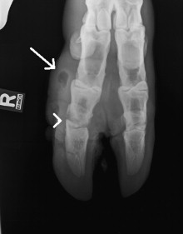Radiographic image of a distal right foot. This dorsoplantar view shows swelling of the lateral digit (white arrow) and subchondral bone lysis of the distal interphalangeal joint.

