Conceptual Mapping Facilitates Coherence and Critical Thinking
in the Science Education System
James Gorman, M.S.
Northbridge High School, Whitinsville, Massachusetts, United States
Jane Heinze-Fry, Ph.D.
Museum Institute for Teaching Science, Quincy, Massachusetts, United States

Executive Summary
In this case, the authors will propose a pathway of visual mapping through which the science education system from professional educators who produce representations of national and state standards to curriculum coordinators at the school district level to individual teachers and students in the classroom could be aligned in order to promote meaningful learning of a connected set of concepts. Conceptual mapping is demonstrated to be a tool that promotes critical thinking, cohesion and meaningful learning in opposition to the learning of arbitrary facts and rote memorization. The authors offer many examples of conceptual maps that have been produced to externalize thinking at each level. This chapter provides a "synthesis case" demonstrating that, not only does it require critical thinking to create conceptual maps, but, equally salient, these visual representations of our thinking catalyze further critical thinking and coherence within the science education system.

Background: Critical Thinking, Meaningful Learning, Conceptual Maps, and the Science Education System
Critical Thinking and Concept Mapping
A host of researchers have linked constructing concept maps (cmaps) with critical thinking (Jonassen et al, 1998; von der Heidt, 2011; Fonseca and Extremina, 2008.) As the chapters in this book will make abundantly clear, "critical thinking" has been defined different ways by different authors. Further, Krathwohl (2002) recognized the terms 'critical thinking' and 'problem solving' lacked clarity of meaning in popular usage and advised that "one must determine the specific meaning of 'problem solving' and 'critical thinking' from the context in which they are being used." A clear articulation of the relationship between cmapping and critical thinking comes from the field of nursing education. Daley et al. (1999) turned to a Delphi research project of the American Philosophical Association (APA) (1990), which published a consensus definition of 'critical thinking' based on the views of 46 published critical-thinking theorists from numerous disciplines. This definition states: "Critical thinking is the process of purposeful, self-regulatory judgment. This process gives reasoned consideration to evidence, contexts, conceptualizations, methods, and criteria” (APA, 1990, p. 2). She continues with Facione (1995) "Like many other descriptions of higher order thinking, the original Delphi authors conceptualized a simultaneous, metacognitive, self-appraisal of one's thinking process (that is, thinking about and evaluating one's thinking while engaged in the process of purposeful judgment (p.2). Drawing the connections clearly to the cmapping process, Daley concludes: Cmaps. . . link directly to the APA (1990) definition of critical thinking. Cmaps are metacognitive tools that assist learners to develop a self-appraisal of their own individual thinking processes. The maps foster a careful consideration of evidence drawn from clinical practice. Through use of cmaps, learners develop the ability to consider the context of nursing practice in their conceptualization of client problems. Finally, purposeful judgments are made regarding interventions based on how methods and criteria are linked to the conceptualization of the problems." Chabeli (2010) sinks deeper, providing a table correlating core cognitive critical thinking skills, related subskills and affective dispositions with the educational processes of cmapping.

In his literature review pertaining to the use of cmapping techniques and technologies for education and performance support, A. Cañas (2003), listed "to teach critical thinking" along with a variety of uses of cmaps. Novak and Cañas (2008) further explain, that the creation of cmaps clarifies a growing conceptual framework as individuals (or a group) learn a new field of study. This conceptual framework is very significant because it forms one of the filters through which the world is observed and interpreted and forms the basis for problem-solving and decision-making processes. Note that these complex mental processes are undergirded by the higher order thinking processes of analyzing, synthesizing, and evaluating. (Anderson and Krathwohl, 2001). Thus, we will restrict our comments to critical thinking as being able to carry out complex problem-solving and decision-making, supported by the foundation of Bloom's higher order thinking, as defined by the American Philosophical Association (APA), and as applied by Daley et al. (APA, 1990; Daley et al, 1999). Further, we make the intellectual leap that strand maps also require critical thinking in their construction. We will demonstrate connections between critical thinking and conceptual mapping at all levels of the science education system. We will articulate some of the critical thinking questions that are asked at each level and we will ask how clarity at each level contributes to the coherence of the system. The salience of this work is highlighted by the addition of "metacognitive knowledge" to the revised Bloom's taxonomy. Regarding knowledge about cognition in general and one's own cognitive knowledge, Krathwohl (2002) stated, "It is of increasing significance as researchers continue to demonstrate the importance of students being made aware of their metacognitive activity, and then using this knowledge to appropriately adapt the ways in which they think and operate." We hope that our work demonstrates the importance of cognitive knowledge for those who work at all levels of the science education system.

Meaningful Learning: Theoretical Underpinnings of Conceptual Maps
The authors will use the term "meaningful learning" as defined by David Ausubel (1978). In its simplest form, meaningful learning requires learners to actively attach new learning to their prior knowledge. Conceptual learning requires the perception of "regularities in objects or events" and labelling them with a term. Meaningful learning requires " 1) that the learner has prior knowledge that is relevant to the new learning to be done; 2) that what is to be learnt is presented in ways that have meaning; and 3) that the learner must choose to learn meaningfully." (Novak, 1998) Meaningful learning, organized in concepts linked in a hierarchical fashion enables long term retention and application of those concepts. Meaningful learning contrasts with rote learning, in which learners memorize arbitrary concepts, do not link them to prior understanding, and consequently do not store them in long term memory nor have access to them for future problem-solving and decision-making. Meaningful learning is characterized by both progressive differentiation and integrative reconciliation. During progressive differentiation, learners over time add subordinate (more specific) concepts to a superordinate (more general) concept. During integrative reconciliation learners restructure conceptual understandings under a new overarching concept.

Conceptual Maps
Conceptual maps are visual representations of knowledge that clarify relationships among multiple concepts. The structure of a topic can be viewed holistically through both strand maps and cmaps. Content presented in either form provides an opportunity to more easily spot patterns of linkages than content presented through traditional bullet points or numbering schemes. While similar in addressing linkages of concepts, strand maps are structurally distinct from cmaps. Strand maps would be helpful in to demonstrate the progression of learning over grade spans. The Commonwealth Massachusetts has employed the use of learning progressions to inform the science curriculum review process (Foster and Wiser, 2012).

Strand maps. Strand maps represent learning progressions, the development of linkages among concepts over the K-12 grade levels. They show the progressive differentiation of big ideas of science over time and the integrative reconciliations that occur going from one grade span to another.

Learning progressions can account for how students think and learn about science from a cognitive perspective. A learning progression, by definition, bridges the scientific version of a big idea to the intuitive ideas children develop about it before formal instruction (Corcorcan et al, 2009; Wiser and Smith, 2009). While learning progressions are research-based, they are hypothetical; they are ideal paths for successful conceptual development about a big idea; they propose how a network of knowledge about a big idea could coherently evolve over long periods of time from young children’s ideas if students are exposed to curricula with appropriate consideration given to “concepts, stepping stones, levers, and linchpins.” (Wiser & Smith, 2009; Wiser et al., 2009). That is why a learning progression can be so useful; it invites standards developers to design coherent standards that will bring the learning progression about according to cognitively appropriate core ideas.

While strand maps do show conceptual relationships between key concepts, they do not include a variety of linking words that explicate the nature of the relationship between connected concepts; nor are they designed to clarify meaning of particular concepts. Additionally, some standards expressed in strand maps may contain more than one specific concept or skill, depending on how those are written and connected to other standards. We have seen these maps used to clarify representation of learning standards at both the national and state levels. [See Science Literacy Maps at the National Science Digital Library: (http://strandmaps.nsdl.org/) See the Massachusetts Science, Technology and Engineering Framework Strand Maps at: (http://www.doe.mass.edu/omste/maps/default.html).]

Concept maps. Cmaps as defined by Novak (1984) are generally applied at a "finer grain size" than strand maps. These graphical tools for organizing and representing knowledge are characterized by four elements: concepts, propositional linkages, hierarchy, and cross-links.
- Concepts are defined as perceived regularities in objects (such as “plant”) or events (such as “photosynthesis”). Generally, each concept is represented by a one-word label enclosed in a circle or box. (This contrasts with the “standard” composed perhaps of multiple concepts enclosed in a circle or box on a strand map.)
- Propositions are two or more concept labels linked together in a semantic unit. The simplest propositions are composed of only 3 words, such as “grass is green.” The more the propositions radiating from a concept label, the richer the meaning of the concept. When a teacher reads a student’s cmap, the linking words found on the lines between concept labels clearly indicate how the student is making the connections.
- Hierarchy describes the nature of the organizational layout of the concepts. The most general concept (superordinate) is at the top of the cmap. Progressing to the bottom, the concepts get more and more specific (subordinate). Thus, the map reveals the relationship of the parts to the whole.
- Cross-links are particular propositions that connect and integrate different parts of a cmap. One of the strengths of cmaps is that they can actually show this integration, while linear outlines so often used in teaching and learning can not perform this function.

Cmaps have been used extensively as a research and “learning-to-learn” tool to clarify and demonstrate how individuals are thinking about a particular concept. In this chapter, we will provide one example in which cmaps were used at the curriculum coordinator level to demonstrate the relationship between a school's program and the state standards. In practice, we have seen these maps used by both teachers and students. We will provide a case study to demonstrate in depth how one of the authors and one of his students exemplify the application of meaningful learning theory to practice through their use of cmaps.

In our view, strand maps and cmaps are valuable visual representations that clarify how individuals serving across the science education system represent the key science concepts. As such, these maps provide "clear thinking," which is the foundation for advanced critical thinking, problem-solving, and decision-making.

Science Education System
The authors present their conceptual mapping experience in a sequential fashion that reflects their thinking about the hierarchy of the U.S. Science Education system from the most broad level, the national level down to the most particular level of the individual student learner. The chapter will link readers to conceptual maps produced at the national level by the AAAS Project 2061; at the state level by the Massachusetts Department of Elementary and Secondary Education by Jacob Foster and the co-authors; at the school district level by the curriculum coordinator of the Lexington Public Schools and co-author Jane Heinze-Fry; at the teacher level by co-author of this chapter James Gorman; and by student teams and an individual student in Gorman's physics classes. The authors will focus on how conceptual maps are produced through critical thinking and how they can provide the foundation for critical thinking questions key to each level of the system. Our hope is that this chapter will catalyze readers to think of conceptual maps as effective tools to enhance critical thinking, meaningful learning. and coherence across the entire science education system. The authors visualize an emerging synergy of the levels of the science education system in which the conceptual maps of each level may serve as advance organizers for each succeeding level of the system.

Conceptual Mapping Facilitates Critical Thinking in the Science Education System
The National Level: U.S. Science Education Reform and the First Strand Maps
Context: Bulleted Standards to Strand Maps. Science education in the United States has been undergoing concerted reform for decades. The first American Association for the Advancement of Science (AAAS) Project 2061 publication, Science for All Americans (AAAS, 1989), set out to define science literacy and lay out some principles for effective learning and teaching. This was quickly followed by Benchmarks for Science Literacy (AAAS, 1993), specifying how students should progress toward science literacy, recommending what they should know and be able to do by the time they reach grade levels 2, 5, 8, and 12.

The Atlases of Science Literacy (AAAS, 2001, 2007) transformed the benchmarks into strand maps that demonstrated how the most important ideas of science fit together and develop across the K-12 grade spans. Each strand map focuses on a topic important for literacy in science, mathematics, and technology and displays the benchmarks across the K-12 span that are most relevant to understanding it. For each benchmark, there is a suggestion of earlier benchmarks upon which it builds and later benchmarks that it supports, thus highlighting the developmental nature of the topic. These maps can be viewed on the web at http://strandmaps.nsdl.org

Critical Thinking to Create Strand Maps. Even a brief look at these maps generated by Project 2061 of the AAAS leads one to wonder at the number of critical thinkers who contributed to their construction. It is clear that a considerable amount of higher order analytical, evaluative and synthesis style thinking went into the construction of these maps. They rest on a foundation of knowledge of the content and the processes of science and of the research into student thinking at different grade levels. Of particular note is the use of the web in making these maps accessible and the linking of these maps to both science education research resources about how students think and instructional resources peer-reviewed for these standards.

Catalyst for More Critical Thinking. Not only, then, did it take critical thinking to construct these strand maps, but they are designed for continued critical thinking to keep them updated with new research and newly created and reviewed resources. Further, curriculum coordinators can use them to guide the development of science curriculum at the school district level and teachers can use them to guide curriculum design at the classroom level. In this process, educators will continue to evaluate and make decisions about the design of instruction at those levels. We see that the construction of the Atlas maps promotes critical thinking by those who constructed them and will be responsible for revising them and for those who use them. What critical thinking questions might these professionals address upon which these maps cast light?

Those who construct the maps might ask: Do these maps reflect our best learning progressions research of science concepts across the K-12 grade spans? Do the strand maps show salient connections across the traditional science disciplines? Do they show important prior knowledge that is prerequisite to learning more complex concepts? Is updated research provided for teachers to understand what students think at each level?

For teachers using the maps: What prior learning should my students have before I start to teach certain concepts? What prior thinking is common about the concepts I teach? What can I tell my students to expect about what they might learn next once their understanding of the concepts at my grade level are understood? What instructional resources are available to teach the concepts for which I am responsible? If I am not satisfied with the progress of my students, are there additional resources I might try in the future? Are there ways to feed back to the map designers if I identify alternative learning pathways in my students?

For those responsible for a state’s curriculum framework: Could state standards be represented in strand maps? Would such a representation lead to more coherence in the standards as they are revised? Can the Atlas strand maps offer meaningful connections as standards are revised? How have these strand maps produced by national leaders in science education influenced critical thinking at the state level of the science education system?

The State Level: Creation of Strand Maps for Science, Technology, and Engineering Curriculum Framework Review
Context: The Science Standards Review Process. At the state education governance level, the authors describe how strand maps influenced the critical thinking of the committee responsible for revising the Massachusetts Science, Technology and Engineering Framework (MADESE, 2001/2006) which establishes the state’s standards for grades PreK-12. In 2008-2009, the MA Department of Elementary and Secondary Education set out to produce strand maps of the state science standards, modeled on the AAAS Atlases for Scientific Literacy (AAAS, 2001, 2007) to facilitate the review and revision of those standards (Heinze-Fry et al, 2010). CmapTools was used for the initial production of these state science strand maps.

Strand Maps: Representation of Progressions of Learning. The current Massachusetts science strand maps (available at http://www.doe.mass.edu/omste/maps/) show how students’ understanding of ideas and skills that lead to scientific and technological literacy might develop over time from PreK to high school. The Atlas for Science Literacy strand maps were used as a model for the Commonwealth’s strand maps. All figures in this section are examples taken from the Massachusetts strand maps. Clear text and color-coding can be viewed via Internet. Each cell of the strand map is an actual state science standard. The arrows between cells represent conceptual (not curricular) relationships between concepts.

The strand maps enable educators to see how the knowledge and skills students learn in different grades depend on and support one another. Thus, strand maps represent a progression of learning. For example, Figure 2 presents a portion of the Life Science strand map on the topics of characteristics of living things and evolution and biodiversity.

Foundations of understanding about evolution and biodiversity are established at the grade 3-5 level. Students are expected to "Give examples of how inherited characteristics may change over time as adaptation to changes in the environment that enable organisms to survive. In grades 6-8, students are expected to develop ideas of evolution further and be able to "recognize that biological evolution account for the diversity of species developed through gradual processes over many generations and to give examples of ways in which genetic variation and environmental factors are causes of evolution and the diversity of organisms.” By high school, students are expected to construct an even more detailed conception of evolution and be able to “describe species as reproductively distinct groups of organisms; describe the role that geographic isolation can play in speciation; [and]explain that evolution through natural selection can result in changes in biodiversity through increase or decrease of genetic diversity within a population."

As we discuss the strand maps, we will use terminology that is specific to Massachusetts. It is worth taking a moment to define strand, topic, standard, and link. A strand is a science subject or discipline in the state Framework; each strand is represented on its own strand map and assigned a color scheme (Earth and Space Science—blue; Life Science—green; Chemistry—blue-green; Introductory Physics—purple; Technology/ Engineering—yellow-brown). A topic is a major subcategory within a strand and is assigned its own color from within the strand color scheme. For example, there are six topics within the Life Science strand: anatomy and physiology; cells and biochemistry; heredity and genetics; characteristics of living things; evolution and biodiversity; and ecology. A standard is a particular learning expectation. A standard specifies what students should know and be able to do and explicates the knowledge or skills to be assessed.

A link is an arrow that connects standards and represents the conceptual relationship between the two standards. These links are meant to make explicit the concepts that are considered necessary in order to learn later concepts, not any possible connection between concepts. Links within strands are solid; links across or between strands are dashed. An arrow leaving a standard implies that the concept contributes to learning the concept of the next, connected standard. These links are primarily based upon available cognitive research (often limited) specific to a particular idea, general principles of cognitive development (for example, concrete before abstract), logic of the subject matter, and wisdom of practice/ professional judgment.

One additional principle informed the development of these strand maps: simpler is better. The maps aim for as few arrows and crossings as possible. Placement of topics and concepts on the maps is first by “affiliation to a topic” but when needed standards are moved to place them in closer proximity to conceptually connected standards. Figure 1 presents an excerpt highlighting two topics from the Life Science strand map that illustrate each element discussed here. Topics are listed on the left: “Characteristics of Living Things” and “Evolution and Biodiversity.” Each cell encloses one standard; each arrow represents a conceptual relationship between standards.

Figure 1. Excerpt from the Life Science strand map showing standards from multiple topics and cross-linking with Earth & Space Science (From “Strand Maps of the 2001/2006 Science and Technology/Engineering Standards” http://www.doe.mass.edu/omste/maps/).
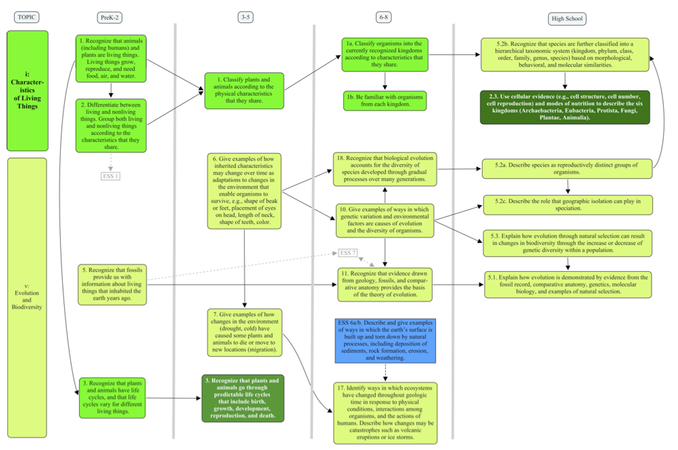
Features Revealed by Strand Maps of the State Science, Technology & Engineering Framework. The strand maps revealed two major features of the current state framework: 1) standards with varying levels of conceptual support across the entire PreK-12 span and 2) recurring patterns of relationships among standards. In particular, the strand maps revealed standards that were not conceptually supported in early grades and “opportunity-to learn-gaps” in which standards for a topic were at early and late grades but without concepts bridging those years, and some standards that were simply isolated from other standards. Patterns of relationships among standards included diverging and converging concepts and cross-linking within and among topics and strands. Readers will recognize the significance of these patterns for their visual representation of Ausubelian learning theory.

Unsupported standards. Some topics revealed unsupported standards, in which some upper grade-span standards did not have related standards at early grade levels. Sometimes this is quite reasonable given the topic. For example, a number of chemistry concepts are not reasonably considered by elementary or middle school students. Further, not all grade spans must have concepts for each topic. However, this feature is revealed a number of times in each strand. For example, in engineering design, knowledge and skills needed to successfully represent problems and solutions are missing. In particular, analysis of the AAAS Atlases revealed two concepts fundamental to the development of this topic (Figure 2). Thus, the current framework targeting the topic of engineering design might benefit from the addition of foundation standards that emphasize student ability to “draw pictures that portray features of a thing being described” (PreK-2) and to make “scale drawings that show shapes and compare locations of things very different in size.” (Grades 3-5).
Figure 2. Portion of the Technology/Engineering strand map showing weakly supported standards for representing problems and solutions. Standards from the Atlases of Science Literacy that would better support those begin with “AAAS”(From “Strand Maps of the 2001/2006 Science and Technology/Engineering Standards” http://www.doe.mass.edu/omste/maps/)
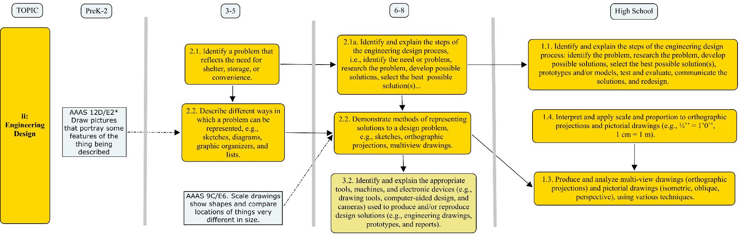
A second type of unsupported standards is represented in an “opportunity-to-learn gap,” a break in learning of a topic for a full grade span or more. An example of this is depicted in an excerpt from the Physical Science strand map in Figure 3. The framework stipulates that students begin learning about motion in PreK-2 but then not again until grades 6-8. This presents a large conceptual challenge, as it may be between 4 and 6 years without learning about force and motion. How to address this gap, and others like it, is a key issue in the review process. Likely the reviewers will need to reference national documents such as the AAAS Benchmarks to identify appropriate concepts for grades 3-5.
Figure 3. The force and motion topic of the Physical Science strand map showing an opportunity-to-learn gap (grades 3-5) and two isolated concepts (grades PreK-2 and HS). (From “Strand Maps of the 2001/2006 Science and Technology/Engineering Standards” http://www.doe.mass.edu/omste/maps/).
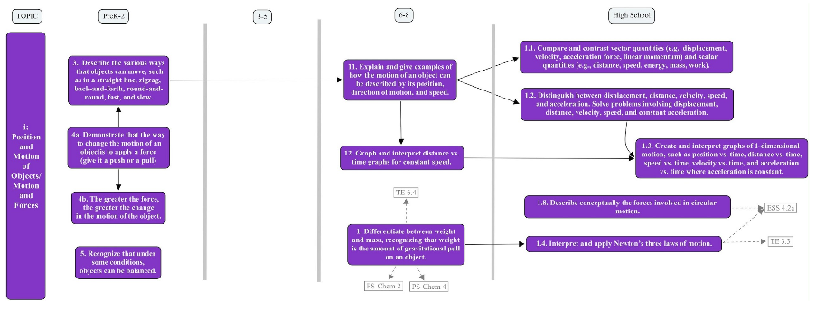
Figure 3 also illustrates a third type of unsupported standard: isolated concepts. At the PreK-2 level, a standard suggesting that students be able to “recognize that under some conditions, objects can be balanced” is not developed further at any grade level; nor is it conceptually related to any other standard. This is also the case for the high school standard suggesting that students “describe conceptually the forces involved in circular motion.” Isolated content sends up a “red flag.” Research indicates that arbitrary content is learned in a rote manner; i.e., not learned meaningfully, and is, therefore, less likely to be retained and applied in the future (Ausubel, 1978; Novak, 2009.)

Patterns of divergence, convergence, and cross-linking. Three patterns of linkages among standards resonate with Ausubelian learning theory: diverging, converging, and cross-linking standards. Awareness of and emphasis on these linkages increase the opportunities for educators to facilitate meaningful learning by PreK-12 students in the classroom.

Diverging standards reflect what Ausubel would have called “progressive differentiation.” Subordinate concepts are linked to or ‘subsumed’ under superordinate concepts. Learners add details to their general understandings, deepening conceptual structure. Figure 1, for instance visually represents the progressive differentiation of "evolution" over the Grade 3-high school spans.

In a second pattern, simple ideas introduced in early years are synthesized into more complex understandings in later years. None of the relevant concepts are more general than the others. The standards represent the learning of many new linkages among concepts that are non-arbitrary and relate to a broad background of generally relevant content in cognitive structure. Ausubel might have labeled the example in Figure 4 as a “combinatorial relationship.” Much construction of knowledge must be carried out in early grades in order for high school students to be able to “provide examples of how the unequal heating of Earth and the Coriolis effect influence global circulation patterns, and show how they impact Massachusetts weather and climate.”

A third pattern, cross-linking between topics within a strand and between strands themselves, is also commonly found throughout the standards. For instance, in Figure 4, the PreK-2 standard “understand that air is a mixture of gases that is all around us and that wind is moving air” is an “Earth Processes and Cycles” topic standard that lays a foundation for higher-level “Energy in the Earth System” topic standards. Additionally, in Figure 4, there are two standards from the Physical Science strand (found in sharp-cornered boxes with dashed arrows) that are crucial to the understanding of a Grade 6-8 standard in this excerpt from the Earth and Space Science strand.
Figure 4. Portion of the Earth and Space Science strand map showing converging concepts leading to the high school standard #1.4. Cross-linking between topics and between standards is demonstrated. (From “Strand Maps of the 2001/2006 Science and Technology/Engineering Standards” http://www.doe.mass.edu/omste/maps/).
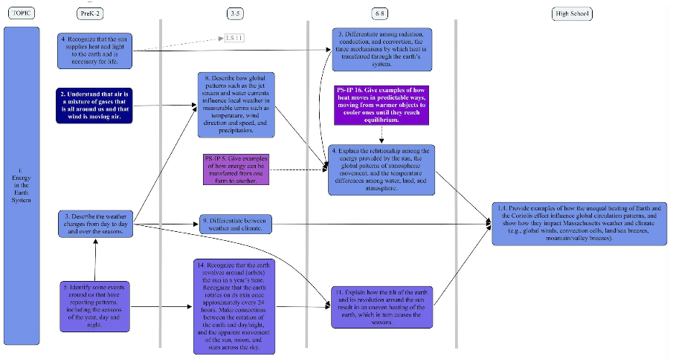
Using Strand Maps and Learning Progression Research to Revise State Standards. While we see the great value and potential of learning progressions on standards development, it is important to note that a full standards development process based on learning progressions is not possible at this time due to the early state of learning progression research. As such, the best we can do at this time is to revise our current standards to include what cognitive insights are now available. Using strand maps to visualize the progressions of standards is key to this process. For the present, our revision process will use what research is available, as well as collective wisdom of those teaching students, to appropriately address the features or patterns identified in the strand maps that may hinder student learning of science. Strand maps will help us enhance the relationships and progressions of standards to better support student learning of science.

Critical Thinking and Strand Maps. It certainly took a considerable amount of critical thinking to produce these maps (note the transformation of an outline style to a learning progressions style with linkages among concepts.) In addition, a considerable amount of judgment went into the creation of linkages among the science silos (cross-links). In addition, positioning of concepts to reduce confusion from crossed lines, thus meeting the "keep it simple" criteria, was required. Also, a considerable amount of effort went into filling in potential gaps with input from the AAAS Atlas maps.

The strand maps enabled the committee to question the relevance of some learning standards and to question the strength of learning progressions of the big ideas of science over the K-12 grade spans. Understanding these features is key to revising state standards to enhance progressions of learning across grade spans to make explicit conceptual relationships across grade spans. State standards revised into strand maps offer a foundation to integrate efforts across the educational community that target meaningful learning.

It is important that these maps offer visual representations that were distributed to each member of the review committee to reflect on and offer feedback in groups. As groups, they worked to review and update the standards. They struggled with many critical thinking questions: Do these maps represent what the Commonwealth of Massachusetts expects its students to know and do over the preK-High School experience? Are the learning standards linked in clear learning progressions over the grade spans? Do the citizens of the Commonwealth support the learning standards inclusion of science content and science and engineering practices? Which concepts need more support? How can those gaps be filled? Which concepts should be eliminated?

The School District Level: Coherence with State Standards
Strand maps take a big step toward demonstrating the Pre-K-12 grades connectivity among the Massachusetts standards. Standards connected to prior standards imply that curriculum, teacher’s instruction, and student’s learning will be targeted toward connectivity and greater coherence. Such an approach foregrounds meaningful learning over rote learning.

Context: Concept Maps to Align Local Curriculum with State Standards. In 2006, the elementary science curriculum coordinator at the Lexington Public Schools worked with Heinze-Fry to investigate how the local life science curriculum benchmarks and the interdisciplinary Big Backyard Program aligned with state standards. Cmaps facilitated this process. (Note that this investigation preceded the development of the state strand maps.) CmapTools was used to create a template cmap of the MA Life Science Framework. (Today, either strand or cmaps could be used for this comparison.) The Science, Technology, Engineering Framework is available in pdf format at http://www.doe.mass.edu/frameworks/scitech/2001/0501.pdf.

Individual school districts, as is the case with the Lexington Public Schools, often operate from local curriculum guidelines. The Lexington Elementary Science Benchmarks described the overall goals and objectives of the entire science program. These goals included conceptual content from the life sciences, earth sciences, and physical sciences, as well as inquiry skills. (The original document used in this study has been updated. The current Lexington Public Schools K-5 Science and Technology/Engineering Curriculum is available at http://lps.lexingtonma.org//site/Default.aspx?PageID=1614 .)

A color-coding system was used to compare life science concepts from the Lexington Elementary Life Science Benchmarks with the state template map. Concepts were color-coded to indicate alignment with the state (green in web version; medium-gray in print version), nonalignment with the state (red in web version; dark gray in print version), and more depth than the state (yellow in web version; light gray in print version). The same method was used to examine how the interdisciplinary Lexington Big Backyard program supports the state’s life science framework.

This alignment can be viewed in color and with submaps on the web at: http://cursa.ihmc.us:80/servlet/SBReadResourceServlet?rid=1143727786182_1874593061_6336&partName=htmltext. To view the Lexington Benchmarks concept list, one can click the icon at the bottom of the ‘Environment’ concept.
Figure 5. ‘Core’ Concept Map Aligning Lexington Benchmarks with State Framework
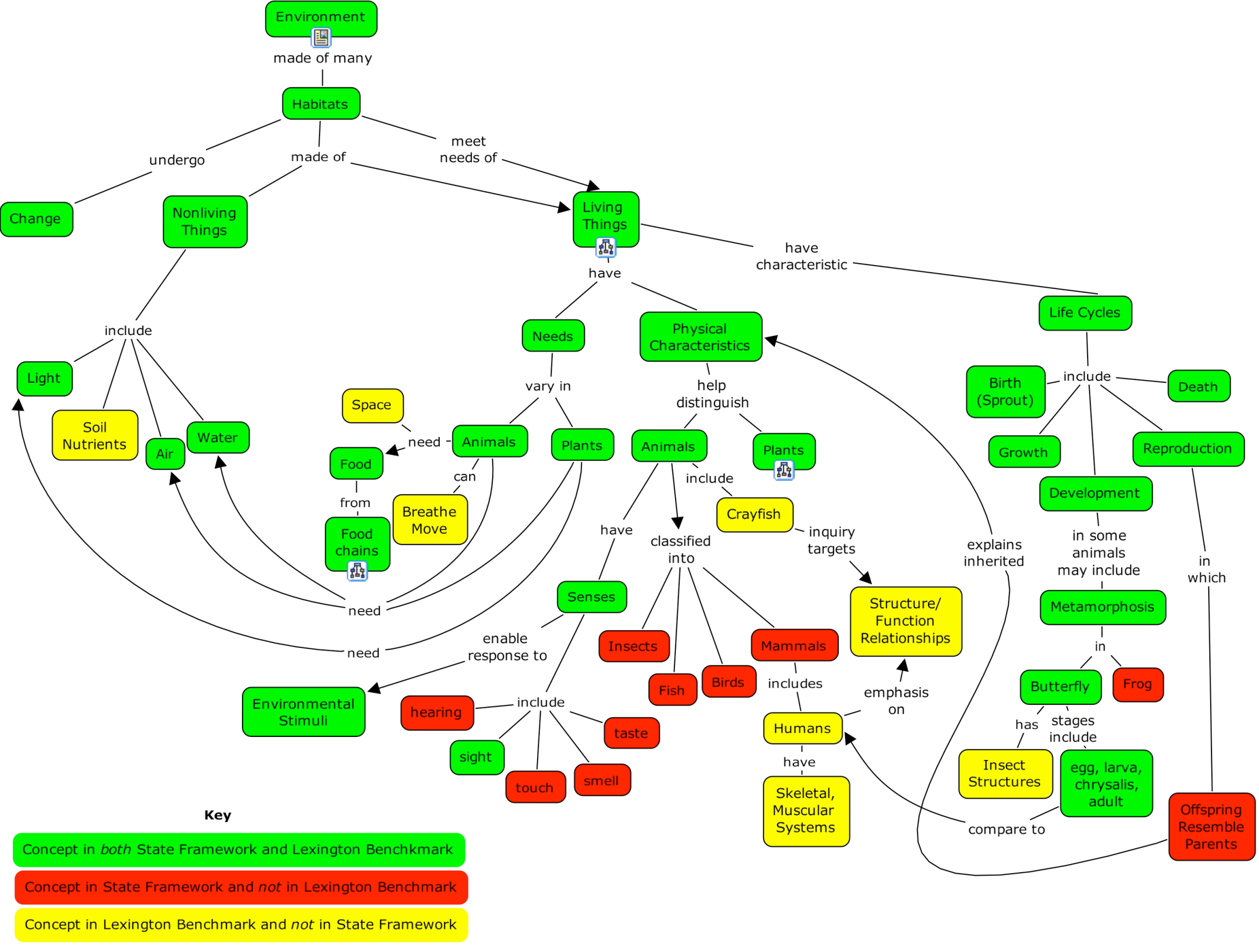
The analysis visually represented in Figure 5 is useful in that it offers a clear visual indicator of “fit” between the state framework and local benchmarks. Its utility comes primarily in assuring that the district addresses the state frameworks. This alignment strategy offers insight into recommendations that can easily incorporate “red concepts” into existing instructional activities and objectives. As state science testing becomes more high stakes along with English and mathematics, such alignment methods increase in value. While other alignment strategies exist, cmapping offers a particularly robust decision-making tool for a constructivist-based learning community. In addition to providing a visual framework, the cmaps, by demonstrating connections among concepts, can help teachers develop instructional activities in a cohesive manner.
Potential to Facilitate Critical Thinking and Coherence. Depending upon school policy, the science coordinator could work to increase alignment of the local curriculum to the state framework. Assuming closer alignment is desired, content areas coded ‘green’ should remain in the local curriculum. In general, educators should consider the green-coded concepts as “core” and strive for high performance by all students in attaining them. The curriculum coordinator should work to incorporate content areas coded ‘red’ into the local benchmarks. The Department of Elementary and Secondary Education [transformed from prior “Department of Education (DOE)] might also take note of this analysis. The maps demonstrate areas that the locality considers significant and are areas left unaddressed at the state level. During the review process, participants in the review process consider the importance of those concepts in the larger scheme of the state framework.
Alignment maps could be used in a number of ways by the science coordinator to more fully integrate the educational system. Sharing these alignment maps with teachers and volunteer parents demonstrates how their efforts in individual activities contribute to the development of a larger integrated “whole” for their learners. Individual teachers could create cmaps to align their particular class with local or state curricula to see how their classroom work supports systemic priorities. And they could further link digitized instructional materials to the maps, as demonstrated in the next section, to make the educational system even more coherent.

The Classroom Level: Teacher's Instructional Use of Concept Maps
Guided by state and local standards, teachers through instruction and assessment need to provide an environment that promotes meaningful learning by their students. Foremost in a teacher's mind has to be what order he/she is going to guide students through the established standards which do not prescribe an order but demonstrate a progression of concepts and skills. John Dewey (1910, p. 204) provides insightful advice for teachers:

...[J]ust because the order is logical, it represents the survey of subject matter made by one who already understands it, not the path of progress followed by a mind that is learning. The former may describe a uniform straight-way course; the latter must be a series of tacks, zig-zag movements back and forth.

The most prudent route for teachers is to become familiar with their subject area's pertinent standards described in their state’s curriculum framework as well as their district's 'core' cmap if available. This will form the foundation of the curriculum and instruction, addressed in this section. It will also guide assessment of student learning, addressed in the Evaluating Concept Maps For Evidence of Meaningful Learning: the Teacher’s Assessment Role section.

Concept Mapping Facilitates Teacher's Critical Thinking And Topic Order. Each teacher comes to the classroom with a personal understanding of the subject area. An expert teacher is one who can move back-and-forth between personal understanding and a sequenced presentation of concepts (Kinchin, 2009). In order to strategically organize the presentation of concepts, teachers must reflect deeply upon their own understanding of the subject. Afamasaga-Fuata’i (2006) has demonstrated the usefulness of cmapping for this purpose. She worked with pre-service teachers to construct concepts maps which represent their understanding of topics they were given. A fascinating observation was that in the process of critically thinking about how two concepts were related, teachers were also drawn to reflect on the relationship between those concepts and ones beyond the scope of their topic.

Gorman has also found this process of reflection to be very effective in his classroom experience. This practice has resulted in the creation of a “course organizer,” which is a collection of linked cmaps with student resources attached. The process of constructing a course organizer is laborious because the authors are forced to clarify their own thinking in the process but so worth the investment of time and energy. For his course organizer, Gorman started by establishing the overarching concepts between which he then seeks to establish relationships. (See Figure 6a for an example.) This version is the result of much work and re-working, as new insights change the structure periodically. Part of the beauty cmapping brings to one's understanding is the visualization and construction of a record of how one’s understanding changes over time. We will delve more deeply into this idea in the student section below.

Key features of a course organizer are: 1) it is composed of cmaps; 2) resources are attached to concepts; and 3) progress can be visualized. It is crucial that the cmaps have concise concepts since the intent is to break the concepts down for the students. No lengthy statements are allowed. Linkages between concepts must clearly but concisely express the relationship, thereby giving the students some insight into how the two concepts are related. Limiting the number of relationships lends clarity to the overall structure. The purpose here is to create a scaffold for future student work, not to do the work for them. Resources should be attached to pertinent concepts. (See Figure 6b.) Associated resources help students build their own understanding of the concept that they are linked to which can include activity sheets, tutorials, labs, videos, Web pages or any resource in digital format if CmapTools is used. Another important feature is the ability to provide a visualization of progress that not only highlights current concepts but also those already covered. Gorman used different color shadows to differentiate between current and past concepts.

Tracking progress has a couple of pedagogical advantages to the cmap-based course organizer. First, student attention is drawn to the concept at hand and how it relates to previous concepts. Second and more important, the linearity of progress through the concepts covered in class is countered by the cross-links between the different branches on the organizer. The 2D motion unit organizer in Figure 6b demonstrates this point very well. There are three branches evident: 1) unidirectional 1D motion concepts which were studied in the previous unit; 2) vector branch; and 3) the projectile branch. In class, as the students progress down each branch, they can “miss the forest amid the trees.” The organizer seeks to remind them of the more complex big picture. Lastly, these organizers help scaffold learning by providing a framework with which students can begin constructing their own understanding (Ausubel, 1968). Prior knowledge is placed into context of the new unit. However, the organizer's author has carefully tried not to provide the students with too much information about the relationships among the concepts. Students are expected to create their own understanding of the topic and not memorize the organizer.

When developing course organizers, physics teachers may wish to consult Hyperphysics (http://hyperphysics.phy-astr.gsu.edu), a Web resource where non-Novakian cmaps are used to help students learn about physics. Conceptual nodes contain links to written tutorials with examples and calculators. Over the years Hyperphysics has continued to develop tutorial resources for chemistry, biology and geophysics. Curriculum developers have also started to provide a cmap overview of their curriculum. For instance, the Boston Museum of Science's acclaimed Engineering The Future (ETF) curriculum published unit cmaps in the appendix of their teacher manual (Gorman, 2008). These cmaps are static as it is a print resource so no links can be attached like Gorman's digitally available unit organizers but they provide a cohesive view of the central concepts and the relationships among them. As of the writing of this chapter, Kahn Academy has begun to create “knowledge maps” for their lectures and activities (https://www.khanacademy.org/exercisedashboard). These knowledge maps lack the propositional phrases of Novakian cmaps, but do have links that turn colors according to the user’s progress through the activities associated with that particular concept.

Course organizers help clarify the teacher's own understanding and provide a hierarchical view of the topic which can be used in the classroom as a scaffold to facilitate student understanding. An important facet of unit organizers is that prior knowledge is present so that new concepts are shown in relation to them. Cross-linking between branches is a key component as well as showing the progress through a unit. Taking this first step helps teachers break a linear model of teaching (which only promotes a naive, false certainty in students' minds) and bring students to an awareness of more complex understandings.

Figure 6. Example of a course organizer a) Gorman’s physics course home page b) 2D motion unit organizer with a partial view of the resources available for the vector addition concept.
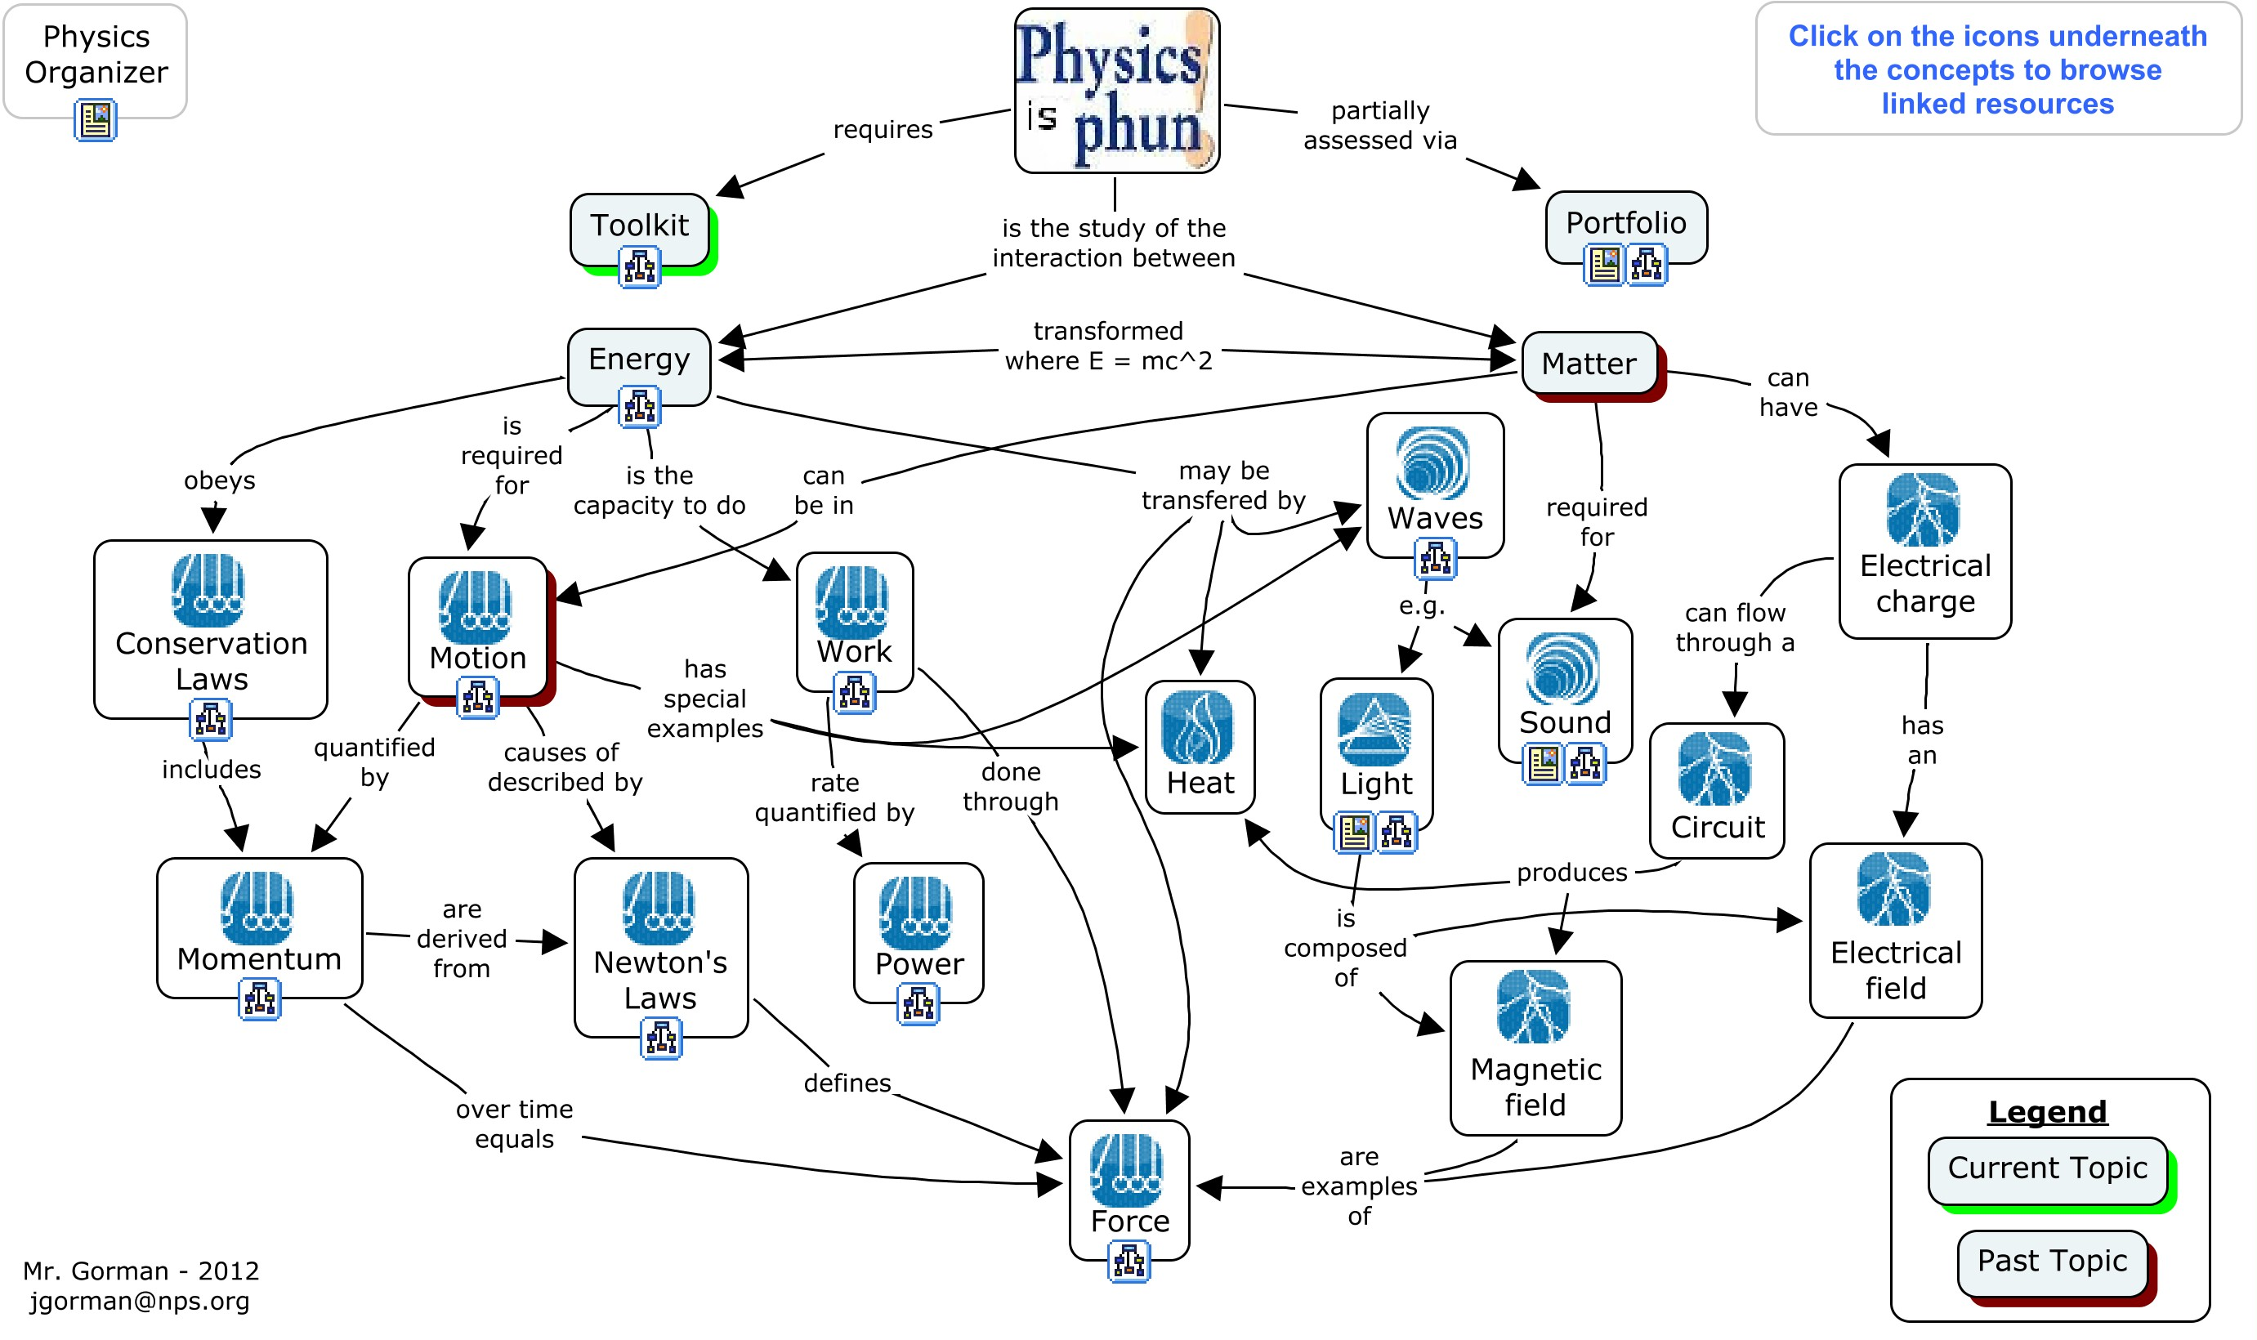
a)
b)
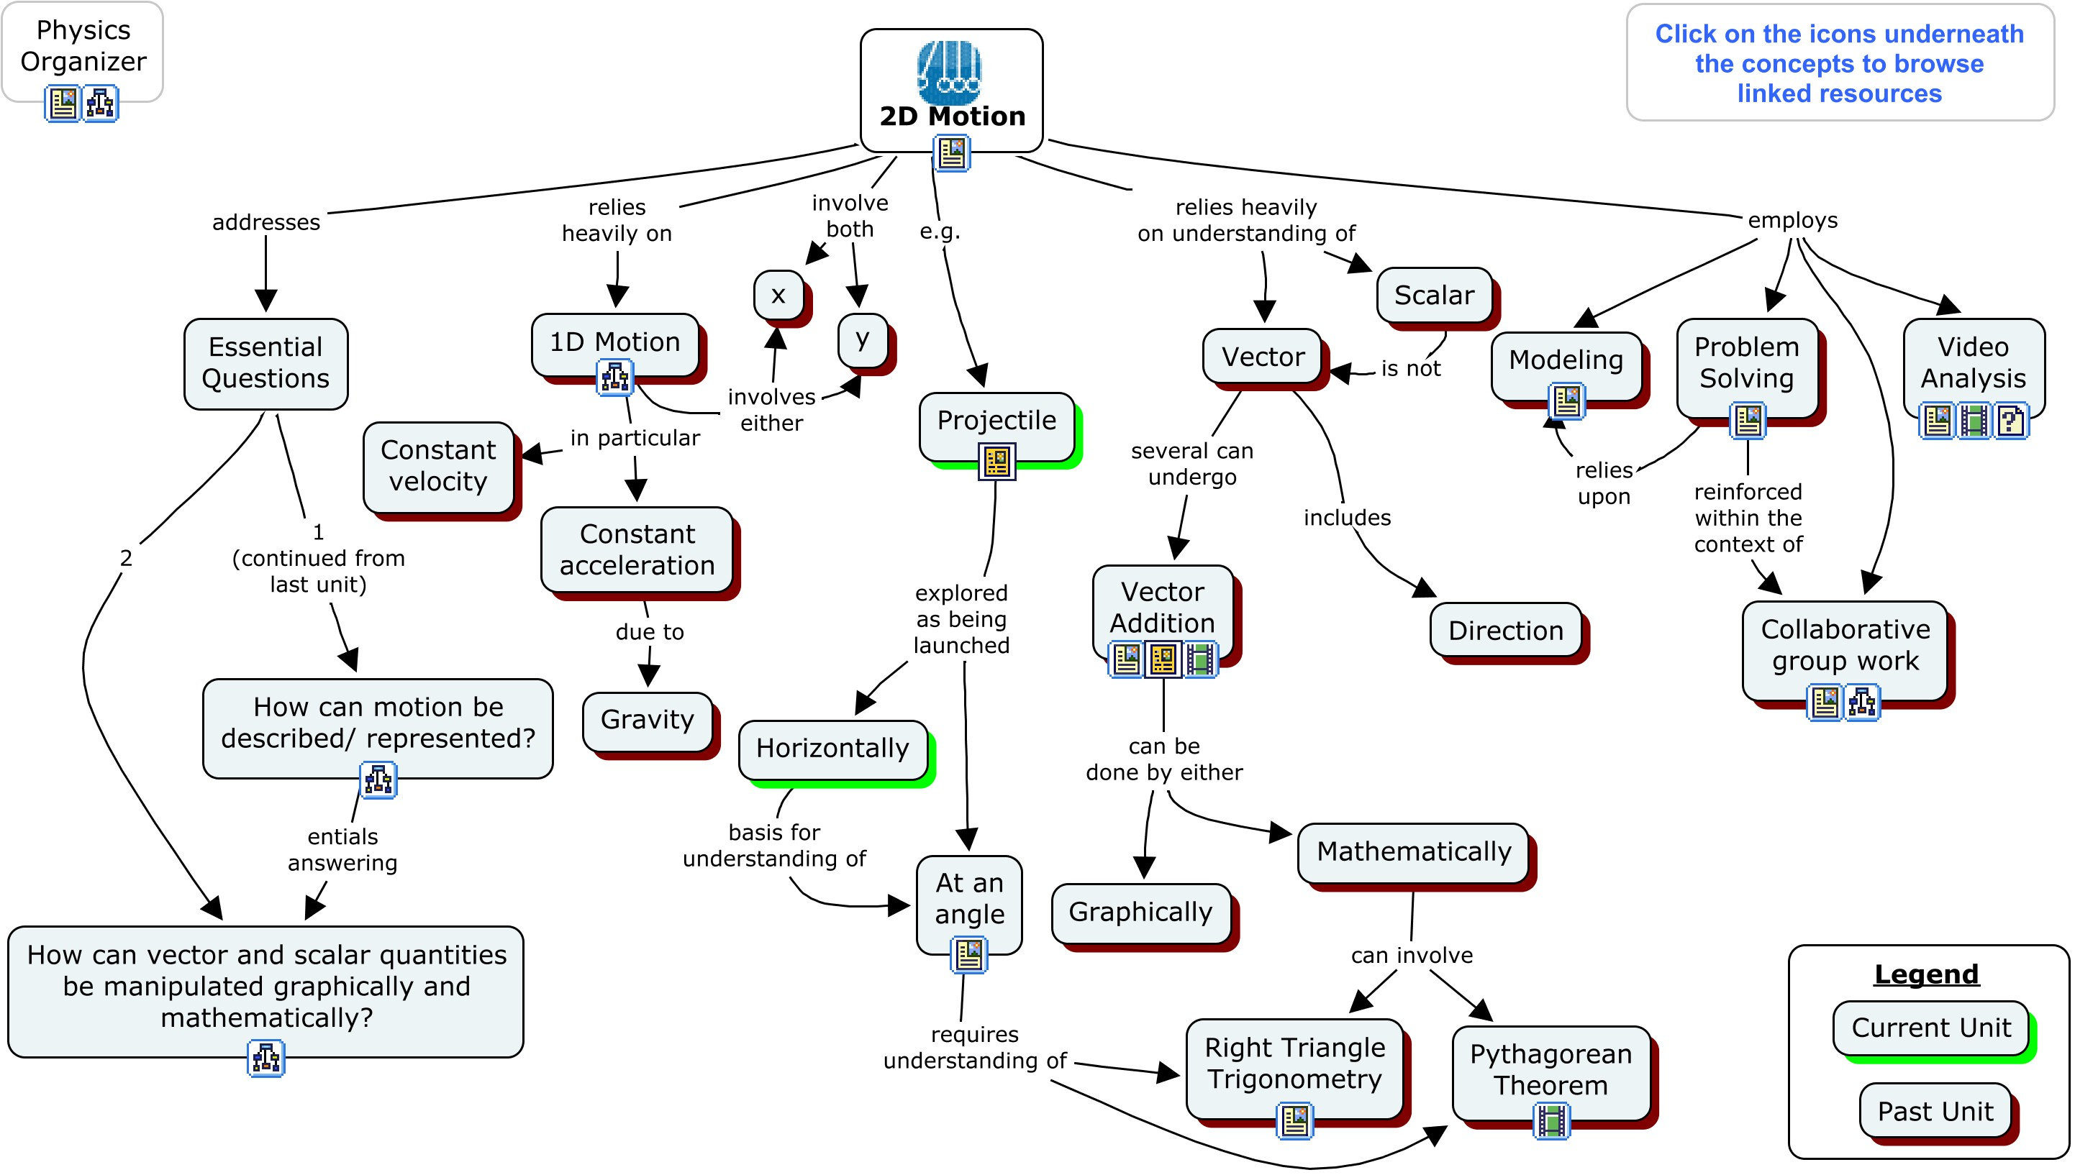

Concept Mapping Positively Impacts Presentations. Rooted in a strong awareness of their own understanding and the resulting self-confidence, teachers can then begin to construct lesson plans that promote critical thinking. PowerPoint presentations are at the core of many teachers’ repertoire and can be a useful tool. However, Kinchin (2007) found that use of linear presentation formats like PowerPoint in an unreﬂective manner tends to result in short-term learning. They also promote surface learning or rote learning which does not lead to critical thinking or mastery of the material. This is not to say that all linear presentation formats are always bad because in his survey students saw the advantages of bullet-pointed presentations for short-term learning goals. Interestingly, the students were able to recognize the tension between short-term and meaningful learning. This suggests students often adopt a rote learning style to successfully navigate through their school years.

To combat this problem, Kinchin applied cmapping principles to transform the linear PowerPoint format into a more interconnected structure. Students were presented with a cmap which only contained the main concepts of that presentation. Figure 7 is an example of this methodology from Gorman. The slides are numbered in the order they appear in the presentation. This is not meant to be a substitute for taking notes so the bullet-points are not quite readable on the slides. However, the main concepts covered on the slides are more readable. As a cmap, relationships contain linking phrases to move students to think more deeply about the topic. These links not only reveal a hierarchical structure among the concepts, but also provide cross-links between slides which are significantly separated in the linear presentation (e.g., the cross-link between slide 5 and 11 or slide 6 and 10).

Moon et al. (2008) followed up on these observations with a quantitative study involving pre- and post-tests. Students were presented with one of four different formats of the same material: journal article in traditional text, a hypertext version of the journal article, a Microsoft PowerPoint presentation, and a set of cmaps with attached resources. When comparing pre- and post-test score, they found that the cmap group significantly improved upon their pre-test score compared to the PowerPoint group. A survey also revealed a compelling preference for cmap format over PowerPoint. Therefore, this study provides positive evidence for a teacher to present material in cmaps as it can promote meaningful learning.

Of significant note is the Concept Mapped Project-based Activity Scaffolding System (CoMPASS) under the direction of Sadhana Puntambekar. CoMPASS is geared toward middle school students and combines a hypertext environment with design challenges. Physics-based units have been developed to facilitate students’ visualization of the relationship between concepts and principles. Cmaps are used to supplement the text. In agreement with the previously noted works, Puntambekar et al. (2003, 2007) confirm that when cmaps are used to provide a visual relationship between concepts it promotes meaningful learning and results in significantly improved post-test scores. The significance of this study is that cmapping has been proven to promote critical thinking in grades 6-8. The CoMPASS project can be accessed at http://www.compassproject.net.

Figure 7. A cmap view of a lecture slides on MRSA treatment and molecular geometry/bonding. Each slide’s position in the linear PowerPoint presentation is noted with a number.
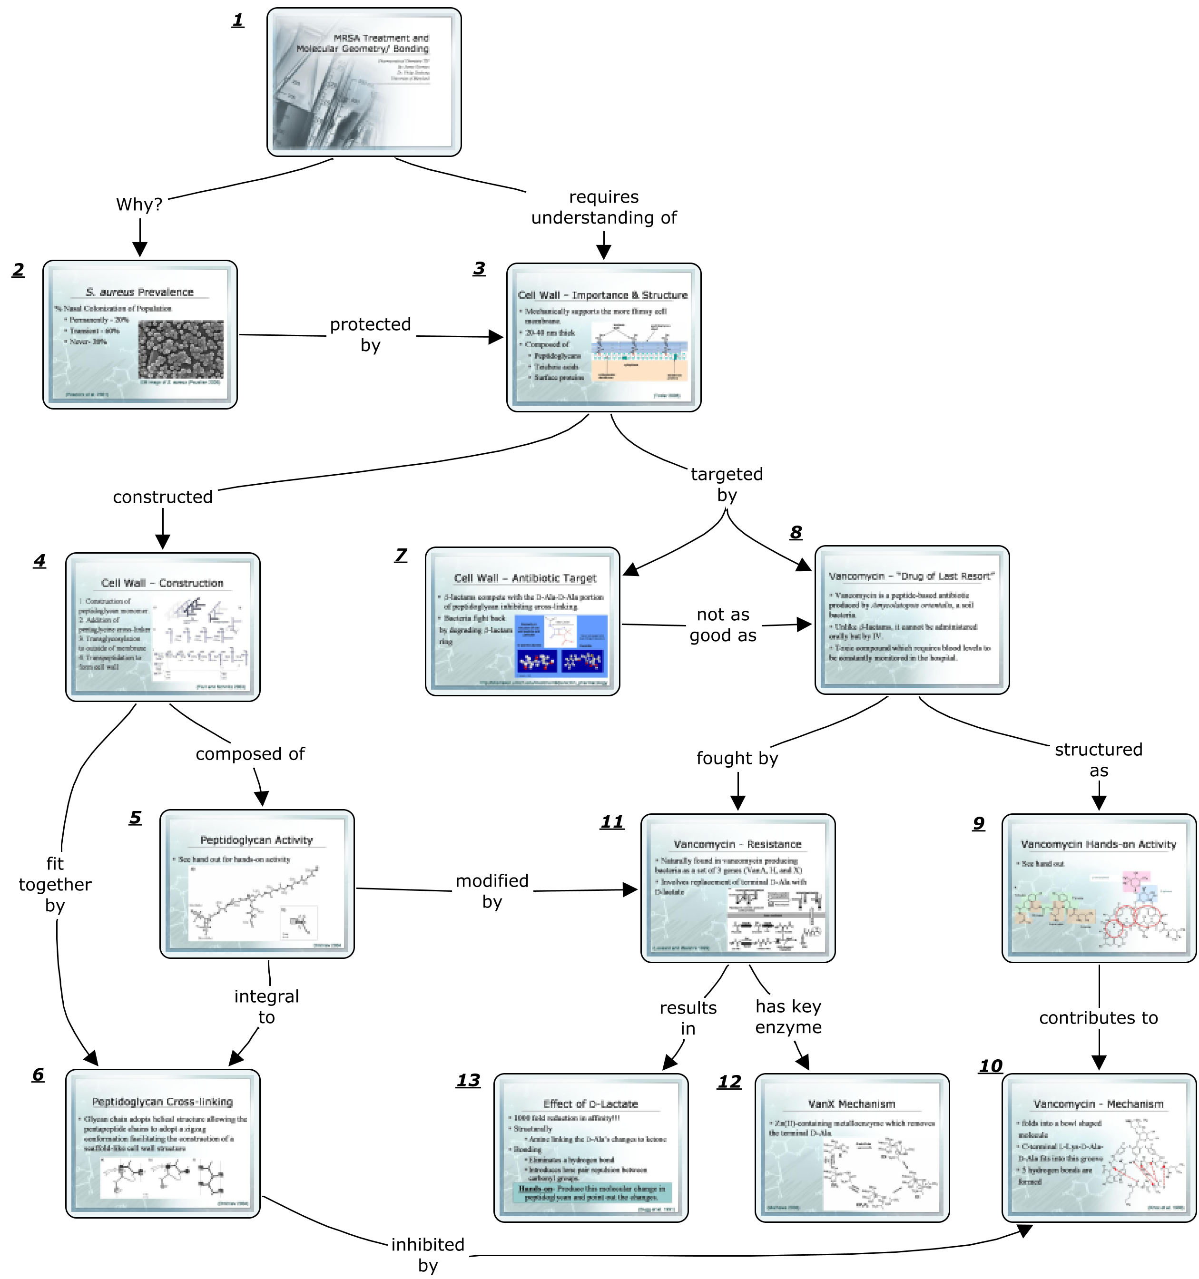

The Classroom Level: Student Concept Maps Represent Meaningful Learning
Teaching is more than delivering a presentation or organizing meaningful lessons for students, it is about prompting and facilitating learning in the classroom. A significant shift from focusing on content to the process of learning the content has already been made by teachers who create course organizers and incorporate cmapping into lessons. With the materials in place, now the teachers are ready to engage with the students helping them to create their own understanding of the topic. Teachers must be keenly aware that students’ understandings will not be a copy of the their own, but will instead reflect each student’s experiences and prior knowledge.

Concept Mapping to Facilitate Personal and Negotiated Meaning. In a meaningful learning environment it is important to start with students' prior knowledge because this is the foundation upon which new knowledge will be constructed. In the teacher section, we reviewed the value and process for reflecting upon their understanding of a topic. For students, however, the process is more in depth as they have little to no knowledge or understanding of the topic. If a student were given the expert cmaps that the teacher created the student could be overwhelmed. Furthermore, provision of the connections actually blocks the development of the students' own critical thinking skills.

Novak (1984) promotes the use of expert skeleton cmaps (ESCM) which are developed by a teacher from his expert concept maps and can be used as pre-tests to see what knowledge the student has about a particular topic. These pre-tests are not graded. ESCMs also serve as advance organizers to scaffold learning by providing starting points. That is, ESCMs provide an initial hierarchical structure which incorporates prior knowledge and a "parking lot" populated with threshold concepts. "Threshold concepts" are central to the mastery of the subject area (Meyer and Land, 2003). Some main attributes of threshold concepts are transformative (changes the student’s view of the subject), troublesome (often are counter-intuitive or alien), irreversible (unlearned only through considerable effort), and integrative (showing the relatedness between two other concepts which were previously hidden) (Meyer and Land, 2005). The utilization of threshold concepts not only focuses the student to critically think about these key concepts but also empowers the teacher to recognize/assess when students have acquired key understanding and help negotiate a more precise meaning with the students. Through this process, students’ assumption of concepts can be concretely visualized over time as the cmaps evolves in complexity to reflect their new understanding.

Novak (1984) found that ESCM help build mapping skills and learner confidence while promoting meaningful learning, as we will point is a manner of promoting critical thinking in the classroom. Additionally, ESCMs reduce the chance of misconceptions being perpetuated and maximize the chance that the knowledge structure will help remove or at the least decrease misconceptions (Novak, 2002). Figure 8a is an example of an ESCM for a physics 1D motion unit. This concept has also been extended to enriched ESCMs by Marée et al. (2012) which like the unit organizers above have resources attached to each concept and found that students’ test scores correlated with their cmap scores.

There is one last key component of a ESCM, the focus question which serves to limit the scope of the cmap. Research has demonstrated that phraseology employed in a focus question directs the structure and quality of the resulting cmap. Derbentseva et al. (2004, 2006) studied declarative vs. dynamic focus questions as applied to cmapping and established that dynamic focus questions encouraged the use of richer propositional phrases. Therefore to encourage more critical thinking, dynamic focus questions should be used as much as possible (i.e., “How do the different parts of the plant help to produce food for the plant?” as opposed to “What are the parts of a plant?”).

Gorman administers ESCMs as pre-tests not only to get a sense of what students understand, but also to provide students with time to reflect about what they might know or understand about a particular topic. This activity can be eye-opening for students and helps start the teacher-student conversation. Figure 8b is the result of a student's first attempt to express what he knew using the ESCM. The student only made three connections to the existing structure and was unsure how the other concepts fit in. After some meaningful learning time, the student then revised his cmap, Figure 8c. Notice that in this cmap, the majority of the concepts are used as well as additional concepts the student has acquired. However, some misconceptions are present. Once the teacher assesses where the students are starting from, he can make adjustments to the lessons to follow. After some instruction, it is important to have students compare their cmaps and negotiate the meaning of the individual concepts.

There are a myriad of different methods to encourage negotiation and group construction of a cmap. Gorman prefers to break students up into groups of three or four and have them negotiate meaning to arrive at a group cmap using 2'x3' whiteboards (Wells et al., 1995) because students can easily erase and redraw their cmap. Sticky notes or index cards would also work well as they can be easily rearranged. As a teacher, this is one of the best times to listen in on student conversations and observe their cmaps. The teacher can quickly identify misconceptions and ask probing questions to make the students critically think about their understanding. Giving them the answer is counterproductive when facilitating critical thinking. When circulating through the classroom and monitoring conversation, the teacher can clearly observe the progressive differentiation (lengthening of chains) and integrative reconciliation (the changing of hierarchical structure and cross-linking). Occasionally, a debate will erupt in a group and the teacher will be brought in to mediate. More often than not, both the students are correct but they think they are at odds with each other because they have been accustomed to thinking that there is only “one correct answer.”

Once each group has been given enough time, the groups switch whiteboards and compare their negotiated cmaps, with the opportunity of incorporating any new insights on their own cmap. The rotation continues until the groups are back at their own whiteboard where they review and consider the comments. Their homework is to revise their own personal cmap, the result of which can be seen in Figure 8d. The teacher should be cognizant of the misconceptions and holes in student understanding. After additional meaningful learning time, which seeks to address the persistent misconceptions and elaborate on existing understanding, students revise their cmap to reflect their current understanding. The yellow notes in Figure 8e which was created in CmapTools are the teacher’s comments to the student. This version can then be revised in groups and after an additional remediation period a final cmap is constructed, Figure 8f. Comparing the depth and complexity of understanding between the first cmap and last in Figure 8 reveals that this student has significantly improved over the course of the unit. Kern (2008) provides a similar methodology with four cmapping periods each with a different emphasis and role for the teacher.

Figure 8. Student example of how his personal understanding has evolved over the unit from a basic spoke structure to the complexity of a network. This example is from a unit on motion with the focus question, “How can motion be described/represented?”
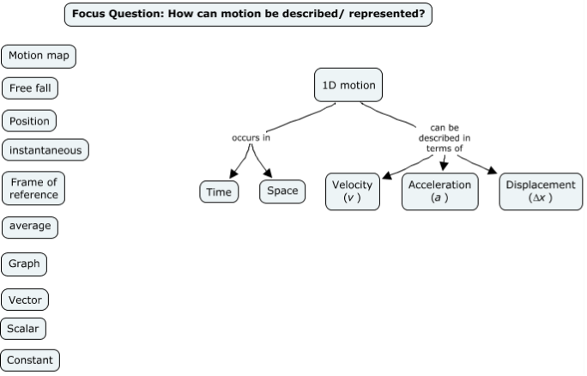 | 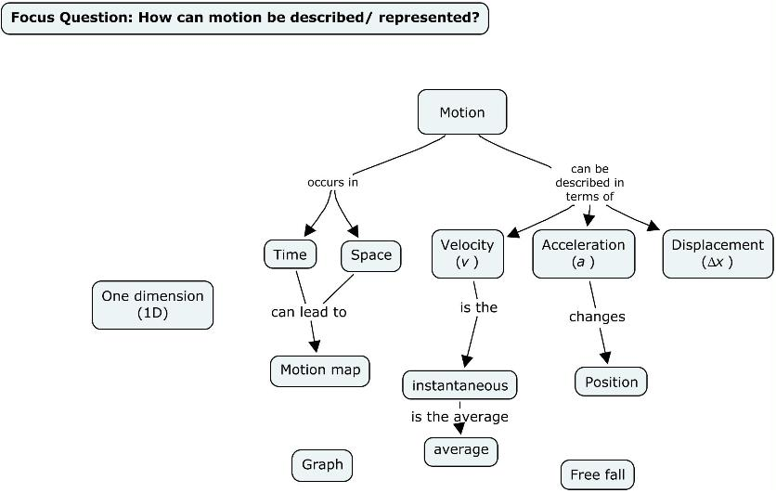
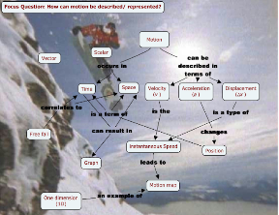 | 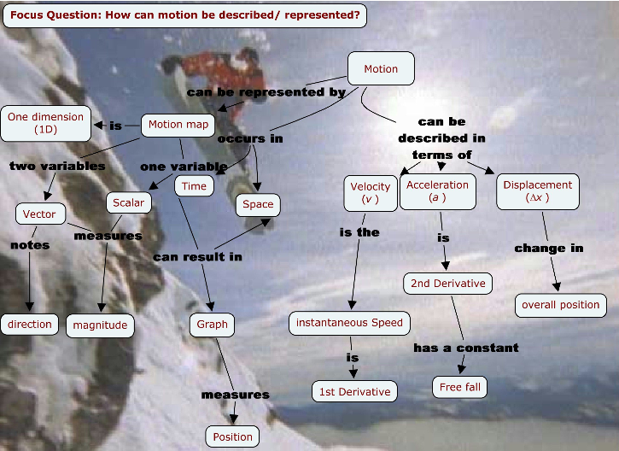
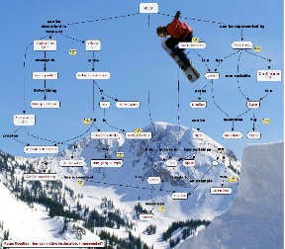 | 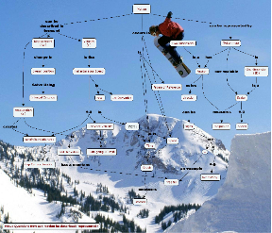

The knowledge portfolios assigned to Gorman’s physics class require the students to make the individual topics of physics relevant to their lives. Thus, the students were challenged to critically think about how the topics they were learning in the classroom applied to their lives. One student’s way of demonstrating his connection is demonstrated in Figure 8. The colorful background in the student cmaps were placed there by the student who likes to ski, demonstrating his way of relating to the topic. Steps like this tap into students’ emotions (i.e., Bloom’s affective domain) by making them realize that these concepts apply to their lives. Making these concepts personal raises student responsiveness and causes them to be active learners, a key component to meaningful learning.

Teachers can focus their critical thinking about teaching methods on a wide array of cmapping activities. Anohina-Naumeca and Graudina (2012) classified cmapping tasks and ranked them from the simplest to the most difficult, Table 1. The simplest tasks involve very little freedom to the student and can be found in many text book chapter review sections. These cmaps. though, require the least amount of critical thinking while the more difficult cmaps offer more freedom to the creator. These are best for a meaningful learning environment as they require the student to critically consider the relationship between concepts and develop the structure of the cmap themselves. There are two cmapping tasks which preclude the use of linking phrases, the 3rd and 5th degrees. The authors strongly advocate for the inclusion of linking phrases because the students are then forced to articulate the relationship between concepts. As Vygotsky (1997, p. 218) states, “Thought is not merely expressed in words; it comes into existence through them.” The externalization of student thoughts is a crucial factor to facilitate critical thinking and opens up a space for dialog and negotiated meaning.

Table 1. Summary of cmap based intelligent knowledge assessment system (IKAS) developed at Riga Technical University, Latvia (table modified from Anohina-Naumeca and Graudina 2012)
Mirzaie et al. (2008) conducted a study with high school chemistry students in which they used cmapping with half of the students and traditional instruction with the other half. Their cmapping methodology was similar to the one described above. The teachers administered pre- and post-tests but the uniqueness of their study is that test questions were designed according to Bloom’s taxonomy. The assessments focused on the Bloom's factual and conceptual knowledge dimensions and covered all cognitive process dimensions. In their analysis, Mirzarie et al. found that both groups of students performed similarly on the lower cognitive skills (remember, understand and apply). However, the students who were immersed in a cmapping environment significantly outperformed the traditional classroom students on questions which involved the higher critical thinking skills (analyze, evaluate and create). Cmapping forced the students to break down the information into parts and find evidence to support the generalizations they were making (analyze). The students then had to fit these new insights in relationship with their prior knowledge (create). After reviewing other student cmaps, students needed to “negotiate meaning.” (evaluate). Each of these skills are given little emphasis in traditional classrooms so it is little surprise that students who consistently employed cmapping during the learning process would excel with these higher critical thinking skills. This work suggests that instruction in the higher order cognitive processes that address metacognition knowledge facilitates learning of the higher order cognitive processes of factual and conceptual knowledge in a science discipline. Furthermore, it is easy to consider that such instruction would also catalyze higher order thinking across all the disciplines, not just the sciences.

Evaluating Concept Maps For Evidence of Meaningful Learning: the Teacher’s Assessment Role. Teachers must grade and provide feedback on their students’ work to report on their progress. Johnstone and Otis (2006) suggest viewing cmaps as a learning tool rather than an assessment tool. However, even learning tools must be accompanied by some form of assessment. Assessments can be broken into two types: qualitative and quantitative.

Qualitative analysis of cmaps relies heavily on the gross cmap morphology. Kinchin et al. (2000) clearly identify three types of structure with a cmap: spoke, chain and network (Figure 9). A spoke structure is similar to a bulleted list which indicate learner readiness but does not demonstrate an understanding as there are no links present between concepts. Considering Bloom's revised taxonomy, spoke structures can also represent the learner putting factual knowledge on paper without any critical thinking involved. While spoke structures are indicative of novice learners, teachers can guide students to rudimentary understanding that is evident in chain structures which are indicative of goal-oriented learning. Rote learning encourages chain structures which are resistant to change because student are not yet personalizing the concepts. Considering Bloom's revised taxonomy, chain structures can also be indicative of procedural knowledge. Students who engage in meaningful learning, as seen in the previous section, critically think about the relationship between all the concepts. Thus, they tend to produce network-like cmaps which show a degree of cross-linking between concepts in separate chains. Network structures are evidence that critical thinking is occurring and, as a result, is indicative of student understanding. Since network structures emphasize the link between concepts in different domains it could also be indicative of Bloom's conceptual knowledge dimension which focuses on the interrelationship among concepts. Content experts produce cmaps with a great deal of network structure. Safayeni et al. (2005) identified a fourth morphology called a cycle which is well suited to represent functional or dynamic relationships including mathematical relationships.

Figure 9. This cmap details knowledge structure variations which can be indicative of types and levels of understanding (modified from Kinchin et al., 2000).
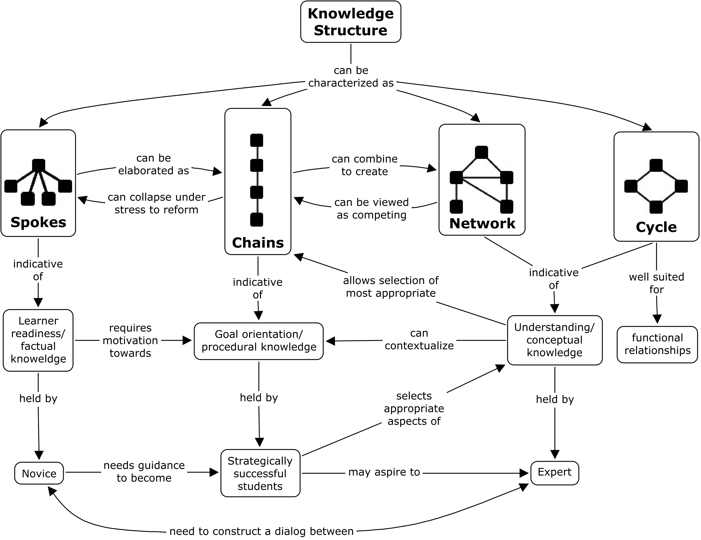
The four knowledge structures are not in opposition to each other and often several types can co-exist in a single cmap. Dependent on the focus question, a structure can evolve from spoke to chain to cycles or networks and back again. Where procedural knowledge is asked for, chains become more prevalent, while mathematical relationships favor a cycle structure. While evaluating cmaps, the teacher should be cognizant about these types of structures and how they can give insight into the level of understanding.

It is instructive to apply Kinchin’s insights (Figure 9) to analyze the cmap time sequence found in Figure 8. What do the knowledge structures imply about the student’s depth of thinking and understanding? At the start of the unit, the student took the skeleton map and was able to relate a couple of concepts in a spoke-like arrangement. By the next snapshot, this student was able to add more concepts and make more connections among them. The cmap has a single cross-link and a chain element demonstrating the fact that the student is beginning to think more critically about the relationship between concepts. In the fourth cmap, there are several chains linked by phrases that are mostly accurate. This is evidence the student has learned at least the definition of each concept but has not yet achieved a cohesive picture of how the concepts relate to one another. The fruit of much critical thinking is clearly evident in the final two cmaps where the student was able to make cross-links between different chains, thus forming a clear network structure typical of an expert.

Knowledge structures present in a cmap provide a key initial impression of the understanding held by a student, but it should not be the only criteria. Hays (2007) suggests qualitative analysis in terms of depth of learning: deep, surface, and non-learning. His methodology takes into consideration knowledge structure and two additional factors: concepts and linkages. A rubric which summarizes Hays’ criteria and Kinchin et al.’s (2000) morphologies can be found in Table 2. A cmap demonstrates deep learning when new concepts have been added as well as the linkages are valid and explanatory. These qualitative depth of learning criteria fit well with our observations based on the knowledge structure of the student cmaps in Figure 8 while taking into account the concepts & linkages.

Table 2. Rubric for the qualitative analysis of the depth of learning based on cmap analysis.
Depth of Learning | Criteria comparing final cmap to the first
Depth of Learning | Concepts | Linkages | Overall Structure
Deep | - Original concepts remain  - New concepts added | - Valid  - Explanatory  - Evidence of meaning in the mind of the map author | - Network and/ or cycles are present.  - Well defined organization.  - Increased number of cross-links between branches.
Surface | - Significant number of new concepts but not linked with prior knowledge. | - The overall number of linkages has not changed significantly | - Chain structures are present.  - None to few cross-links  - Explanatory power not significantly increased
Non-learning | - None to few new concepts added | - Zero to few new linkages made  - no new cross-linking between concepts | - No change in knowledge structure or significant reorganization of concepts

From a teacher’s perspective, quantitative analysis is often the end result of most activities. However, there are several concerns that need consideration before setting out to “grade” cmaps. First, not all concepts are equal in value or weight. Some concepts are not as crucial to understanding as others (Mintez and Quinn, 2007). Crucial concepts definitely include threshold concepts discussed earlier in reference to ESCMs. Second, the most important concepts are more indicative of student understanding than the overall number of concepts present; bigger is not always better (Clariana and Taricani, 2010). Expert maps tend to have fewer concepts than novice maps as experts are more prudent by selecting the key concepts and linking them with meaningful phrases. Clariana and Taricani (2010) found that a score derived from the 16 most important concepts in cmap correlated well with the performance on a multiple choice test. Third, a student who demonstrates surface learning might understand more than is portrayed because that limited set of propositional phrases might be enough to serve as a memory jog. Any cmap assessment regime must be vigilant to assure that students are accurately representing the full extent of their understanding. Assessment criteria must be made clear and upfront.

A widely used semantic grading rubric was developed for Panama’s large-scale Conéctate al Conocimiento Project to assess the meaningful learning as evidenced by cmaps. This rubric is content-based and details a set of "six criteria: 1) concept relevance and completeness, 2) correct propositional structure, 3) presence of erroneous propositions (misconceptions), 4) presence of dynamic propositions, 5) number and quality of cross-links, and 6) presence of cycles” (Miller and Cañas, 2008). Even with a rubric, cmap assessment is inherently subjective in nature. However, while testing this rubric over many evaluators, Miller and Cañas (2008) demonstrated a moderate level of consistency between evaluators suggesting that this rubric would have potential for large-scale use. In a classroom where one teacher is assessing all the cmaps, subjectivity between evaluators is negated. A copy of this rubric can be found in the appendix of Miller and Cañas (2008) at http://eprint.ihmc.us/320/1/cmc2008-p253.pdf.

Analysis of large cmaps or large quantities of cmaps can be taxing. In 2010, CmapAnalysis was developed to alleviate some of the pain by automating the collection of key parameters about a set of cmaps (Cañas et al., 2010). This software pulls out data relative to size, quality, and structural properties while remaining flexible so that users may define their own assessment parameters. Output from the software is in the form of an Excel spreadsheet (.xls) for ease of viewing and manipulation. CmapAnalysis only accepts cmaps in open CXL file format which can be easily exported from CmapTools. This multi-platform software is freely available through the Google Code project at https://code.google.com/p/cmapanalysis/. While this software will not be able to fully automate cmap analysis, it can mitigate some of the more tedious aspects.

Meaningful learning can be assessed using either qualitative or quantitative methods. Qualitative assessments are very well suited for formative evaluations which are extremely important in meaningful learning because it starts a dialog between the students and teachers. Quantitative analysis arrives at a “score” for a cmap but the process can be tedious and requires keeping several caveats in mind.

Discussion
In the recently published book Surpassing Shanghai: An Agenda for American Education Built on the World’s Leading Systems, editor Marc Tucker summarizes international student performance in science as measured by the PISA assessments, highlights case studies of the five countries who are the top performers, and recommends an action plan for the United States to reassert its efforts in this playing field. (Tucker, 2012) Among the top two recommendations is “coherence in the design of the overall education system itself.” The authors of this chapter described key levels of the science education system, some of the salient critical thinking questions that must be addressed at each level, and how conceptual maps, as visual representations, can facilitate clear understanding of and communication about the science content at each level. Our hope is that this chapter will catalyze readers to think of conceptual mapping tools in their application to enhance coherence, critical thinking, and meaningful learning across the entire science education system. The authors visualize an emerging synergy of the levels of the science education system in which the conceptual maps of each level may serve as advance organizers for each succeeding level of the system. We can visualize how each lower level in the system can access and use the structure created at the level above, select the most salient parts and add parts particular to its needs, thus benefiting from the work provided, but also adapting it to its own critical thinking questions.

CmapTools is one mechanism which can be used to link all of these efforts together, thus making the system as a whole more coherent. Curriculum coordinators can parse the requisite knowledge into expert cmaps that clearly label the relationship between concepts. The advantage here is that the curriculum coordinator can directly link their school or school system’s goals to the standards while fleshing their meaning out for educators. Teachers can also link their instructional efforts to the curriculum coordinators' work. Students, in turn, can demonstrate mastery of subject matter by linking their learning efforts to the teachers’ instruction. A demonstration of this vision can be found at http://cmapspublic3.ihmc.us/rid=1HL3HCVNB-8H9KH3-J6J/Vision.cmap. The vision demonstrates that the educational professional and governing institutions can articulate the standards of scientifically literate citizens, and school systems, individual teachers, and students can demonstrate their unique pathways to addressing those standards.

There are many further directions to pursue. directions to pursue. The table that articulates the two dimensions of the new Bloom's taxonomy (Krathwohl, 2002) offers a fruitful tool to investigate further the connections between metacognitive instruction and its interaction with instruction targeting different types of knowledge at different levels of cognitive processing. Validity of the cmapping/critical thinking connection still requires work. (Daley, 1999) Other mapping strategies, such as vee-mapping (Novak and Gowin, 1984) play a role in problem solving and scientific research. Other metacognitive strategies will surely be developed as mind tools to develop other aspects of both critical and creative thinking.

Cited Resources
Afamasaga-Fuata’i, K. (2006) Innovatively Developing A Teaching Sequence Using Concept Maps. In A. J. Cañas, J. D. Novak (Eds.), Concept Maps: Theory, Methodology, Technology, Proceedings of the Second International Conference on Concept Mapping, San José, Costa Rica (September 5-8, 2006), Editorial Universidad de Costa Rica.
American Association for the Advancement of Science (AAAS). (1989) Science for All Americans. Oxford University Press: New York, New York.
American Association for the Advancement of Science (AAAS). (1993) Benchmarks for Science Literacy. Oxford University Press: New York.
American Association for the Advancement of Science (AAAS). (2001) Atlas of Science Literacy, Volume 1. American Association for the Advancement of Science and the National Science Teachers Association: Washington, DC.
American Association for the Advancement of Science (AAAS). (2007) Atlas of Science Literacy, Volume 2 American Association for the Advancement of Science and the National Science Teachers Association: Washington, DC.
American Philosophical Association. (1990) Critical thinking: a statement of expert consensus for purpose of educational assessment and instruction. Columbus, OH Center on Education and Training for Employment. College of Education. The Ohio State University (ERIC) Document Reproduction No. ED 315-423.
Anderson, L.W. (Ed.), Krathwohl, D.R. (Ed.), Airasian, P.W., Cruikshank, K.A., Mayer, R.E., Pintrich, P.R., Raths, J., & Wittrock, M.C. (2001). A taxonomy for learning, teaching, and assessing: A revision of Bloom's Taxonomy of Educational Objectives (Complete edition). New York: Longman.
Anohina-Naumeca, A. and Graudina, V. (2012) Diversity of Concept Mapping Tasks: Degree of Difficulty, Directedness, and Task Constraints. In A. J. Cañas, J. D. Novak and J. Vanhear (Eds.), Concept Maps: Theory, Methodology, Technology, Proceedings of the Fifth International Conference on Concept Mapping. Valletta, Malta.
Ausubel, D. P. (1968) Educational psychology: A cognitive view. New York: Holt, Rinehart & Winston.
Ausubel, D. P., Novak, J. D., and Hanesian, H. (1978) Educational Psychology: A Cognitive View, Second Edition. Holt, Rinehart, and Winston, Inc.: New York, New York.
Cañas, Alberto J. July, 2003. A Summary of Literature Pertaining to the Use of Concept Mapping Techniques and Technologies or Education and Performance Support. Prepared for The Chief of Naval Education and Training, Pensacola, FL. The Institute for Human and Machine Cognition, 40 S. Alcaniz St., Pensacola, FL.
Cañas, A., Bunch, L., and Priit, R. (2010) Cmapanalysis: An Extensible Concept Map Analysis Tool. In A. J. Cañas, J. D. Novak and J. Sánchez (Eds.), Concept Maps: Theory, Methodology, Technology, Proceedings of the Fourth International Conference on Concept Mapping. Viña del Mar, Chile.
Chabeli, M. (2010) Concept-Mapping as a Teaching Method to Facilitate Critical Thinking in Nursing Education: A Review of the Literature. Health SA Gesondheit Vol. 15 No. 1.
Clariana, R.B. and Taricani, E.M. (2010) The consequences of increasing the number of terms used to score open-ended concept maps. International Journal of Instructional Media, 37(2): 218 – 226.
Corcoran, T., Mosher, F., and Rogat, A. (2009) Learning Progressions in Science: An evidence-based approach to reform. Consortium for Policy Research in Education: Philadelphia, Pa.
Daley, Barbara J., et al. (January, 1999) Concept Maps: A Strategy to Teach and Evaluate Critical Thinking. Journal of Nursing Education. Vol.38. No 1.
Derbentseva, N., Safayeni, F., and Cañas, A. J. (2004) Experiments on the Effect of Map Structure and Concept Quantification during Concept Map Construction. In A. J. Cañas, J. D. Novak & F. M. González (Eds.), Concept Maps: Theory, Methodology, Technology, Proceedings of the First International Conference on Concept Mapping. Pamplona, Spain: Universidad Pública de Navarra.
Derbentseva, N., Safayeni, F., and Cañas, A. J. (2006) Two Strategies for Encouraging Functional Relationships in Concept Maps. In A. J. Cañas & J. D. Novak (Eds.), Concept Maps: Theory, Methodology, Technology. Proceedings of the Second International Conference on Concept Mapping. San Jose, Costa Rica: Universidad de Costa Rica.
Dewey, J. (1910) How we think. Boston: DC Heath & Co.
Facione, P.A. (1995) Critical thinking and clinical judgment: Goals for nursing science. Paper presented at the annual meeting of the Western Institute of Nursing, San Diego, CA.
Fonseca, A. P. and C.I. Extremina. (2008) Concept Maps as Tools for Scientific Research in Microbiology: A Case Study. Proceedings of the Third International Conference on Concept Mapping. Tallinn, Estonia & Helsink, Finland.
Foster J. and Wiser M. (2012) The potential of learning progression research to inform the design of state science standards. In Alonzo AC, Gotwals AW (Eds.) Learning progressions in science: Current challenges and future directions, 435-459. Sense Publishers, Rotterdam, The Netherlands.
Gorman, J. Concept Map Advance Organizers. In Engineering the Future : Science, Technology, and the Design Process (Teachers Guide). Emeryville, CA: Key Curriculum, 2008. Print.
Hays, D. (February 2007) Using Concept Maps to measure deep, surface and non-learning outcomes” Studies in Higher Education. Vol 32, No. 1, pp. 39-57
Heinze-Fry, J. (2006) CmapTools Facilitates Alignment of Local Curriculum with State Standards: A Case Study. In Concept Maps: Theory, Methodology, and Technology: Proceedings of the Second International Conference on Concept Mapping. Cañas, A. J. and Novak, J. D. eds. San Juan, Costa Rica.
Heinze-Fry, J., J. Gorman, and J. Foster. (2010) Conceptual Mapping to Facilitate Review of State Science Standards. In Concept Maps: Making Learning Meaningful: Proceedings of the Fourth International Conference on Concept Mapping. Sanchez, J., Cañas, A. J. and Novak, J. D. eds. San Juan, Costa Rica.
Johnstone, A.H. and K.H. Otis. (2006) Concept mapping in problem based learning: a cautionary tale. Chemistry Education Research and Practice, 7(2): 84 – 95.
Jonassen, D. H., C. Carr, and H-P Yueh. (March, 1998) Computers as Mindtools for Engaging Learners in Critical Thinking. TechTrends, v43, n2, p24-32.
Kern, C. and Crippen K. (January, 2008) Mapping For Conceptual Change. Science Teacher v.75 No. 6. National Science Teachers Association: Arlington, VA
Kinchin, I., Hay, D. and Adams, A. (2000) How a qualitative approach to concept map analysis can be used to aid learning by illustrating patterns of conceptual development. Educational Research, 42(1): 43 – 57.
Kinchin, I (2007). Using Concept Mapping principles in PowerPoint. Eur J Dent Educ 2007; 11: 194–199
Kinchin, I. (2009). A Knowledge Structures Perspective on the Scholarship of Teaching & Learning. International Journal for the Scholarship of Teaching and Learning, 3(2).
Krathwohl, D.R. 2002. A Revision of Bloom's Taxonomy: An Overview. Theory into Practice. Volume 41, Issue 4.
Marée,T., van Bruggen, J., and Jochems, G. (2012) Using Enriched Skeleton Concept Mapping To Support Meaningful Learning. In A. J. Cañas, J. D. Novak and J. Vanhear (Eds.), Concept Maps: Theory, Methodology, Technology, Proceedings of the Fifth International Conference on Concept Mapping. Valletta, Malta.
Massachusetts Department of Elementary and Secondary Education (MADESE). (2001/2006) Massachusetts Science and Technology/Engineering Curriculum Framework. Malden, Massachusetts, USA. (Available online at www.doe.mass.edu/frameworks/current.html.)
Meyer J, and R. Land (May, 2003) Threshold concepts and troublesome knowledge: Linkages to ways of thinking and practising within the disciplines. School of Education, University of Edinburgh Occasional Report 4. (Edinburgh)
Meyer, J. and Land, R. (2005) Threshold concepts and troublesome knowledge (2): epistemological considerations and a conceptual framework for teaching and learning, Higher Education, 49 (3), 373-388.
Miller, N., Cañas, A (2008) A Semantic Scoring Rubric for Concept Maps: Design and Reliability. In A. J. Cañas, P. Reiska, M. Åhlberg, and J. D. Novak (Eds.), Concept Maps: Theory, Methodology, Technology, Proceedings of the Third International Conference on Concept Mapping. Tallinn, Estonia & Helsinki, Finland. http://cmc.ihmc.us/cmc2008papers/cmc2008-p253.pdf
Mirzaie, R., Abbas, J., and Hatami, J. (2008) Study of Concept Maps Usage Effect on Meaningful Learning Frontier in Bloom’s Taxonomy for Atomic Structure Mental Concepts. In A. J. Cañas, P. Reiska, M. Åhlberg, and J. D. Novak (Eds.), Concept Maps: Theory, Methodology, Technology, Proceedings of the Third International Conference on Concept Mapping. Tallinn, Estonia & Helsinki, Finland.
Moon, B., Hoffman, R., Shattuck, L., Coffey, J., et al. (2008) Rapid And Accurate Idea Transfer: Evaluating Concept Maps Against Other Formats For The Transfer of Complex Information. In A. J. Cañas, P. Reiska, M. Åhlberg, and J. D. Novak (Eds.), Concept Maps: Theory, Methodology, Technology, Proceedings of the Third International Conference on Concept Mapping. Tallinn, Estonia & Helsinki, Finland.
National Science Digital Library (NSDL) Literacy Maps: http://strandmaps.nsdl.org/
Novak, J. D. (1998) Learning, Creating, and Using Knowledge: Concept Maps TM as Facilitative Tools in Schools and Corporations. Mahwah, NJ: Lawrence Erlbaum Associates.
Novak, J. D. & Gowin, D. B. (1984) Learning How to Learn. Cambridge: Cambridge University Press.
Novak, J. D. (1998) Learning, Creating, and Using Knowledge: Concept Maps TM as Facilitative Tools in Schools and Corporations. Mahwah, NJ: Lawrence Erlbaum Associates.
Novak, J. D. (2002) Meaningful learning: The essential factor for conceptual change in limited or appropriate propositional hierarchies leading to empowerment of learners. Science Education, 86(4), 548-571.
Novak, J. D and Cañas, A. J. (2008) The Theory Underlying Concept Maps and How to Construct Them. Technical Report IHMC CmapTools 2006-01 Rev 01-2008 available at http://cmap.ihmc.us/publications/researchpapers/theorycmaps/theoryunderlyingconceptmaps.htm
Novak, J. D. (2009) Learning, Creating, and Using Knowledge: Concept Maps as Facilitative Tools in Schools and Corporations, Second Edition. Routledge Taylor & Francis Group: New York, New York.
Puntambekar, S., Stylianou, A., & Hübscher, R. (2003) Improving navigation and learning in hypertext environments with navigable Concept Maps. Human Computer Interaction, 18 (4), 395-426.
Puntambekar, S., Goldstein, J. (2007) Effect of Visual Representation of the Conceptual Structure of the Domain on Science Learning and Navigation in a Hypertext Environment. Journal of Educational Multimedia and Hypermedia, 16(4), 429-441.
Safayeni, F., Derbentseva, N. and Cañas, A.J. (2005) A theoretical note on concepts and the need for cyclic concept maps. Journal of Research in Science Teaching, 42, 741 – 766.
Tucker, Marc S., ed. (2012) Surpassing Shanghai: An Agenda for American Education Built on the World’s Leading Systems. Harvard Education Press: Cambridge, MA.
von der Heidt, Tania. (2011) Learning with Concept Maps: A Study to Measure Change in Learning in Undergraduate Chinese Marketing Students. Southern Cross University. Conference Presentation.
Vygotsky, L.S. (1997) (Revised and edited, A. Kozulin). Thought and Language. MIT: Cambridge.
Wells, M., Hestenes, D. & Swackhamer, G. (1995) A modeling method for high school physics instruction. American Journal of Physics, 64, 114-119.
Wiser, M., and Smith, C. (2009) How does cognitive development inform the choice of core ideas in the physical sciences? Commissioned paper for National Research Council: Committee on Core Ideas in Science: Washington, DC.
Wiser, M., Smith, C. L.,Doubler, S., and Asbell-Clarke., J. (June 2009). Learning Progressions as a Tool for Curriculum Development: Lessons from the Inquiry Project. Paper presented at the Learning Progressions in Science (LeaPS) Conference. Iowa City, Iowa.

Key Terms & Definitions
Strand map: Stand maps represent learning progressions, the development of linkages among concepts over the K-12 grade levels. They show the progressive differentiation of big ideas of science over time and the integrative reconciliations that occur going from one grade span to another.

Concept: A perceived regularities in objects (such as “plant”) or events (such as “photosynthesis”). Generally, each concept is represented by a one-word label enclosed in a circle or box.

Concept map (cmap): Guided by a focus question, concept maps are visual representations of the meaningful relationship between concepts. Any relationship between two concept can be read as a precise statement of fact.

Critical thinking: A higher ordered thinking skill directed toward the purposeful evaluation of evidence, contexts, conceptualizations, methods, and criteria.

Expert skeleton concept map (ESCM): A type of concept map developed by an expert which is composed of a focus question, parking lot of threshold concepts and an initial hierarchical structure which incorporates prior knowledge. ESCMs serve well as advance organizers because they scaffold learning by providing starting points.

Integrative reconciliation: A metacognitive skill during which the learner restructures their conceptual understanding under a new overarching concept.

Learning progression: A written description of the road a learner follows to develop mastery of skills or a concept.

Meaningful learning: In Ausubelian learning theory, meaningful learning describes the active process of incorporating new learning to prior knowledge. This new learning must be presented in ways that are meaningful to the learner who must in turn choose to learn.

Progressive differentiation: A metacognitive skill where the learner elaborates on an existing, more general concept.

Threshold concepts: Concepts which are central to the master of a subject area. Key attributes of threshold concepts are transformative (changes the student’s view of the subject), troublesome (often are counter-intuitive or alien), irreversible (unlearned only through considerable effort), and integrative (showing the relatedness between two other concepts which were previously hidden).

