Dehorning in 6 mo. Holstein calf

Dehorning in calves is a procedure that should be essentially done at a young age <2mo. to minimize pain and reduction in growth performance and production. This is because at around 2 month the horn bud is ‘free floating’ in the skin, and as the calf gets older the horn bud attaches to the skull bone with a hollow centre connecting with the frontal sinus.

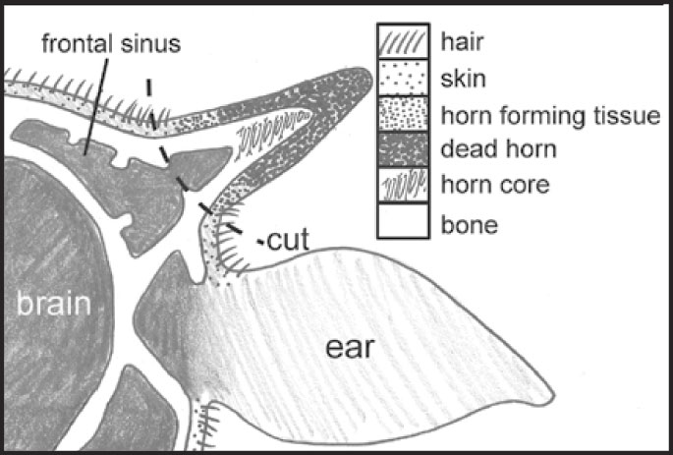
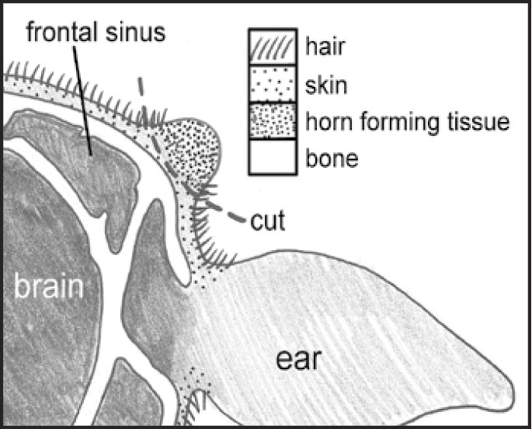
2 showing anatomy of horn in 6mo. calf

1 showing anatomy of horn in calf <2 mo.

