PREOPERATIVE MEASURES FOR CASE 2

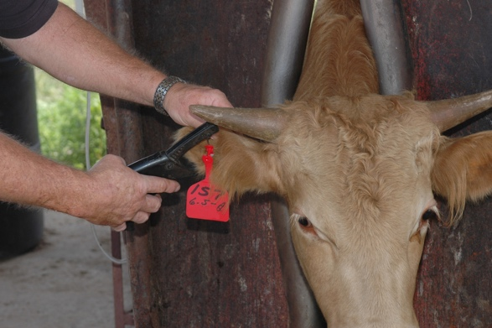

- INDICATIONS FOR DEHORNING
  - Prevention of horn-induced bruising of herd mates
  - Decreases aggressiveness at feed bunk
  - Enhance on-farm safety for producers and employees and facilitate easier handling
  - Market value is increased
  - Improves appearance of animal

- HISTORY
- No history was obtained for this calf at the time of the procedure, but it is very important in routine operations that this is obtained. Some of the relevant information that is included in this is:
  - Mother’s age, tag number and parity
  - The type of delivery of the calf (normal or assisted)
  - Suckling observation after birth (if additional colostrum was needed)
  - Present or past illnesses
  - Vaccination history
  - Current diet plan
  - Any current or previous medication used
  - Prior medical and surgical procedures underwent
  - Any recent calf deaths on the farming operation

- SIGNALMENT
  - ID#: 111
  - Nickname: Dolly
  - Age: 6-month-old calf
  - Breed: Black and white Holstein
  - BCS: 3/5
  - Weight: 397 pounds/ 180.076 kg

- PHYSICAL EXAM
  - A physical exam is always preceded by a distance exam. The environment is observed and assessed for factors such as cleanliness, proper and adequate bedding, airflow and presence of other pen mates. The calf’s appearance is then assessed by its ability to stand, gait and posture, any visible abnormalities (congenital eg. Cleft palate), signs of fecal staining and the respiration rate. After this, a 5-station physical exam is done, and all parameters are observed to check if they are within the normal ranges.

- EQUIPMENT USED
*Note: all surgical instruments used in a corneuctomy should be kept sharp and in optimal operating condition for rapid and efficient transection of the horn.
  - Halter
  - Standing chute
  - Penlight
  - Stethoscope
  - Digital rectal thermometer
  - 18-22-gauge 1.5 inch needles
  - Plastic syringe
  - Alcohol soaked swabs
  - Small Barnes- Type scoop Dehorner (13 inches) Manual dehorner
  - A hot iron cauterizer

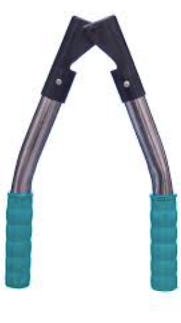
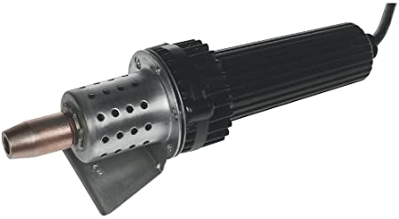

- RESTRAINT AND SAFTEY
  - Use of standing chute restraint along with a halter to secure the head snugly against the side of the restraint with room to do so in either direction should be available.

- 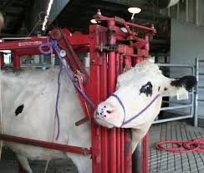

- CALCULATIONS OF DRUGS USED (COMBINATION THERAPY)

- Long acting antibiotics: Penicillin- streptomycin (Penstrep-400)

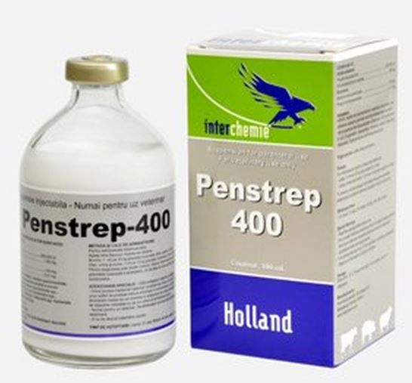

Dose Calculation of PenStrep -
(Body Weight x dose rate) divided by concentration of drug
(180.076 kg x 20,000IU/kg) divided by 200,000 IU/ml
=18.0076 ml

Widthdrawal period-
Meat- 10 days
Milk- 3 days

- SEDATIVE: An alpha 2-agonist Xylazine:

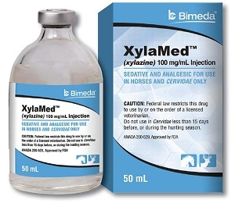

Dose Calculation of Xylazine-
(Body Weight x dose rate) divided by concentration of drug
  - kg x 0.1 mg/kg ) ÷ 100mg/ml =0.18 ml so approximately 0.2ml

- NON- STEROIDAL ANTI- INFLAMMATORY DRUG: Meloxicam is to be given 12 to 24 hours during and after the procedure to help control pain.

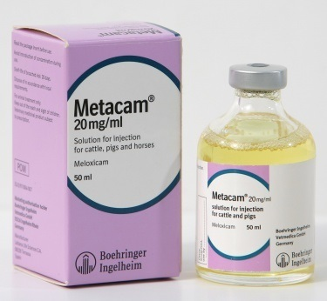

Dose Calculation of Meloxicam-
(Body Weight x dose rate) divided by concentration of drug
(180.76 kg x 0.5 mg/kg) divided by 20mg/ml
= 4.5 ml

- LOCAL ANAESTHETIC: Administration of local anesthesia prior to dehorning eliminates acute pain for a few hours after combined with sedatives and analgesic will provide the best pain relief. A cornual nerve block is done with short acting 2% (20mg/ml) lidocaine with an18- gauge needle with 1.5-inch needle. The cornual nerve, a branch of the zygomaticotemporal nerve, innervates the horn area. The nerve runs with the cornual artery and vein below the temporal bone. The effect of this local anesthetic is about 60-160 minutes.

Dose Calculation-
(Body Weight x dose rate) divided by concentration of drug
(180.076 kg x 2 mg/kg ) divided by 20mg/ml = 18m

TECHNIQUE:
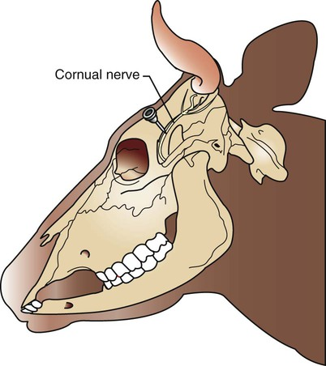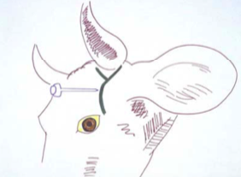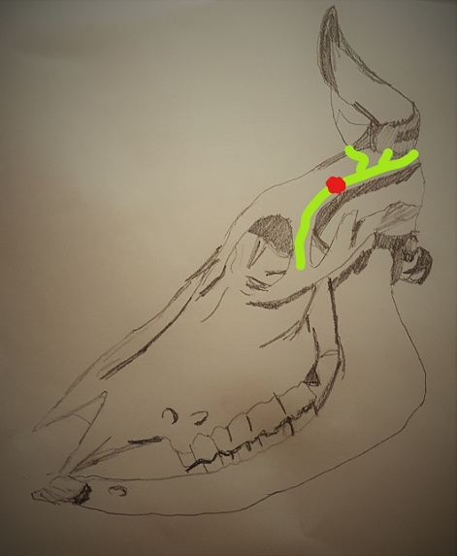

- Locate the injection site by putting thumb finger on the skin just beside the outside corner of the eye. A soft depression will be felt. Move thumb backwards toward the horn and a small groove that runs in the bone of the skull is felt. The nerve runs along and under this groove. The injection site is in the upper third (closer to horn bud) between the corner of the eye and the base of the horn.
- Disinfect site with an alcohol swab
- An 18-gauge needle with 1.5-inch needle is used together with a 6 cc syringe.
- Use 3-10 cc (in calculation)
- While holding the head steady and with the needle on the syringe, push the needle through the skin at the injection site. The needle should penetrate perpendicular to the skull at the site. Once you are through the skin, pull back on the plunger to be sure the needle is not in a blood vessel; then inject about 1.5 cc of lidocaine. Push the needle in about 0.25 inches and inject another 1.5 cc. Push it in about another 0.25 inches and inject the remaining lidocaine. Then withdraw the needle. If you hit the bone with the tip of the needle, withdraw it slightly and give the last of the lidocaine.
- Repeat on the other side of the head.
- Wait 15 minutes for it to take effect. The upper eyelid usually droops with correct injection techniques.

- TOXIC DOSE CALCULATIONS
- Keep total dose of lidocaine below 10mg/kg

