POST OP
Wound management
- Clean the area with an antiseptic.
- Apply topically: Tetravet (Oxytetracycline Hydrochloride) to prevent bacterial infections and Bactrovet to prevent myiasis.
- Dress the wound using a bandage or dehorning pads.
- If the wound extends into the frontal sinus- soak gauze in iodine and plug the hole.
- Keep the calf in a clean, confined area to ensure the wound heals well.

Drugs
Pen-strep 400 (Penicillin/Streptomycin 200,000U/mL)- A broad spectrum antibiotic given intramuscularly.
Dose = 1ml per 10kg body weight
= 140kg/ 10kg
= 14ml
Withdrawal time:
- Meat- 21 days
- Milk- 3 days
This is not applicable as the calf is too young.

Banamine (Flunixin meglumine)- A non-steroidal anti-inflammatory drug (NSAID) which is given intramuscularly as an analgesic.
Volume = dose × weight / concentration
= 2.2mg/kg × 140kg / 50mg/ml
= 6.2ml
Withdrawal time:
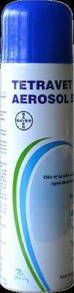
- Meat- 4 days
- Milk- 36 hours
This is not applicable as the calf is too young.

Tetravet (Oxytetracycline hydrochloride)- A broad spectrum antibiotic aerosol.
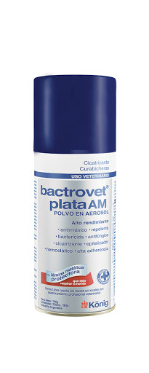
Bactrovet- An aerosol that prevents myiasis.

Ivermectin- Given subcutaneously to prevent myiasis.
Volume = dose × weight / concentration
= 0.2mg/kg × 140kg / 10mg/kg
= 2.8ml
Withdrawal time:
- Meat- 28-58 days
- Milk- should not be given in animal intended for milk production.
This is not applicable as the calf is too young.

Observation
The calf should be observed for any behavior that may indicate pain or infection. Head shaking, ear flicking, head rubbing, or vocalization indicate pain. If the calf is dull and depressed, this may indicate an infection. The hydration status and appetite of the calf should also be observed.

The wound should be monitored for any extensive bleeding as well as any signs of complications.

The vital signs of the calf should be monitored; temperature, pulse rate, respiratory rate.

Complications
Hemorrhage- There can be excessive bleeding if the area is not cauterized properly. This is controlled with cautery.

Sinusitis- As the calf grows, the horn fuses with the bone covering the frontal sinus. When the calf is dehorned, this can open the sinus, allowing for infection. Signs of sinusitis include redness and swelling at the site of infection, vocalization indicating pain and nasal discharge. Treatment include draining the sinus, flushing with peroxide and applying mastitis treatment ointment.

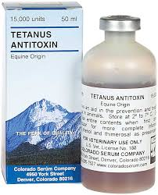
Myiasis- This is as a result of poor wound management, allowing flies to lay eggs in the wound. This is prevented by the use of an oxytetracycline hydrochloride spray (Tetravet) on the area or injectable ivermectin.

Tetanus- Tetanus antitoxin should be given after dehorning as the risk of tetanus infection increases with the new open wound.

