JOINT BLOCKS IN THE FORELIMB
Some of the common joints blocked in a horse is the distal interphalangeal (coffin), proximal interphalangeal (pastern) and the metacarpophalangeal/metatarsophalangeal (fetlock) joints.
The coffin block is broken up into 3 locations as follows:
- Dorsal pouch: 1cm dorsal to coronary band, abaxial to extensor tendon, 45-degree angle.
- Dorsal pouch: above coronary band, midline, the needle is directed horizontally.
- Palmar pouch: abaxial, above the collateral cartilage, the needle is directed in a 45-degree angle dorsally.
The needle size required is 18-20 gauge, 1.5 inches with about 5-10ml of anaesthetic. The time taken about 5 mins. The time taken is about 10 minutes. This blocks the coffin joint, navicular bursa.
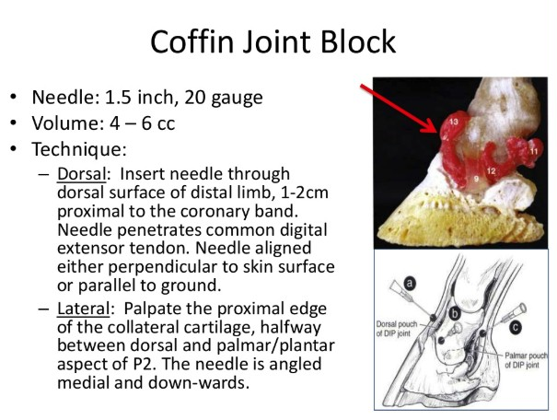

The fetlock joint is also done with the animal standing. The needles used are 18-20 gauge, 10ml administered. It is broken up into 4 locations as follows:
- Proximopalmar- distal to the splint button, proximal to sesamoid and dorsal to suspensory ligament.
- Dorsal- abaxial to CDE tendon
- Distopalmar- depression proximal to palmar process (p1)
- Palmar- Between the dorsal sesamoid and palmar distal MC3
Structures blocked are the fetlock joint and may also block the suspensory branches, digital flexor tendon sheath and proximal sesamoid bones.
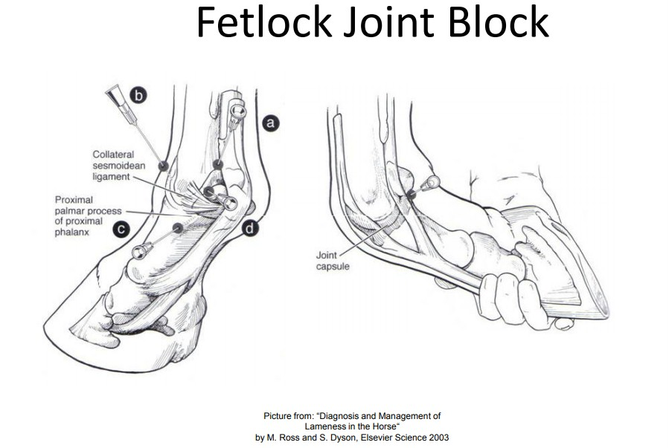

Tarsometatarsal Joint block:
Done in a standing position, just proximal to the lateral splint bone at the level of palpable depression between the head of the splint and 4th tarsal bone. It is done at a 45-degree angle craniomedial and distally. The needle used is a 20-22gauge with 5-10ml. Structures blocked are the TMT joint as well as distal intertarsal joint.
