Basic knowledge
Needles
Horses that are anesthetized below the carpus or hock are done using a 25-gauge, 5/8-inch needle whereas a larger gauge 22-20, 1 ½ inch needle is used to anesthetize nerves more proximal on the limb. If a larger needle is to be used, a small amount of anaesthetic solution is done using a 25-gauge SC to prevent resentment by the horse when the larger one is inserted.
It should be noted to prevent needles from breaking and bending during perineural administration of local anaesthetic, the needle should be inserted detached from the syringe. Spinal needles should be used as they are more flexible and less likely to break. The needle is inserted distally when anesthetizing nerves in the distal portion of the limb. Proximal insertion would result in the unintended anaesthesia of proximal branches of the nerve.
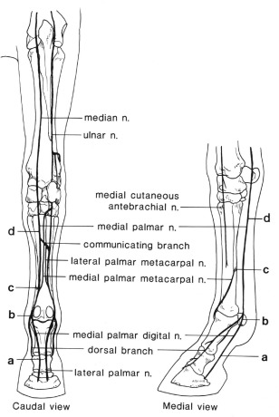

Preparation of the injection site:
The site of injection should be wiped with cotton or gauze sponges soaked in 70% isopropyl alcohol. However, if the site is excessively dirty it can be scrubbed with antiseptic soap. It is important to have a clean injection site to prevent septic synovitis.

Assessment of anaesthetized limb:
Assessment of the distal portion of the limb is important as anaesthetic may migrate up the nerve to more proximal structures. This is avoided but evaluation of the gait every 10-15 minutes after administration. When there is administration of anaesthetic on the proximal portion, horses may develop abnormalities with gait or even stumble because of altered proprioception. The effectiveness of the nerve block is determined by checking skin sensation within the dermatome. It is assessed by pressing an object over the skin of the intended area. Before injections needles should be aspirated to prevent entry of the anaesthetic into the blood stream.

Control of the forelimb:
The limb is held either facing the opposite direction as the horse or facing the same direction. When it is held facing the same direction it is held between the knees of the clinician’s knees and both hands are free for the procedure. This however increases the risk of injury if the horse swings caudally. If the limb is held opposite direction of the horse, one hand holds the limb and the other performs the procedure.

Nerve blocking of the forelimb
Perineural analgesia starts distally and progressively moves proximal therefore the palmar digital nerve block is commonly performed regional nerve block of the forelimb. The needle (25 gauge, 5/8inch) is distally inserted over the palpable neurovascular bundle proximal to the cartilage of the foot where 1-3ml of local anaesthetic solution (mepivacaine) is deposited. This block anaesthetizes the entire foot as well as the distal interphalangeal joint (coffin). The skin is then pinched 5-10 minutes after with a haemostat to check for blockage. This blockage may also cause partial anaesthesia of the proximal interphalangeal joint (pastern) if a large amount of anaesthesia was used. However, if there is no improvement of the gait another nerve block is done, a semi ring block at the pastern to anaesthetize the dorsal branches of the digital nerve.
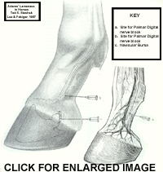
If the palmar digital nerve block is unsuccessful the basisesamoid/abaxial nerve block is done. This results in blockage of the palmar nerves at the base of the proximal sesamoid bones. When performing this blockage, the foot is elevated, and the neurovascular bundle is palpated as the injection site is located at the best of the proximal sesamoid bones. The needle (25g, 5/8 inch) is inserted at basisesamoid level on the axial side of the neurovascular bundle. The syringe is then attached and 2-3 ml of mepivicaine, reassess for lameness 5-10 minutes later. There may be an analgesic effect on the fetlock joint if the anaesthetic was deposited more proximally.

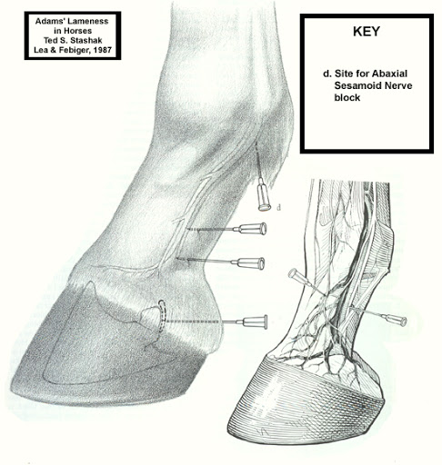

When there is a negative response to the abaxial sesamoid nerve block the low palmar nerve block/ low 4-point block is done. This nerve block is usually done with the horse bearing weight onto the limb. The digital sheath is avoided by measuring a hand’s breadth above the fetlock joint. The medial and lateral palmar nerves are anaesthetized using a 22gauge, one-inch needle with 2-3ml of mepivicaine. This would anaesthetize the medial branch; the lateral side is anaesthetized by withdrawing the needle until the subcutaneous and deposition of the 2-3ml of anaesthetic. The palmar nerves are blocked at the level of the metacarpus to avoid misdirection of the needle into the digital flexor sheath. The needle (25g, 5/8 inch) is then inserted distal to the bell of the splint bone, slightly upwards. 2-3 ml of mepivicaine is injected with the hub of the needle supported with one hand and inject with the other. It is repeated on the medial aspect of the limb.

A positive response to a low 4-point block, performed after a negative response to an abaxial sesamoid nerve block, localizes the site of pain causing lameness to the fetlock.
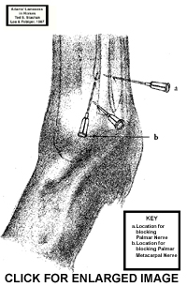

When the low 4-point block fails, the high 4-point nerve block is done. This is done with the limb bearing weight. The medial and lateral palmar nerves as well as the palmar metacarpal nerves are anaesthetized slightly distal to the carpometacarpal joint. A 25-gauge, 5/8 inch needle is inserted through the fascia where the nerves lies near the dorsal border of the deep digital flexor tendon, 3-5 ml of anaesthetic is deposited close to the palmar nerve. The palmar metacarpal nerves are anesthetized distal to the level of the carpometacarpal joint, using a 20-22-gauge, 3/2 inch needle into the junction of the 3rd metacarpal done and the 2nd or 4th metacarpal bone.
Anesthetizing the medial and lateral palmar metacarpal nerves alone desensitizes the splint bones and their interosseous ligaments and the proximal aspect of the suspensory ligament.
There is an alternative to the high palmar nerve block/ high 4-point nerve block which is the lateral palmar nerve block. This is done when the site of pain causing lameness is suspected to be in the proximal portion of the suspensory ligament. It is also performed when the limb weight bearing, by inserting 2ml of anaesthetic with a 25 gauge, 5/8inch needle over the lateral palmar nerve where it courses over the medial aspect of the accessory carpal bone. This is done in a medial to lateral direction at the distal third of the palpable groove. These nerves arise from a branch of the lateral palmar nerve which in turn desensitized the proximal aspect of the suspensory ligament.

Median and ulnar nerve block
The median nerve is blocked by injecting 5cm distal to the elbow joint, on the medial aspect of the limb. The needle is walked off the caudal aspect of the radius. The ulnar nerve is injected 10cm proximal to the accessory carpal bone, between the flexor carpi ulnaris muscle and ulnaris lateralis muscle. The needle used to a 1.5-inch, 22 gauge with 10 ml of anaesthetic. This blocks the entire limb from the distal radius down, including the carpus.

