Restraint for Castrating Goat
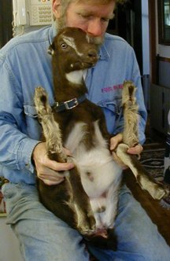

https://www.youtube.com/watch?v=CWcrFwnTp7U
This video demonstrates banding castration of goat and describes the elastrator instrument that is used.



Chemically restrained goat in lateral recumbence for surgical castration

