Restraint for Castrating Piglets
https://www.youtube.com/watch?v=8YSdxi0UVO0
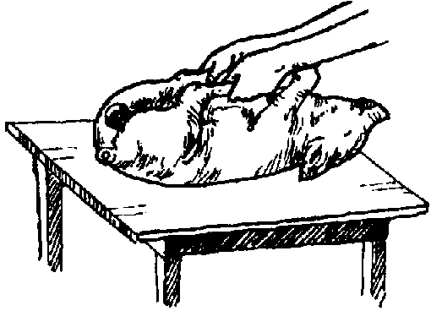

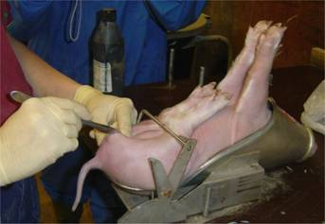

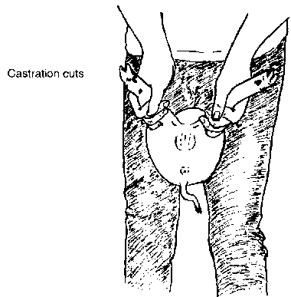

Restraint for Castrating Boar
https://www.youtube.com/watch?v=nFD_hS_B-W4
This video demonstrates both physical and chemical restraint of a boar for the purpose of castration.

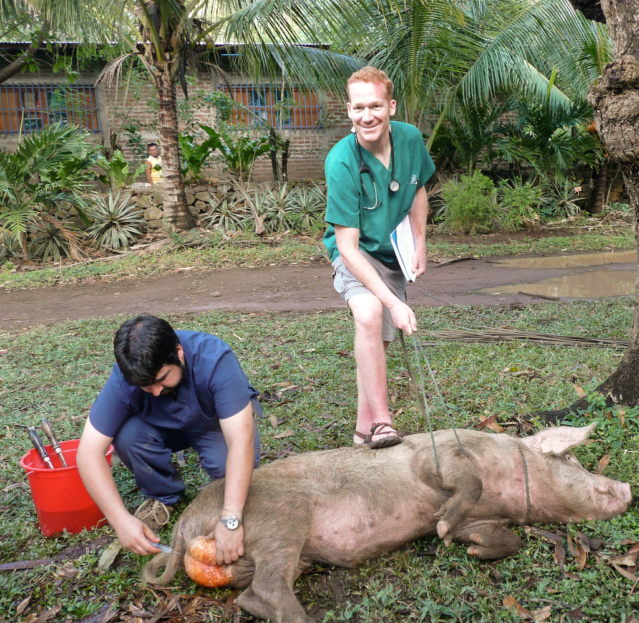

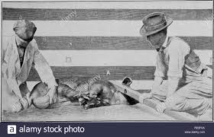

Physical restraint of a boar during castration

