Restraint of Water Buffalo for Castration
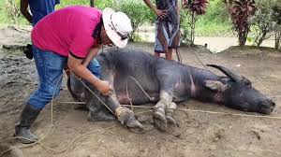
Water Buffalo cast into lateral recumbence to perform castration using burdizzo

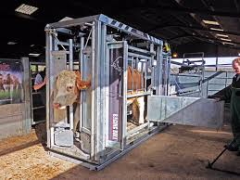
A crush cage as seen above used for restraining a bull can also be used for restraining a water buffalo.

