Restraint For Castrating Bull
https://www.youtube.com/watch?v=bVADZeNh65w
This video demonstrates the casting of bull, restraint in lateral recumbence and description of burdizzo tool used for castration

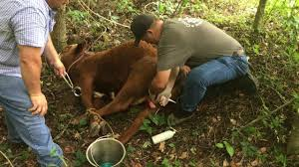
Restraint of bull in lateral recumbence for surgical castration (open castration)

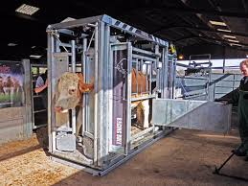

Restraint of Bull in crush cage for castration with Burdizzo

