Reproductive Anatomy Of Goat
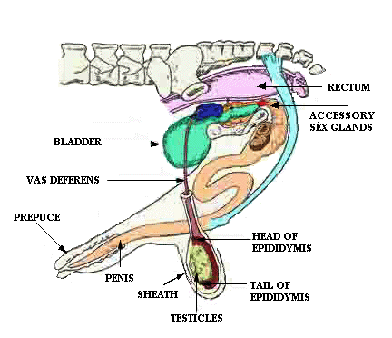

The Scrotum
Two-lobed sac that encloses the testes.
Its main function is in temperature regulation.
Cremaster muscle raises and lowers testes
Improper scrotal function and poor testicular distention during hot weather may lead to temporary infertility in bucks

Testicles
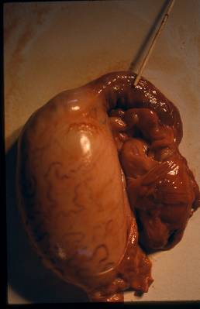
The primary sex organ of a buck
Suspended in the scrotum outside the body
The testicles produce sperm and testosterone

The Epididymis
Functions of the Epididymis:
Develops sperm and stores it
Carries the sperm from the testicle to the vas deferens then to the penis.

Vas Deferens
It is a slender, muscular tube that runs from the tail of the epididymis to the neck of the bladder, where it joins the ampulla and accessory sex glands.
Primary function is to move sperm into the urethra at the time of ejaculation.

Penis
Main function is to deposit semen in the female reproductive tract.
It also serves as the passage for urine to the exterior.
Sigmoid flexure (S-shaped portion) straightens upon erection; allows for extension

Accessory Sex Glands
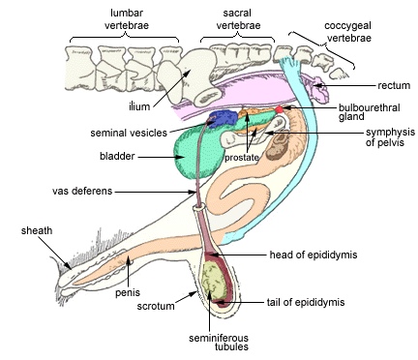
Includes the ampulla, seminal vesicles, prostate gland and the bulbo-urethral gland
Function together to secrete fluids that make up seminal fluid.
Sperm cells are suspended and transported within this seminal fluid

