Reproductive Anatomy Of Pig
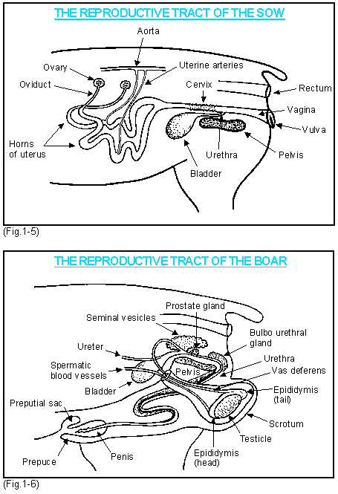
https://www.youtube.com/watch?v=a2HzFr-uCso

Prepucial sac - This is a sac inside the prepuce, the size of a golf ball, that contains a foul smelling fluid with a high bacterial content. Do not squeeze its contents into the vagina at service or you may precipitate an endometritis or cystitis and nephritis. Similarly if you are collecting semen by gloved hand for on-farm artificial insemination you must not contaminate it with prepucial sac contents.
Scrotum - This is a sack made of relatively thin pliable skin which has a muscular inner fibro-elastic layer which contracts in a cold environment and relaxes in a hot environment.
Epididymis - A coiled tube attached to the upper surface of the testicle where the sperm is stored. The sperm leaving it enters the vas deferens. It has a head and a tail. The tail can be cut off (epidectomy) to sterilise the boar.
Vas deferens - The muscular tube that at ejaculation propels the sperm from the tail of the epididymis on the testes up through the inguinal canal and into the urethra where it joins just below the neck of the bladder .
Seminal vesicles - These are glands which together with the prostate and bulbo-urethral glands provide fluid and nourishment for the sperm, the fluids being passed out during ejaculation.
Spermatic cord - Fibrous cord, containing the vas deferens and blood vessels, by which the testicles are suspended.
Testicle - The gland in which the sperm is produced.

