Reproductive Anatomy of Water Buffalo
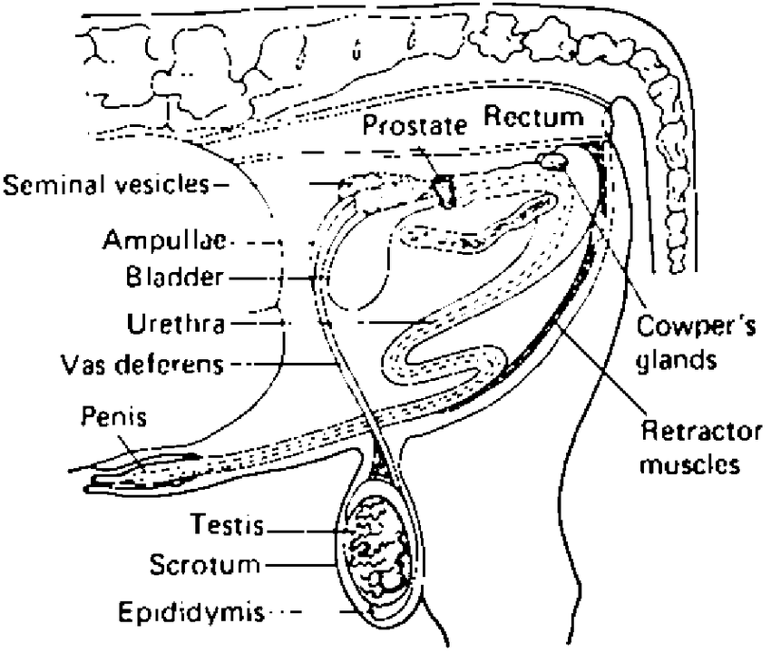
The male reproductive system is comprised of:
Epididymis
Vesicular glands
Bulbourethral gland
Prostate
External genitalia or copulatory organ i.e. the penis

The reproductive organs of the water buffalo bull are similar to those of the bull of domestic cattle (B. indicus), but the testes and scrotum are smaller and the penile sheath is less pendulous. The sheath of the penis adheres close to the body in the swamp type of buffalo. but is more pendulous in the river type. The scrotum of the river buffalo is 20–25 cm in length, has a distinct neck and is pendulous. The normal testes of buffalo are ovoid in shape and turgid on palpation, with a marked resonance. The testes are of unequal size, with the left usually bigger.

During calfhood, the penis is firmly adhered within the sheath and cannot be extended. However, at about 2 to 4 months before puberty, partial protrusion occurs during mounting, followed by separation of penis from the sheath, complete erection and eventually mating and ejaculation. The prepuce of water buffalo is long and narrow, and is devoid of hairs.

