ADVANTAGES AND DISADVANTAGE OF DIFFERENT METHODS OF EQUINE CASTRATION
METHOD | ADVANTAGES | DISADVANTAGES
OPEN CASTRATION  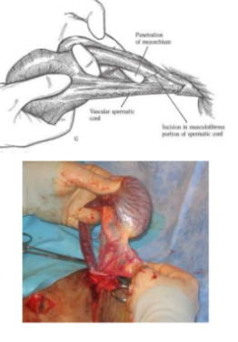 | - Quick  - All tissues in contact with surgeon is removed  - No foreign materials are left behind | - More likely to suffer complications  - Risk of herniation  - Infections can spread to the abdominal cavity  - Not very good asepsis  - Only small portion of vaginal tunic is removed
CLOSED CASTRATION  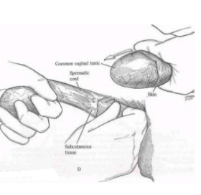 | - If used, ligature prevents herniation  - Peritoneal cavity sealed against infection  - Can close scrotal skin  - Rapid healing | - More surgical and anaesthesia time  - Handle tissues and ligature left behind
SEMI-CLOSED CASTRATION  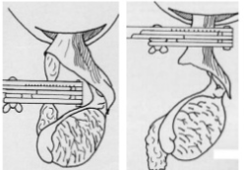 | - Opening of the parietal tunic during a semi-closed castration allowing direct visualisation of the testis, epididymis, the spermatic vasculature and the ductus deferens  - This technique also allows the surgeon to check for the absence of herniated intestine. | - It requires significant manipulation of the structures involved and in case of  inguino-scrotal hernia, accidental puncture of the herniated bowel may occur

