The Surgical Approach to an Abdominal Cryptorchid Testis
(https://www.r-vets.org/The-Cryptorchid.html)

There area a variety of techniques to finding and removing an abdominal testis in the horse. The following approach has proven effective and safe for field cryptorchid castrations and will be discussed in a series of sequential steps. To be successful, a grasp of the anatomical and developmental aspects of the testis and surrounding structures is essential. Once it has been established that the testis is not in the scrotum, the inguinal canal, or under the skin between these two structures, proceed as follows:
1.Establish that the horse is at an adequate plain of anesthesia to allow it to be placed in dorsal recumbency and that it is adequately relaxed. This may require additional xylazine, ketamine, and valium. Glycerol Guaicolate or “Triple Drip” may also be used if a catheter is in place. A good experienced field anesthetist should be in charge of anesthesia.

2.Roll the horse into dorsal recumbency and untie the hind legs. If the rear legs are flexed with a rope it will be much more difficult to visualize the external inguinal ring. The horse can be stabilized by a handler supporting each forelimb at the shoulder. A large pad for the horse’s head and some attention to the rockiness of the ground will prevent pressure injuries to the patient.

3.Place bags, towels, or aluminum foil over the horse’s hind feet to prevent dirt from dropping into the surgical field.

4.Do a good surgical prep over the entire inguinal area, including the medial sides of the thighs and from the pubis to the end of the sheath. Place a dry towel or cotton in the sheath to keep the penis out of the way and absorb leaked urine.

5.Draping in the triangular pattern shown is highly desirable, as there will be instances when it may be necessary to enter the abdominal cavity.

6.Surgeon and assistant must scrub their hands and wear gloves. Sterile sleeves for the surgeon will also allow entry into the abdomen in the rare instances where that is necessary.

7.The surgeon kneels directly behind the patient with the assistant in front of the leg on the side to be explored.

8.Palpate the external inguinal ring as above, just to be sure that the testis is not inguinal and to identify the incision site.

9.Make an incision directly over the external inguinal ring and parallel to it. The incision should be about 1½ times the length of the palpable slit that is the external ring and should be extended no deeper than the dermis. The remaining dissection to find the external inguinal ring is done bluntly with the fingers. Injury to large vessels in this region will make visualization very difficult. As the external inguinal ring is dissected out, the assistant uses fingers or retractors to open the incision and allow visualization. A large self-retaining retractor can be used, but is less adaptable than an assistant.

10.The loose areolar connective tissue is bluntly dissected until the white, fibrous external inguinal ring is exposed. A white finger-like projection coming up from the interior of the ring indicates an incomplete cryptorchid covered by the vaginal process. If this is the case, the white membrane (vaginal process) is opened with scissors and the epididymis is pulled into the incision and used as a handle to deliver the testis from the abdomen, as described below.
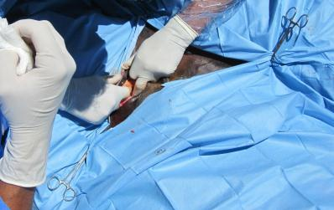
Prior to birth, the testes begin to shrink. As they shrink, they pull away from the kidney, while they remain very close to the inguinal canal. Just as they added cells to grow in size, they lose cells to shrink. This process leaves each testis somewhat soft and pliable, which allows it to slip through the internal inguinal ring (vaginal ring) and into the inguinal canal.
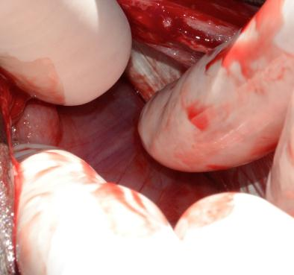
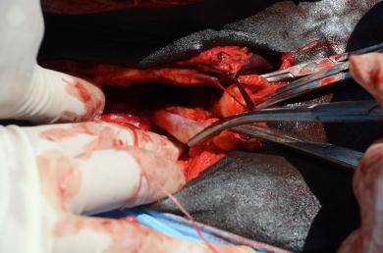
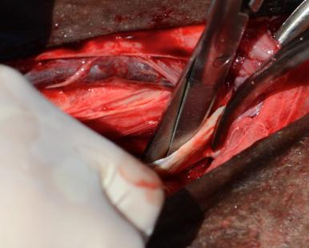
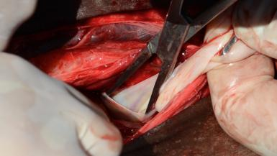
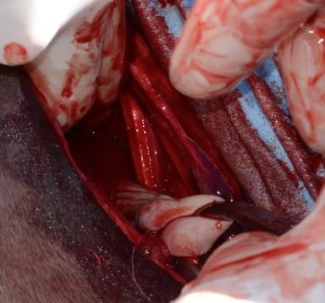
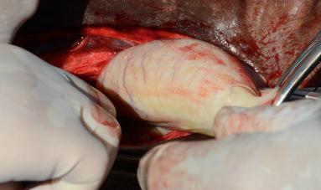
11.More commonly, a group of very thin vessels will be seen going from the surrounding fascia, over the edge of the external inguinal ring and down into the inguinal canal. These vessels may fan out along the entire length of the canal or be in a more discrete bundle. They indicate the tissue that would become the scrotal ligament in a normally descended testis. They should be grasped together, making a bundle.

12.Carefully place traction on the bundled vessels (scrotal ligament) to evert the vaginal process through the internal inguinal ring (vaginal ring) and into the inguinal canal. The vaginal process is conical and the tip can be visualized as a small white structure as it passes out of the external inguinal ring. Palpation with an index finger during traction, will establish that the base of the cone is deep inside the inguinal canal. This structure will be more or less easy to mobilize in different horses.

13.Once the vaginal process is identified, it is opened with scissors or the point of a scalpel. Immediately inside the tip of the vaginal process is the ligament of the tail of the epididymis (remnant of the embryonic gubernaculum). This structure is grasped and used to deliver the epididymis through the inguinal canal and into the incision. Firm pressure is required to do this, but it is important not to break and lose the ligament or the epididymis.

14.Using the epididymal structures as a guide and handle traction in placed on the abdominal testis. The object is to deliver the testis through the smallest hole in the vaginal process and without disrupting the internal inguinal ring. A combination of traction, massage with an index finger, and occasionally stretching the vaginal process will deliver nearly every testis, with some patience.

15.Once the testis appears through the external inguinal ring, its vessels are ligated as one unit with 2 or 3 Vicryl and cut, along with the vas deferens. The cryptorchid testis and the epididymis are removed and the contralateral testis is castrated.

16.If only minor stretching of the vaginal process is required to remove the cryptorchid testis and the internal inguinal ring was not invaded, the incision is left open to heal by second intention and no further suturing is required. If the testis was larger and more difficult to deliver the inguinal canal can be closed with 2 or 3 Vicryl, by placing one or a few cruciate or simple interrupted stitches across the inguinal canal.

17.Because the inguinal canal in the horse is long and runs up the body wall, the internal inguinal ring cannot be readily identified for suturing. So it is difficult to do a firm closure of the canal if the internal ring has been opened significantly. Further, any suturing in this area should be done with care, due to the large vessels that lay in the fascia around the inguinal canal. If there is concern about the integrity of the closure and possible evisceration, the incision should be tightly packed with a sterile towel and the skin closed in a simple continuous pattern, over the towel. Then in 48-72 hours the sutures and towel are removed. At this time swelling caused by the towel will have closed the canal and granulation has started. This generally requires a second, though brief, anesthesia.

18.IF the vessels indicating the scrotal ligament cannot be identified; IF the landmarks are broken while attempting to exert traction; or IF the testis is too large to be delivered through the internal inguinal ring: a parainguinal incision can be made, allowing the surgeon to enter the abdomen through a very small incision just next to the inguinal canal.

19.To utilize the parainguinal incision the assistant retracts the existing skin incision cranially and medially. In this region the internal abdominal oblique muscle is thin, but strong and fibrous. The surgeon selects a site a few inches medial and parallel to the external inguinal ring. A small stab incision is made just though the external muscle sheath. This is extended into the abdomen by using a blunt instrument, such as a the tip of Mayo scissors. The instrument is opened, stretching the incision so that the surgeon can stick two or three fingers into the abdomen.
20.Since the majority of abdominal testes are just next to the internal inguinal ring, the surgeon sweeps laterally and deep to the body wall incision, to palpate and grasp the testis, epididymis, or vas deferens and deliver the testis from the abdomen. The vessels are ligated and cut as above. Closure of the parainguinal incision with sutures in the internal abdominal oblique is a simple matter and very strong. No towel packing or removal is necessary. The skin incision is left open to heal by second intention.

21.In the rare instances in which the abdominal testis cannot be found via the small parainguinal incision described above, the surgeon simply extends the incision made bluntly in the abdominal wall, and, with a sterile sleeve, can explore the entire abdomen, following the decent of the testis from the dorsal body wall. Again, the incision, just large enough to permit the surgeon’s arm is easy to close, once the testis is found and removed.

Things Not to Do

- Start surgery before all anesthetic drugs and surgical supplies are immediately ready
- Start surgery before the horse is adequately anesthetized
- Sharply incise structures deep to the skin in the inguinal region. Injury to the large external pudental veins in this region and their branches will result in extreme difficulty in visualizing structures.
- Attempt to find the landmarks around the inguinal canal without good light. Especially avoid having the sun shining in the surgeon’s eyes when working outdoors. A good bright headlamp is a big help.
- Inadequately dissect the fascia from the external inguinal ring. Visualization of the edges of the ring is essential for success. Make sure you can clearly see the ring and if that requires a longer skin incision, make a longer incision.
- Break the remnant of the scrotal ligament: it is the major landmark to the vaginal process. Using large curved Carmault forceps seems to be less traumatic than Ochsners or Kellys. Some surgeons use sponge forces.
- Disrupt the internal inguinal ring. This necessitates suturing the inguinal canal and packing the area with a sterile towel, which must be later removed in a second anesthesia.

A Few Last Points:

- IF the patient’s castration history is unclear and there is scar on the scrotum it may better to postpone the surgery until a serum testosterone or estrone sulfate (depending on the age of the horse) can determine if testicular tissue is present. If this is not possible or if the horse is known to be a hemicastrate, exploration of the inguinal canal as described above will either lead to the cryptorchid testis or it will yield the white fibrous stump of the chord from a removed testis, coming from the external ring into the subcutaneous tissues. Since in Quarter Horse and Paint families an abdominal cryptorchid testis is more likely to be on the left side, it is sensible to approach the left inguinal region first. However, if a chord stump is found on the left side then the right inguinal canal is explored to find the testis.
- Always make sure that you can identify the testis, the head of the epididymis, and the tail of the epididymis before completing a castration. The most common cause of hemicastration (leaving an abdominal testis in the abdomen) is mistaking the tail of the epididymis for a small testis. If you can identify all three structures, you know that you have a complete castration.
- While with adequate sterile technique primary closure of inguinal incisions is possible, the issues of positioning, anesthesia, follow-up, and unrecognized breaks in asepsis make healing an open incision a good alternative in the field. These incisions, even with blunt dissection, seem to heal as rapidly as standard scrotal castrations.
- Remember: have a clear plan and everything AT YOUR FINGERTIPS before you consider starting surgery. This is no time to go looking for equipment and always plan for the procedure being difficult! If you find that you are not ready, allow the horse to recover and plan the procedure for another day.
- Be realistic and prepared to stop the procedure and allow the horse to recover IF:
Selected Bibliography:

1.Schumacher J: in Auer, JA, Equine Surgery, 1st ed, W. B. Saunders Co, Philadelphia, 1992, pg. 674-703.
2.Smith JA. The Development and Descent of the Testis in the Horse. Veterinary Annual, 15 th ed., Grunnell CSG and Hill FWG eds. John Wright and Sons Ltd., Bristol, 1975, pgs. 156-161.
3.Bergin WC, Gier HT, et al, A Developmental Concept of Equine Cryptorchidism. Biology of Reproduction, 3, , 1970, 82-90.
4.Dyce KM, Sack WO, and Wensing CJG. In Textbook of Veterinary Anatomy (Second ed.), WB Saunders Company, Philadelphia, 1996.
5.Wilson DG and Reinertson EL. A Modified Parainguinal Approach for Cryptorchidectomy in Horses An Evaluation in 107 Horses. Veterinary Surgery, 16:1,1987, 1-4.

