Drugs used in Equine Reproductive Surgery
Providing general anaesthetic would allow the clinicians to perform their task more effectively as well as provide asepsis, perform closed castrations, and repair umbilical hernias.

For pre-operative care of horses for a castration the animals should have proper tetanus prophylaxis. If the horse has not been vaccinated in 6 months prior to the procedure, a tetanus toxoid booster should be administered. However, if the vaccination status is unknown, the animal should be given the tetanus antitoxin as well as tetanus toxoid.
Before surgery clinicians usually administer one dose of procaine penicillin (22,000u/kg), intramuscular and gentamicin which is given intravenously. This is done as a preventive method for post-operative infections.
Dosage of gentamicin in horses:
Species | Usage | Dose
Horses | For susceptible infections in adult horses | 6.6mg/kg IV q24h (extra-label use)
 | For susceptible infections in foals <2wks | 12mg/kg IV q36h (extra-label use)
 | For susceptible infections in foals >2wks | 6.6mg/kg IV q24h (extra-label use)
 | For susceptible uterine infections | 2.0-2.5g diluted in 200-500mL sterile 0.9% NaCl, infused into the uterus q24h for 3-5d during estrus
 | For regional limb perfusion | 1g or 1/3 the systemic dose diluted to 30-60 ml with sterile 0.9% saline

They are also use of non-steroidal anti-inflammatory drugs such as phenylbutazone 2.2-4.4mg/kg and flunixin meglumine 1.1mg/kg.
Administration of anaesthesia- for castration purposes, an intravenous catheter is placed via aseptic technique before the surgery. Horses are first given butorphanol (0.01mg/kg I.V) and 0.5mg/kg of xylazine for catheter placement and palpation of the testicles.

The site of the surgery should be cleaned with dilute povidone-iodine or chlorhexidine. Local anaesthetic is them administered intratesticular with 2% lidocaine (10-20ml/testis).

When horses are being castrated under general anaesthetic, they are premedicated with an alpha 2 agonist such as xylazine (1.1 mg/kg- iv). This dose is given in addition to the sedation provided to facilitate palpation and iv catheter placement. When the animal is suspected of being adequately sedated, anaesthesia is induced with ketamine (2.2 mg/kg- iv) and diazepam (0.05mg/kg- iv). The horse is then gently placed in lateral or dorsal recumbency with the hindlimbs properly restraint. The depth of anaesthesia is monitored using heart rate, respiratory rate, movement, palpebral reflex and presence of nystagmus. Another combination of drugs that are used for GA is alpha 2 agonist and thiopentone +/- GGE.
Maintenance of the anaesthesia is done with ketamine (1.1mg/kg-iv) and combined with xylazine (0.5mg/kg-iv).

Horses castrated while standing:
Chemical restraints used are- detomidine (0.12ml/100kg)/Romifidine (0.9ml/kg) with a combination of Butorphanol (0.2ml/kg). A twitch maybe added for extra restraint. Lidocaine is also injected into the intratesticular space and on the sides of median raphe. Standing castrations are only done with the horse is known to be less aggressive and can be handled properly.

Drugs | Uses | Complications/Contraindications
Procaine penicillin  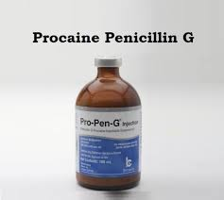 | Combination of an injectable antibiotic and local anaesthetic. treatment of all stages of syphilis, mild to moderate pneumococcal pneumonia, and as an adjunctive in the treatment of diphtheria along with intramuscular (IM) antitoxin  <2kg- 50000 units/kg IM OD  2-27kg-300000 units/kg IM OD for 10-14 days  >27kg- 600000 units-1.2 million IM OD | - diarrhoea from an infection with Clostridium difficile bacteria  - glucose-6-phosphate dehydrogenase (G6PD) deficiency  - methemoglobinemia  - a type of blood disorder  - anaemia from pyruvate kinase and G6PD deficiencies
Phenylbutazone  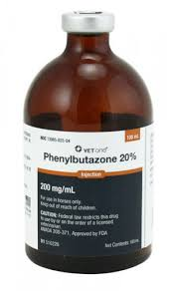 | treating fever, pain, and inflammation in the body. As a group, NSAIDs are non-narcotic relievers of mild to moderate pain of many causes, including injury, menstrual cramps, arthritis and other musculoskeletal conditions.  Dosage: 2.2-4.4mg/kg | unique risk of bone marrow suppression (causing dangerously low white blood counts), phenylbutazone is generally reserved only for short-term use in selected patients.
Flunixin Meglumine  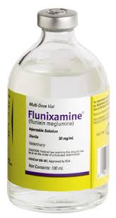 | alleviation of inflammation and pain associated with musculoskeletal disorders. It also is recommended for the alleviation of visceral pain associated with colic.  Dosage- 1.1 mg/kg | Do not give horses intended for food. NSAIDS are known to have potential effects on both parturition and oestrus cycle. Drug compatibility should be monitored closely in patients requiring adjunctive therapy.

Butorphanol  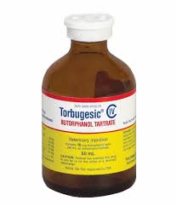 | used for pain relief, making the horse easier and safer to handle. It provides sufficient sedation and pain control for use in post-partum treatment of mares, surgery, and many other veterinary procedures. It is useful for the relief of pain associated with colic in adult horses and yearlings.  Dosage- 0.01mg/kg (IV)- 2-4 hours  0.02mg/kg (IM) | side effect was slight ataxia (loss of coordination) which lasted 3 to 10 minutes.  Transient diarrhoea may occur. Central nervous system excitation has been noted with high doses. Salivation, seizures, hyperthermia, and increased GI motility
Xylazine  Brand name (Sedazine)  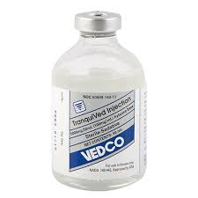 | including short-term sedation, and treatment and management of colic. In combination with butorphanol and other drugs, xylazine is used as a chemical restraint for many veterinary procedures, and as a preoperative drug  Dosage- 0.5-1.1mg/kg- IV  Sedation- 1-2 hours | initially slows the heart rate and can change the heart rhythm in some horses. Moderate loss of coordination and sweating are common, and horses may drop their heads and appear very sedated. should not be used in horses with heart disease or abnormal heart rhythms and should be used with extreme caution in horses with major health problems, including shock, liver and kidney problems, or respiratory disease.  Xylazine reduces the body's ability to regulate temperature.
2% Lidocaine  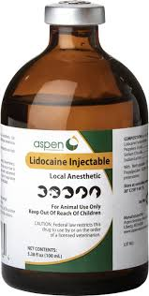 | a local and topical aesthetic, lidocaine is used to treat ventricular arrhythmias.  Toxic Dosage- 10mg/kg  10-20ml/testes could be injected for local blockage. | Caution should be used in horses with liver disease, congestive heart failure, shock, and respiratory depression.  Be sure not to use a product that contains epinephrine intravenously.
Ketamine  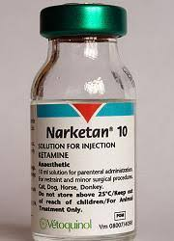 | Dosage- 2.2mg/kg IV  rapidly acting general aesthetic drug that prevents sensations such as pain. Local or regional anaesthesia prevents pain in a limited area or in a specific body region. General anaesthesia prevents pain and causes unconsciousness and generalized muscle relaxation. provides significant pain relief but does not provide relaxation of the muscles. | detoxified by the liver and excreted by the kidneys; therefore, any pre-existent hepatic or renal pathology or impairment of function can be expected to result in prolonged anaesthesia.  Respiratory depression may occur following administration of high doses of Ketamine Hydrochloride Injection
Diazepam  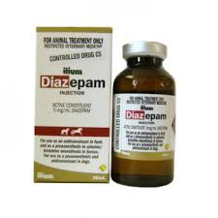 | most often used in horses as a part of a preoperative sedative combination. It is also used for treatment of acute convulsions caused by neonatal maladjustment syndrome or idiopathic epilepsy. Horses with seizures induced by toxins or adverse drug effects are often treated with diazepam. Diazepam acts as a muscle relaxant, an appetite stimulant, and is useful as a tranquilizer.  Dosage: 0.05mg/kg-iv | may cause muscle twitching and ataxia at dosages sufficient to cause sedation. Larger doses may induce recumbency and general central nervous system depressant effects.  Used with caution in horses with decreased kidney or liver function, and animals in shock, coma, or with significant respiratory depression. Diazepam may be addictive and should not be withdrawn suddenly from animals that have been on long-term treatment.
Detomidine  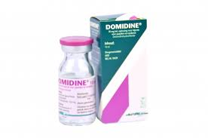 | Cheaper than xylazine  Twice as long compared to xylazine  Dosage- 0.12mg/100kg | Similar effects compared to xylazine.  Sedation may be inadequate if horse was excited before administration of detomidine.
Romifidine  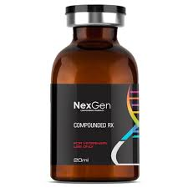 | Dosage- 0.9ml/kg  Longer sedative than detomidine | Similar to xylazine and detomidine
Glycerol guaiacolate (GGE)/ Guaifenesin  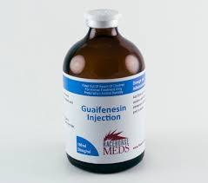 | Muscle relaxation in intravenous anaesthesia.  Expectorant for upper respiratory tract conditions.  Dosage-25-50mg/kg | Physostigmine should not be administered concurrently.  Residual muscle weakness in recovery  Tissue irritant if GG goes peri vascularly (sloughing)  Hemolysis if concentration is over 5%  Mild cardiovascular depressant at higher doses

Calculations:
V= W*D/ C
Therefore, if the weight is 150kg, Dosage of lidocaine- 5 mg/kg
Concentration is 2 %
Concentration = 2*10= 20
Volume that could be administrated is 150*5/ 20= 37.5 ml

