LOCOMOTION SCORING IN DAIRY CATTLE
SCORE | CLINICAL DESCRIPTION | DESCRIPTION
Score 1  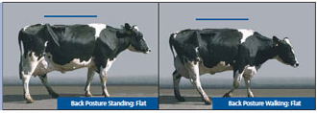 | Normal | Cow stands and walk normally with a level back and makes long confident strides
Score 2  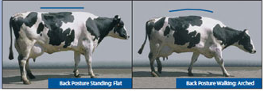 | Mildly lame | Stands with flat back but arches when walking. Gait is slightly abnormal
Score 3  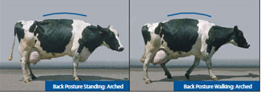 | Moderately lame | Stands and walks with an arched back with short strides with one or more legs, slight sinking of dew-claw in limbs opposite to the affected limb
Score 4  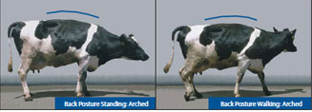 | Lame | Arched back standing and walking, favoring one of more limbs but can still bear weight on them. Sinking of dew-claw in opposing limb to the affected limb
Score 5  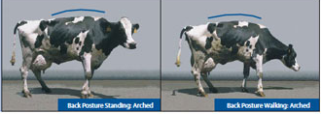 | Severely lame | Pronounced arching of the back, reluctant to move with almost complete weight transfer off the affected limb.

