Male Equine Reproductive Anatomy

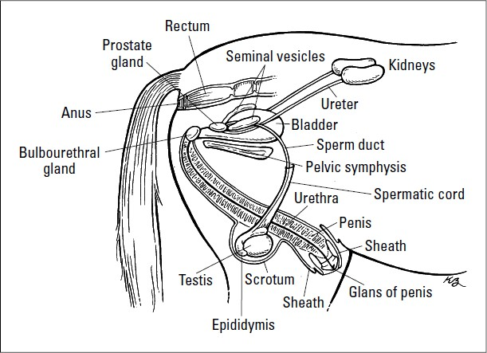

For the purposes of this lab, the focus is the anatomy of the testes and other scrotum contents.

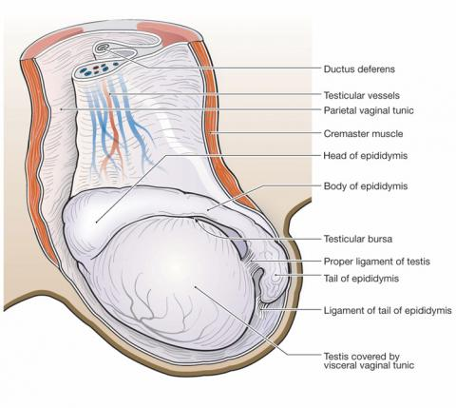

- In order to thermoregulate the testes, the scrotum is slightly pendulous
  - However, it is not enough for bloodless techniques to be available for use when castrating.
- The scrotal wall has four layers
  - The skin, which is external.
  - The tunica dartos, which is muscular and fibroelastic tissue.
  - The scrotal fascia, which is loose and allows movement of the testes independant of the scrotum.
  - The parietal vaginal tunic, which is separated from the visceral vaginal tunic by vaginal cavity.
- The cremaster muscle may cause the testicles to retract into the abdomen if the horse is frightened, making this surgery more difficult.

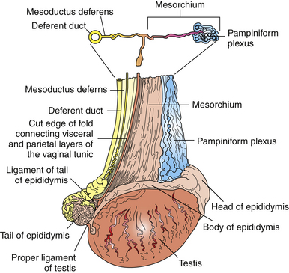

- When the scrotum is open and the vaginal tunic is opened, this is what is visible.
- The pampiniform plexus, also called the spermatic vessels, has a series of veins coiled around an artery.
  - The veins drain the testes while the artery supplies them.
  - The veins coiling around the artery aids thermoregulation, cooling the warm blood entering the heat sensitive organ.
  - The testicular nerves are also present here, and originates in the caudal mesenteric plexus from the splanchnic lumbar nerve.
- The vas deferens is cmedial to the mesorchium, and it originates from the tail of the epididymus.
- The cremaster muscle is absent in the diagram, but is still a part of the spermatic cord.
- The mesorchium is a fibrous sheath that attaches the structures of the spermatic cord together.

