Equipment

Restraint:
- Rope Halters

- Rope

Case 1:
- Hoof nippers
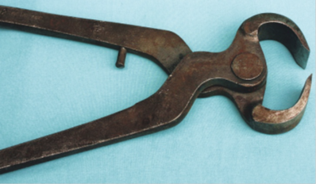

- Hoof knife
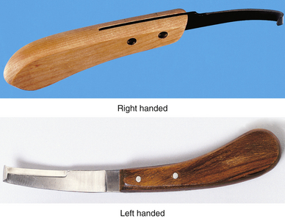

- Hoof rasp
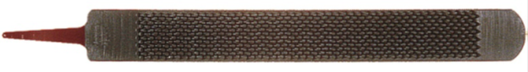

- Hoof shears
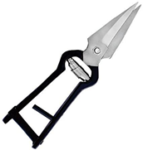

- Hoof grinder
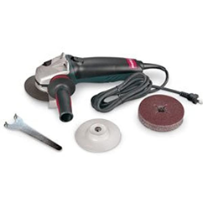
- Swiss hoof knife

Case 2:
- Hair clipper
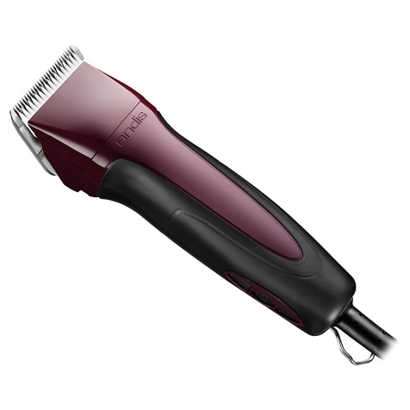
- Gauze pad
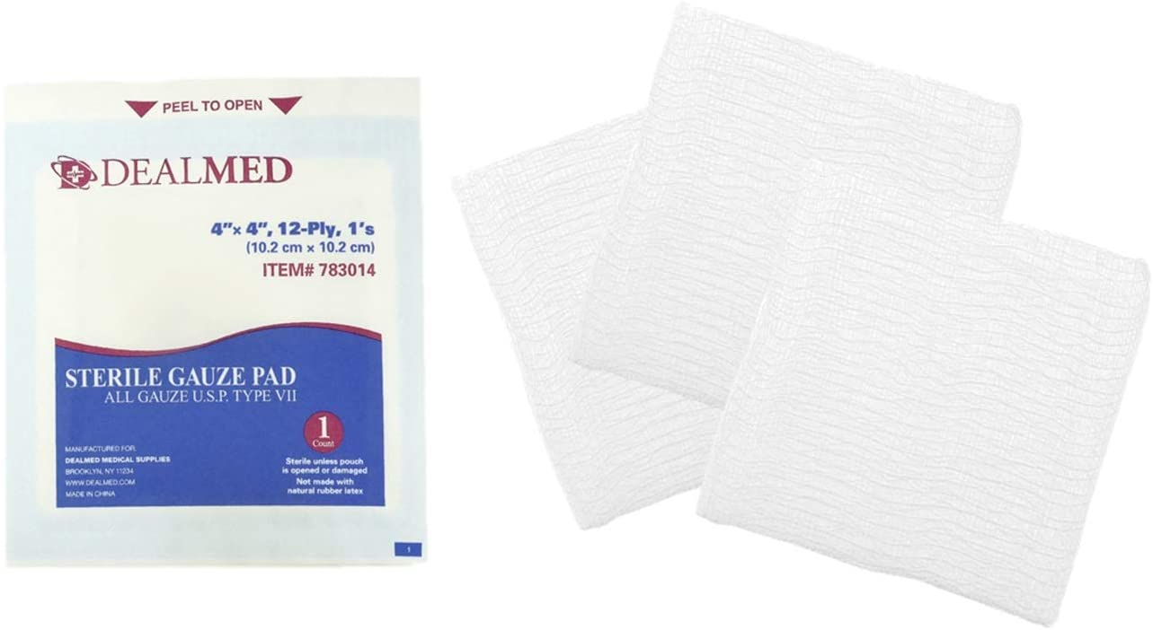

- Syringe
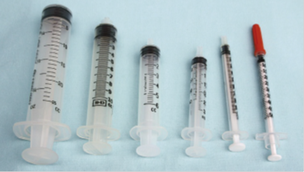

- Hypodermic needle
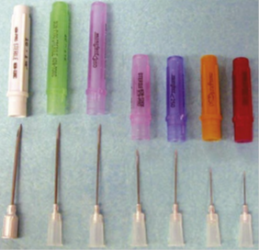

- Scalpel handle (#4, #8)

- Scalpel blade (#20, #23)

- Wire saw with handles
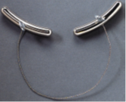

- Bandage material (gauze wrap and, vet wrap)
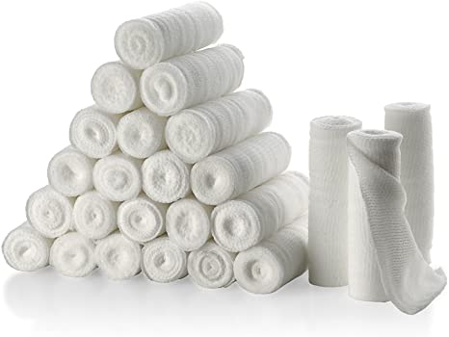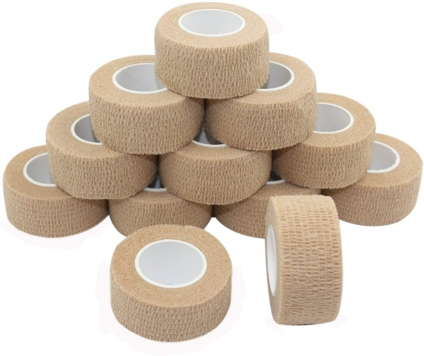

- Cow boot

- Tourniquet
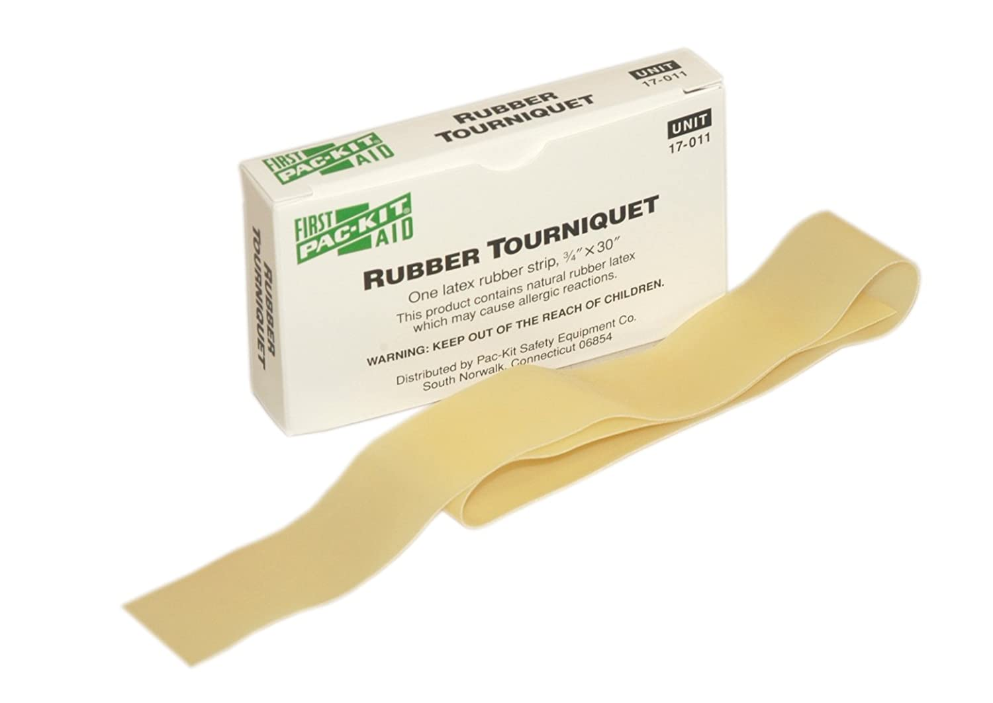

Case 3:
- Hoof tester
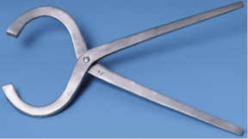

- Hoof abscess knife

- Hoof groover

- Hoof block, Glue and Heat gun

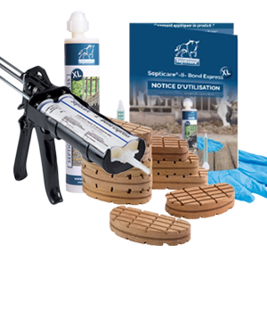

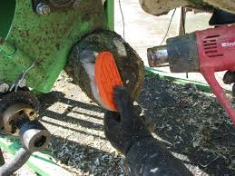

- Brush
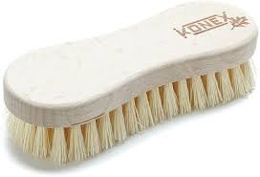

- Hoof knife

- Disposable syringe

- Hypodermic needle

Protective Wear:
- Gloves
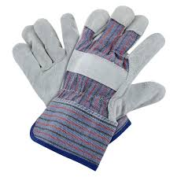
- Protective goggles
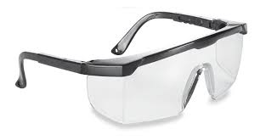
- Rubber boots
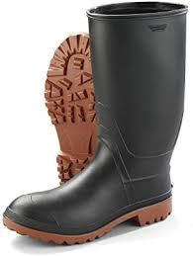

- Ear muffs (for when using grinder)
