Drugs used in GIT surgery

Calculations were done using a 50 kg animal, could be substituted out for another weight.
Drug | Concentration | Dose Rate | CALCULATIONS | Withdrawal | Indication for use
1. Penstrep  (antibiotic)  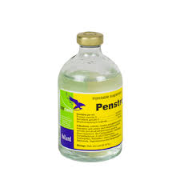 | 200,000 IU/ml | 40,000 IU/kg | V= 50kg x 20,000 IU/kg) /200,000 IU/ml = 10 mls IM | 30 DAYS | Antibiotics  5mls  q3d x 2
2. Sedation  Xylazine  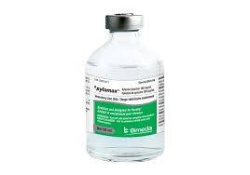  Ketamine  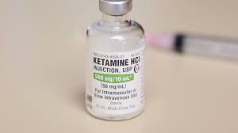 | 20 mg/ml  100mg/kg | 0.05mg/kg  0.5mg/kg | Xylazine- V=(0.05x50)/20 = 0.13mls  Ketamine- V=(0.5x50)/100= 0.25mls | 14 days meat  48 hrs milk
6. Xylazine  (Anaesthetic)  CRI | 20 mg/ml | 0.05 mg/kg/hr | M = DV & V = M  IR C  0.05 x 1000  5  = 10mg …10/20 = 0.5 mls | 14 days meat  48 hrs milk | Continuous analgesia for the 2 hrs of surgery
5. Ketamine  Induction | 100mg/ml | 5mg/kg | V = (5 x 50)/100 =  2.5 mls IV | 3 days meat  24 hrs milk | Balanced anaesthesia
5. Ketamine  CRI | 100mg/ml | 5mg/kg/hr | M = DV & V = M  IR C  5 x 1000  5  = 1000mg ….1000/100 = 10mls | 3 days meat  24 hrs milk | Continuous analgesia for the 2 hrs of surgery
3. Flunixin (NSAIDS)  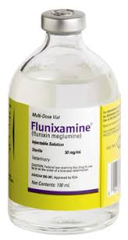  Tetanus antitoxin | 50mg/ml  300IU/ml | 2.2mg/kg | V = (2.2 x 50)/50 =  2.2 mls IV - Slow Iv admin - 1 ml/second  600IU (2mls) | Meat 4 days | preemptive analgesia & post-op for three days.
5. Lidocaine  (Anaesthetic - Induction)  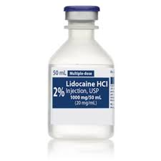 | 20mg/ml | 1.0 mg/kg | V = (1.0 x 50)/20 =  2.5 mls IV | 1 day meat  24 hrs milk | Toxic dose 10 mg/kg
6. Lidocaine  CRI | 20mg/ml | 1.0 mg/kg | M = DV & V = M  IR C  1 x 1000  5  = 200mg .200/20 = 10mls | 1 day meat  24 hrs milk | Toxic dose 10 mg/kg  =25mls
4. EPIDURAL  Bupiv/Ket  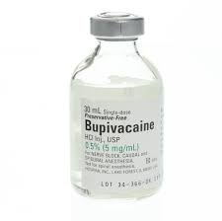 | (B) 5mg/ml  (K) 100mg/ml | (B) 0.25mg/kg  (K) 1.25mg/kg | (B)V = (0.25x50)/5 = 2.5ml  (K)V = (1.25x50)/100 = 0.625ml |  | Toxic dose 2 mg/kg  =20mls
7. Intra-op Fluids  0.9%Saline (use 1L bag) | Calculated of Drip Rate in drops per sec - (ml/min x drip factor)/60 = drops/sec  250 x 20 = 83 / 60 = 1.4 = 3 drops/2sec  60
Tolazoline  (xylazine reversal) | 100mg/ml | 4 x xylazine dose i.e.  0.1 mg/kg | V = (0.1x50)/100 = 0.5mls | None for food animals | Xylazine reversal
Atropine  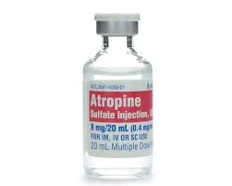 | 0.54 mg/ml | 0.04 mg/kg | V = (0.04 mg/kg)(50 kg) / 0.54 mg/ml  V = 3.7 ml (= 2mg/50kg) | 14 days meat  3 days milk | Use if bradycardia < 30 bpm
Epinephrine  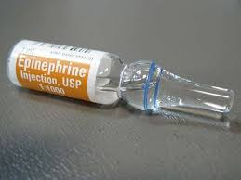 | 1mg/ml  (1:1000) | 0.02  mg/kg | V = (0.02 mg/kg)(50 kg) / 1 mg/ml  V = 1 ml | No WDT | Anaphylaxic reactions

CRI DRUG (mg) =Infusion rate of drug (mg/kg/hr) ÷ fluid infusion rate (ml/kg/.hr) * diluent volume (ml)
M= DV/IR V= M/C

Rate of Fluid delivery = 5 ml/kg/hr
Drop factor = 20 drops/ml
Maintenance rate: 1-2ml/kg/hr
Surgical rate: 5-10ml/kg/hr
Example: Drip rate in drops/ sec in a 50kg animal= 50kg* 5ml*20 drops/60 *60= 1.4drops/second

The use of CRI: Constant Rate Infusion
Using a constant rate of infusion allows for the more stable plane of analgesia with a reduced incidence of break through pain. It also allows for a lower dose to be administered at a given time which reduces the side effects of the given drug. Constant rate infusions also aid in cost reduction and control over drug administration.

Paravertebral nerve block, intravenous regional limb perfusion, and epidural anesthesia are commonly used in ruminant surgery. Various obstetrical operations, surgical procedures of the anus, vulva, perineum, caudal udder, and scrotum are performed under epidural analgesia. Epidural analgesia is also used as an adjunct for the treatment and control of tenesmus the most common sites for epidural administration of aesthetic agents are the first coccygeal intervertebral space (Co1-Co2) and the sacrococcygeal intervertebral space (S5-Co1).The technique is considered easy to perform in standing animals and require no special equipment. The site of injection can be identified by moving the tail up and down in a pump-like manner. The first proximal moving space that can be easily palpated is the preferred location for injection. The site in the dorsal midline is clipped and aseptically prepared using a disinfectant solution. An 18-Gauge, 1.25″ needle is used to penetrate the intervertebral space which is usually directed slightly in a cranial direction and advanced slowly. A lack of resistance or popping sensation usually indicates that the epidural space is entered. Correct placement of the needle can be checked by the hanging drop technique which can be performed by placing few drops of sterile water or lidocaine into the needle hub during insertion. When the needle enters the correct space, the drop of saline or lidocaine is observed to be aspirated under the effect of the negative pressure in the epidural space. Furthermore before injection of the drug, negative pressure is applied by the syringe to ensure blood or spinal fluid is not aspirated. In which case, the needle must be withdrawn and adjusted slightly, and negative pressure is applied again.
According to the volume of injected drug, epidural anaesthesia can be classified into caudal (low dose or low volume) epidural or cranial (high dose or high volume) epidural. Low dose or caudal epidural anaesthesia is the most commonly used technique, and it requires the injection of a small volume of the drug. This technique desensitizes the caudal sacral nerves within the spinal canal. The motor functions of the hind limbs are not affected. Areas that are desensitized by low volume epidural are the tail, vagina, vulva, anus, rectum, caudal prepuce, scrotum, and urethra. This technique is commonly used to prevent or control tenesmus and contractions during repair of a prolapsed rectum or vulva, repositioning of a prolapsed uterus, and dystocia.
In the high dose epidural anaesthesia technique, the volume of the injected drug is relatively large, and analgesia is extended therefore further cranially. Analgesia may reach up to the diaphragm resulting in some degree of cardiopulmonary compromise. In addition, the motor functions of the hind limbs will be affected resulting in ataxia and recumbency in some animals. This technique is less frequently used in adult animals, however in young calves, it is may be used for umbilical surgeries
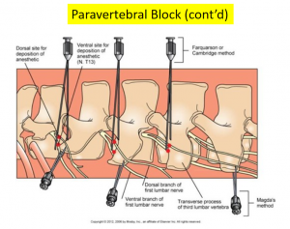

Research has found that the use of combination of buprivacaine /ketamine resulted in a fast onset as well as a prolonged duration of analgesia in caudal areas. This combination allowed for better results with less marked side effects.

Sacrococcygeal epidurals are used for: replacement of cervicovaginal or uterine/rectal prolapse, correction of dystocia and perineal urethrostomy.
Lumbosacral epidurals are used for: ram vasectomy, caesarean section and hindlimb fractures.

Complications:
Use of epidural anaesthesia on large numbers of lambs in dirty farmyards would risk the development of spinal abscesses in some individuals and may also lead to overdose in some individuals.
Injection into the first intercoccygeal space may be less reliable for production of anaesthesia than injection into the sacrococcygeal space.
It may be difficult to identify the first intercoccygeal space in tail docked sheep.
Doses greater than 3 ml of 2% lidocaine in sheep or goats (of about 60 kg bodyweight) may result in hindlimb incoordination and recumbency.

