Equipment | Image | Description
Scalpel | 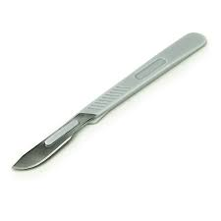 | Used to make fine and precise incision into skin or tissue.
Long gloves | 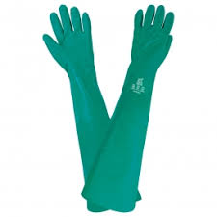 | To explore contents of rumen and other structures within
Drape | 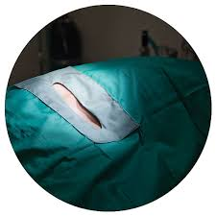 | Used to isolate surgical area and maintain sterile surgical field.
Suture | 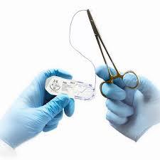 | For closing open wounds made during surgery
Rope halter | 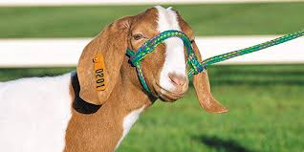 | To restrain animal during surgery and limit movement
Stanchion | 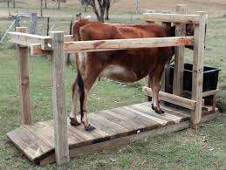 | Used to restrain and isolate animal to a confined area during surgery.
Weingarth’s rumenotomy frame | 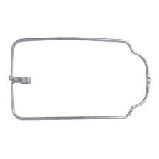 | Holds rumen in tense position together with laparotomy incision
Doyen intestinal forceps | 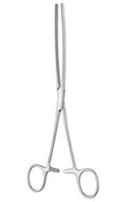 | For grasping large organs and intestines as it is non crushing
Rumenotomy board | 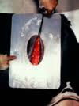 | Used to exteriorize the rumen
Vulsellum forceps | 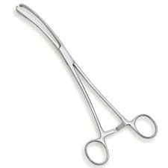 | Used to clamp upper and lower rumen and attach to rumenotomy board

