EYE REMOVAL SURGERY
ENUCLEATION

PREOPERATIVE MEASURES
- Clean periocular skin gauze-soaked sponges of
dilute povidone iodine and alternate with sterile
saline
- Clean the conjunctival sac with sterile cotton
tipped applicators alternate iodine with saline
and work out to the eyelid margins
- Final prep of periocular skin from margins
outward
- Keep surgery eye lubricated with sterile saline or
methylcellulose gel to prevent corneal drying

INTRAOPERATIVE MEASURES
A transpalpebral incision is made around the orbit, leaving as much normal tissue as possible. The incision is generally 5mm from the margin of the eyelid. The ventral incision and subsequent dissection are done first. Blunt dissection is used for 360° around the orbit continuing down to the caudal aspect of the orbit, but avoiding entrance through the palpebral conjunctiva. All muscles, adipose tissue, the lacrimal gland, and fascia are removed, along with the eyelids and eyeball. If the indication for enucleation is neoplasia, then one must make sure that all neoplastic tissue is removed. If the eye is enucleated for a non-neoplastic condition, such as irreparable trauma, then the surgeon can afford to leave some of the retrobulbar tissue, to reduce the amount of dead space and intraoperative haemorrhage. The cavity fills with a blood clot that will organize during the healing period and will leave a large depression in the orbit.
Closure consists of a layer of simple continuous sutures in the subcutaneous tissue using 2-0 absorbable suture material and the skin is sutured using 0 non-absorbable suture in a simple continuous or interrupted horizontal mattress pattern.

There are two types techniques available for this surgery
- Subconjunctival Enucleation
Used for non-contaminated (neoplasia confined to globe) cases

Technique:
Perform a lateral canthotomy to allow better access
Grasp conjunctiva and incise for 360 degrees around the globe approx 5 mm from the
Extraocular muscles are isolated and transected
The optic nerve is severed
Following removal of the globe the eyelid margins,
conjunctiva, third eyelid and gland of the third eyelid are removed
Routine closure
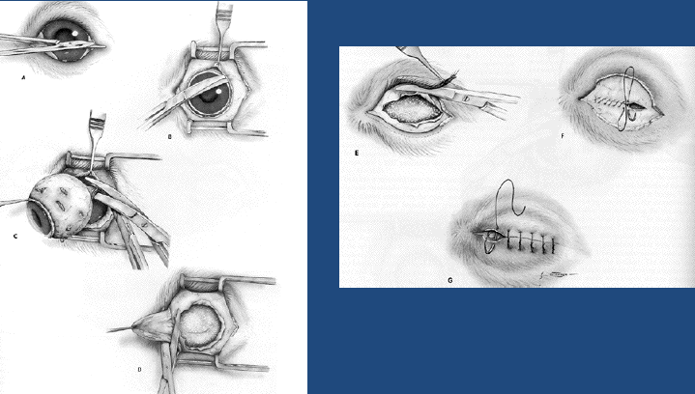

2. Transpalpebral approach
Removes the globe, short piece of the optic nerve, lid margins, conjunctiva, third eyelid and gland of the third eyelid.

Technique:
Lid margins sutured closed with simple
continuous monofilament suture or towel clamps
Incise the skin approx 5 mm from the lid margin
in an elliptical shape, SQ tissues, and obicularis
oculi down to the conjunctiva (but not through
it!) be sure to incorporate both the lateral and the medial
canthus
Be careful to avoid the agularis oculi vein at the
medial canthus Dissect all the way around the globe until you are
past the limbus (this is where the conjunctiva,
and potential contaminants end)
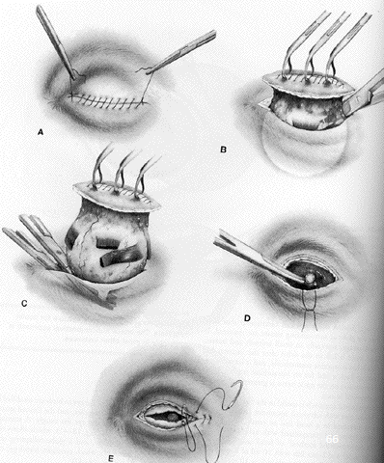

when closing the site, there are two techniques
2 layers
1) subcutaneous tissue, 2-0 absorbable suture, simple continuous
2) skin, 0 non absorbable suture, interrupted horizontal mattress

POSTOPERATIVE MEASURES
Keep clean and spray with wound spray.
Protect the patient from harsh environmental conditions and other animal for several days
Sutures are removed 10-14 days postoperatively.

