Intra-op – Eyelid laceration Repair
V-Plasty
It is important to note if the cornea is intact and that the papillary light response is present, if these are abnormal then the injury may be more than just an eyelid laceration. The cornea is stained with a fluorescein dye to examine the eye for any signs of ulcers and evaluation of the anterior/posterior chambers.
V-Plasty can be used to either for wedge resection or an eyelid laceration repair.
The auriculopalpebral nerve block is done.
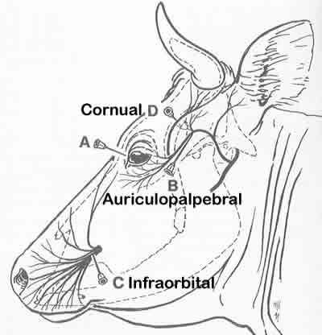
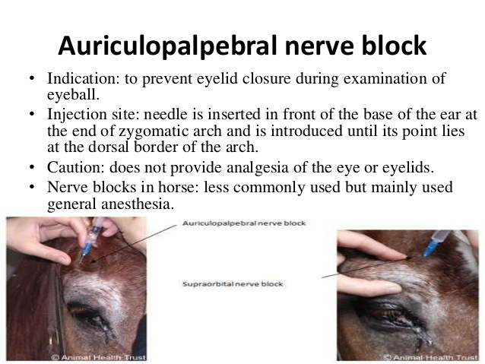
Considerations when performing this procedure are requires meticulous apposition for functional/cosmetic healing and the amount of eyelid removed should not exceed 1/3 of the length of the eyelid margin.
The technique used for wedge resection:
Triangular defect is produced by creating a full-thickness lid defect in a v pattern. The length of sides should be equal and approximately twice the height of the length of the lid margin being removed.
Closer of the laceration should be done from the base to the apex. Nylon, prolene or silk are appropriate to close the laceration. 3-0 to 5-0 can be used based on the size of the animal. The suture technique used is the mattress or figure-of-8 pattern. The tags are pulled away from the eye to prevent any ulcers. 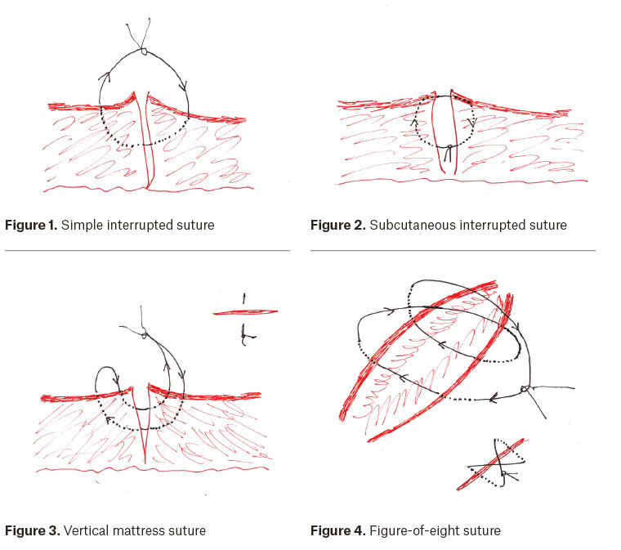
https://www.youtube.com/watch?v=Uk7kkvPwz8Q

Precautions:
- It should be noted that viable tissue should not be excised.
- Cautery should not be used when repairing eyelid lacerations to prevent further damage to the tissues.
- There should be extreme caution when placing sutures as the sutures can impact the cornea and result in complications.

