Instrument | Surgical drapes
General information | To isolate the surgical site from the other areas of the patient's body and nonsterile areas of the OR table to reduce the risk of surgical site infection (SSI).
Pictures | 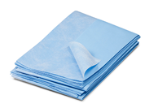

Instrument | Gauze
General information | This is a loosely woven cloth that is used for dressing, surgical scrubbing,debriding, hemostasis, absorbance of blood, and wound packing. It holds 5ml to 10ml of blood.
Pictures | 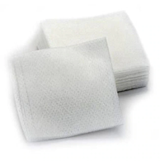

Instrument | Towel clamps
General information | Introduced through the ground drapes (at a corner where two drapes meet) and through the patient's skin in order to securely hold the surgical drape during a surgical procedure. Towel clamps can also be used to secure suction lines, electrocautery cables, and power equipment lines to drapes but this is less desirable because it creates a hole in the drape in an area that may not have been surgically prepared. Towel clamps are considered contaminated once they have penetrated a drape. Therefore, towel clamps must be discarded and replaced with new ones if repositioning is required.
Types (descriptions are in the photos)  We will paraphrase when we’re creating the concept map | Backhaus  Lorna  Roeder  Jones
Pictures | 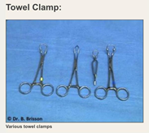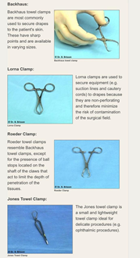

Instrument | Gallipot
General information | Holds ointment and medicine to be used for medical procedures. Eg alcohol & betadine
Types (descriptions are in the photos)  We will paraphrase when we’re creating the concept map | 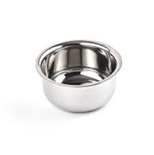

Instrument | Scalpel
General information | Reusable handles with detachable single use blades are mostly used in veterinary medicine but disposable units are also available. #3 and #4 (far right) scalpel handles are used most frequently with #3 being used more often than #4. The #4 handle is larger than the #3 and has a larger fitment for large blades such as #20. The #7 handle (long and skinny) is used frequently for more delicate incisions. We use a #3 scalpel with a #10 blade to make the initial skin incision and then use the #7 scalpel with a #15 blade (sometimes a #11) for all other scalpel incisions. This may vary with surgeon preference.
Pictures | 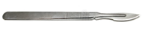

Instrument | Scalpel blade
General information | Various blade shapes and sizes are available to perform specific procedures based on surgeon preference. Blades #10, 11, 12, 12B, 15 and 15C fit the #3 scalpel handle, whereas blades #20, 21, 22, 23 fit the #4 scalpel handle. Beaver scalpel handles will hold a variety of small blades of various shapes (e.g. #64 and 65). In veterinary medicine, #10 blades are most commonly used.
Pictures | 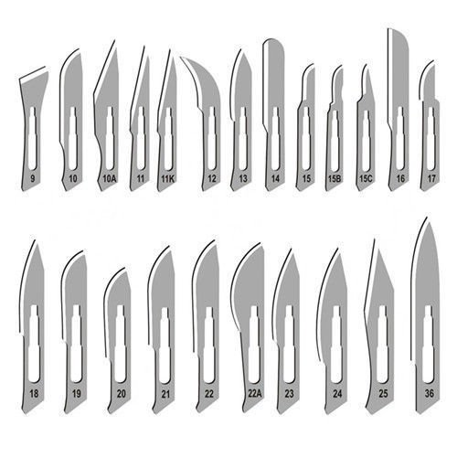

Instrument | Scissors
General information | There are many different types, sizes and shapes of surgical scissors available to the veterinary surgeon. Various tip configurations are available such as sharp-sharp, blunt-blunt or sharp-blunt. For example, sharp-blunt scissors have one sharp tip and one blunt tip. Scissors can also be curved or straight. In general, straight scissors offer better mechanical advantage and are used to cut through tough, fibrous tissue such as fascia and the linea alba. Various scissors are used to accomplish different tasks. Mayo scissors are typically used to cut fascia, Metzenbaum scissors are used to cut through thin and soft tissues such as bowel and fat. Simple sharp-Blunt scissors are generally used to cut suture intraoperatively. Scissors can also be used to bluntly dissect tissues. This is done by inserting the closed scissor within the tissues to be dissected and opening the jaw in a 'stretching' motion without cutting.
Types (descriptions are in the photos)  We will paraphrase when we’re creating the concept map | Sharp-blunt  Mayo  Metzenbaum  Iris  Tenotomy  Bandage (Lister)  Suture
Pictures | 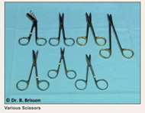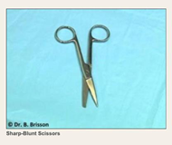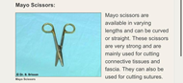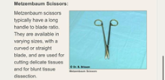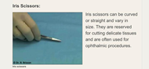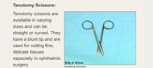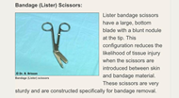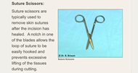

Instrument | Needle holder/ needle driver
General information | Grasp suture needles when suturing tissues. The jaws of the needle holder undergo metal-to-metal contact causing rapid wear of the grasping surfaces. Needle holders should be tested for function regularly by placing an appropriate sized needle in the jaws and noting if needle rotation is possible (indicating that repair is necessary). Tungsten carbide inserts are one of the hallmarks of higher quality needle drivers. The tungsten carbine inserts can be replaced when the needle grip is no longer appropriate.
Types (descriptions are in the photos)  We will paraphrase when we’re creating the concept map | Mayo-Hegar  Olsen-Hegar  Mathieu  Castroviejo (microvascular)
Pictures | 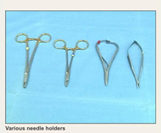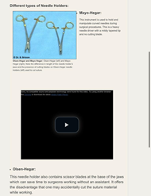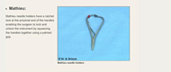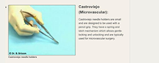

Instrument | Thumb forceps
General information | Thumb forceps are used for the manipulation and grasping of tissues during surgery. They are non-locking, they contain a grasping surface and may or may not have teeth. Forceps without teeth are thought to cause less tissue trauma, however, they often require more pressure to hold tissues than do forceps with teeth, and can subsequently cause greater damage to tissues. Thumb forceps should be held between the thumb and index finger with a pencil grip when in use, and in the palmed position when not in use.
Types (descriptions are in the photos)  We will paraphrase when we’re creating the concept map | Adson  Adson-Brown  Rat tooth  DeBakey  Russian
Pictures | 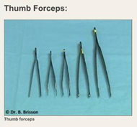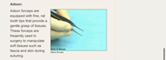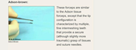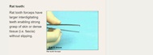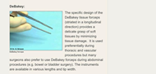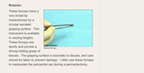

Instrument | Grasping forceps
General information | Various sizes and shapes of tissue forceps have been developed to enable handling of tissues during surgery. These are generally traumatic instruments and should never be applied to the skin or organs that are meant to remain functional (an exception is the Doyen clamp). Doyen Intestinal  Forceps are used for grasping large organs and intestines as it is non crushing-- intestines are grasped with the tip of the forceps and only the serosa is held to minimize bowel crushing
Pictures | 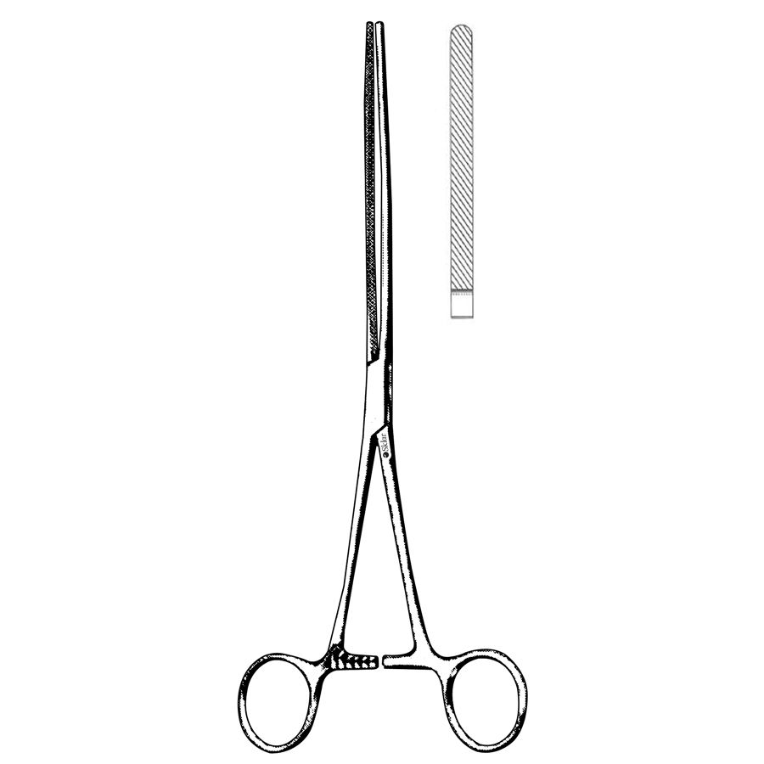

Instrument | Haemostatic forceps
General information | Hemostatic forceps are crushing instruments used to temporarily clamp and occlude bleeding vessels. The crushing action on the vascular wall at the site of application stimulates physiological clotting mechanisms. Unlike thumb forceps, they are equipped with a ratchet mechanism that enables them to maintain hands-free occlusion while a ligature is applied. Hemostatic forceps come in various lengths, shapes (straight or curved) and types. Hemostatic forceps of larger size (e.g. Rochester-Carmalt) are typically used to crush pedicles and stumps prior to ligation and transection. Hemostatic clamps are delicate instruments that are subject to wear and tear and therefore require routine inspection for jaw alignment, shank tension and ratchet wear.
Types (descriptions are in the photos)  We will paraphrase when we’re creating the concept map | Straight  Curved  Mosquito  Kelly  Crile  Carmalt  Satinsky  Bull dog clamp
Pictures | 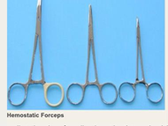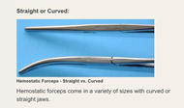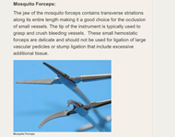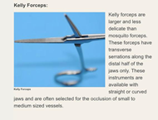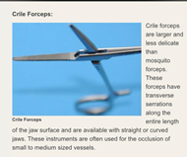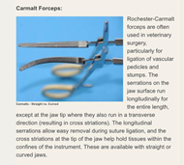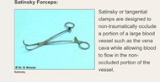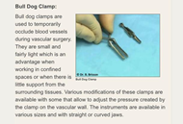

Instrument | Cattle leader
General information | This is used to restrain a cow.
Pictures | 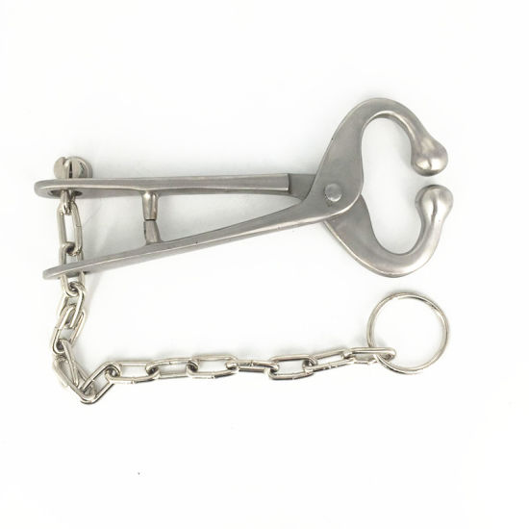

Instrument | Tongue depressor and jaeger plate
General information | Offers stability and protection for the ocular globe and cover the eyeball providing a rigid surface on which surgeons can perform lid dissection
Pictures | 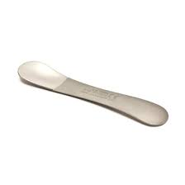

Instrument | Colibri Forceps
General information | A Semi-sharp, fine tips eases grasping and holding the Corneal and Scleral Flap
Pictures | 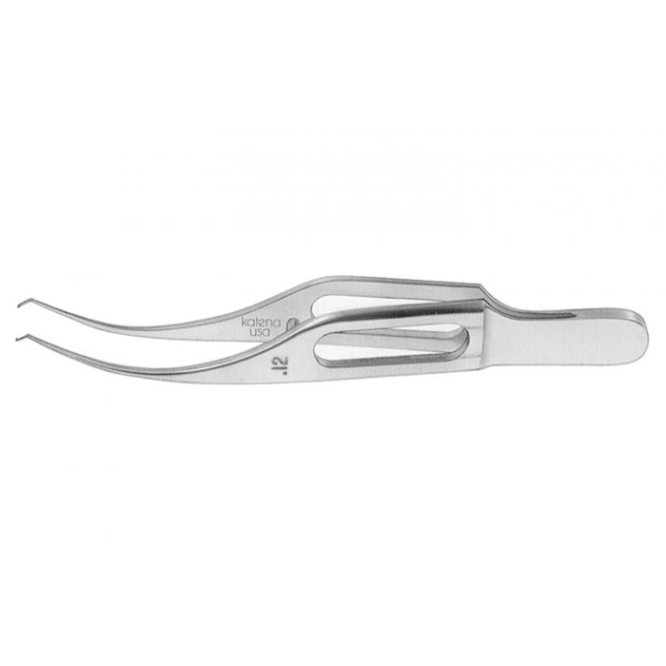

Instrument | Castroviejo eye speculum
General information | Used to hold the eyelids open during optic surgery
Pictures | 