Pink Eye/ Cherry Eye
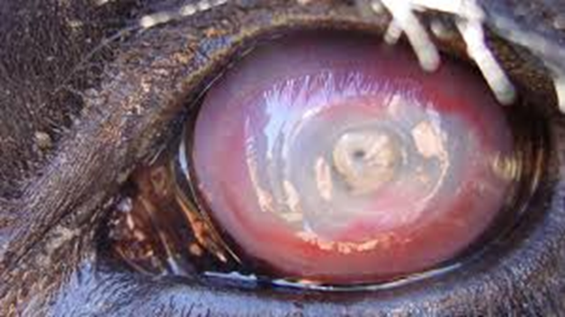
Signalment and History:
A 380kg, 2-year-old Holstein cow presented with a tear stained face and purulent matted lashes of hair surrounding the eye. The animal exhibited pain when eye was exposed to sunlight and also had poor grazing habits with reduced visibility of both eyes and a marked weight loss. There were also the presence of bilateral corneal ulceration and conjunctivitis.
In an emergency management of pink eye, antibiotics can be administered by giving subconjunctival injections which bypasses the lipid layers of the bulbar conjunctiva and places the drugs adjacent to the water-permeable sclera which increases water-soluble drug penetration into the eye.
Restraint:
Since the animal may become aggressive when working on the eye, good restraint is necessary and so the use of a chute to hold the cattle in place and a halter to secure its head to the bars is used.
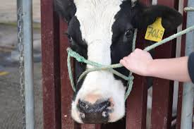
Technique:
Ensure all materials used are sterile as possible and clean gloves are worn when handling the eye to reduce cross contamination.
Hold eye open with hand or by use of a handheld lid retractor to expose conjunctival area for injection
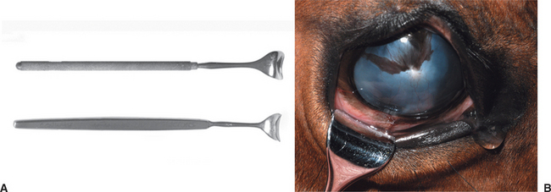
Additionally, conjunctival anesthesia is facilitated by a cotton-tipped applicator soaked in topical anesthesia (proparacaine) and placed against the conjunctiva at the planned injection site for about 30 seconds
Insert a 25-27-gauge needle with 2ml of procaine penicillin into the dorsal bulbar conjunctiva as seen below.
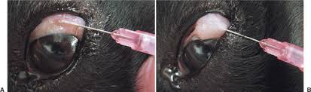

Once complete, gather and sterilize all materials used before proceeding to another animal.
An eye patch can be applied to provide protection from outside conditions and to prevent additional bruising and potential spreading of the causative organism Moraxella bovis. Isolate animal until condition resolves.
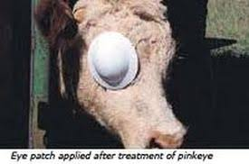
Video links:
https://www.youtube.com/watch?v=A947psxBDFk&ab_channel=SMUVETMED
https://www.youtube.com/watch?v=xgFmdDnmOCU&ab_channel=VET2DAY
https://www.youtube.com/watch?v=F-N4MABqWws&ab_channel=BlakeBalog
Resources:
https://vetgrad.com/uploads/eye_conditions_cattle.pdf
https://veteriankey.com/ocular-pharmacology-and-therapeutics/
https://www.sites.ext.vt.edu/newsletter-archive/livestock/aps-98_06/aps-922.html

