EQUIPMENT & MATERIALS | KEY POINTS
Hoof Knife  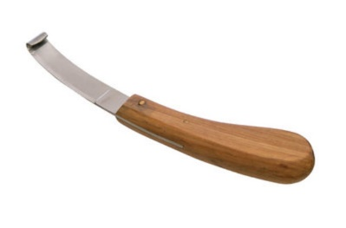 | - Modified knife used to trim loose and dried out part of the sole/hoof wall  - Most essential tool  - Allows for trimmer to switch angles quickly and effectively throughout the process.
Hoof Trimmer  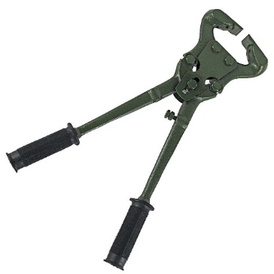 | - Trims hooves
Hoof Testing Pliers  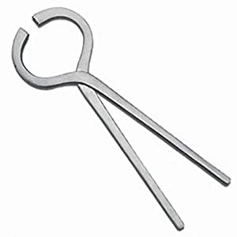 | - Used to assess sensitivity and pain in the weight bearing surface of sole and between claws  - Positive reaction- muscle twitching at the proximal limb when sole is pinched  - Test non injured claw first so that painful claw is more obvious
Hoof Rasp  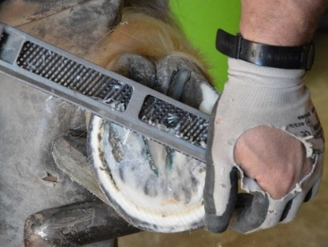 | - Coarse file used for shaping of the animal’s hooves
Measuring Tool  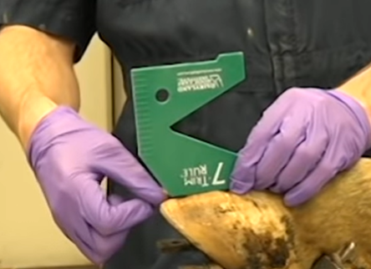 | - Measure toe length and sole depth on hoof  - Ideal toe length should be 3 inches from the coronary band  - Allows trimmer to gauge how much of the toe should be removed
Hoof Nipper  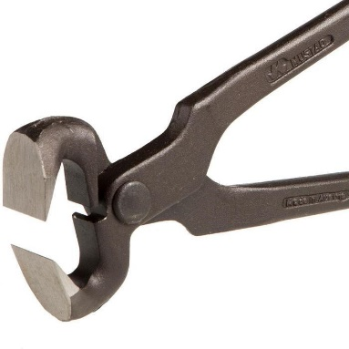 | - Designed to cut out large sections of exfoliating sole or excessive toe  - Always position parallel to hoof wall
Hoof Shears  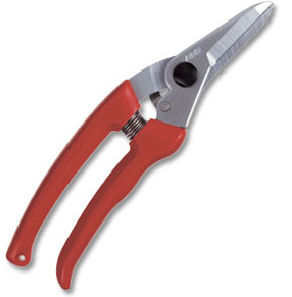 | - Used in small ruminants
Hoof Block  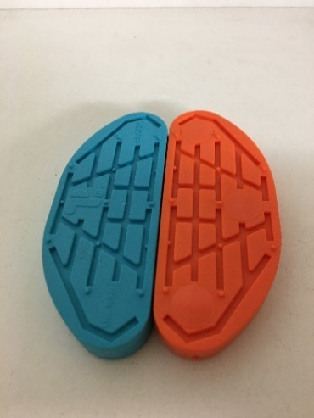 | - Applied to help elevate a severely damaged claw off the ground and reduce weight bearing  - Facilitates faster healing from lameness and comfort
Hoof Angle Grinder  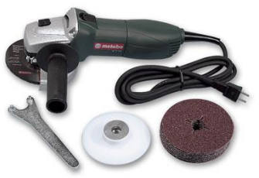 | - Electronic and more efficient than hoof knife  - Quick and easy to use
Merlin Electric Hoof Trimmer  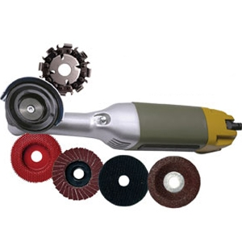 | - Smaller and more precise  - Allows for fine tuning
Personal Protective Equipment (PPE)  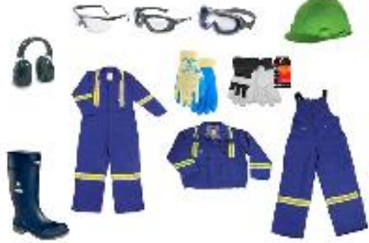 | - Protection and safety
Gigli Wire  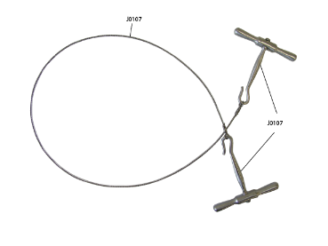 | - Facilitates removal of the claw during digit amputation
Buhner Needle  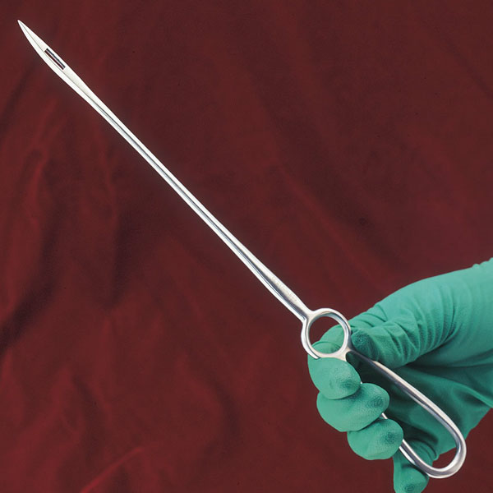 | - Allows for the passage of a drainage tube during deep digital flexor tendon resection or coffin joint arthrodesis
Drainage tube  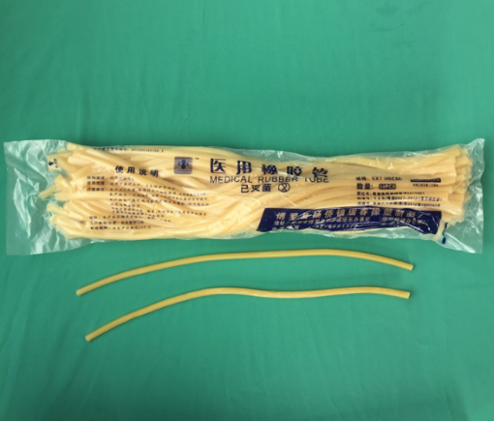 | - Used to drain exudate from wounds  - Indicated during complicated sole ulcer treatment, deep digital flexor tendon resection or coffin joint arthrodesis
Suture Kit + Suture Material (nylon)

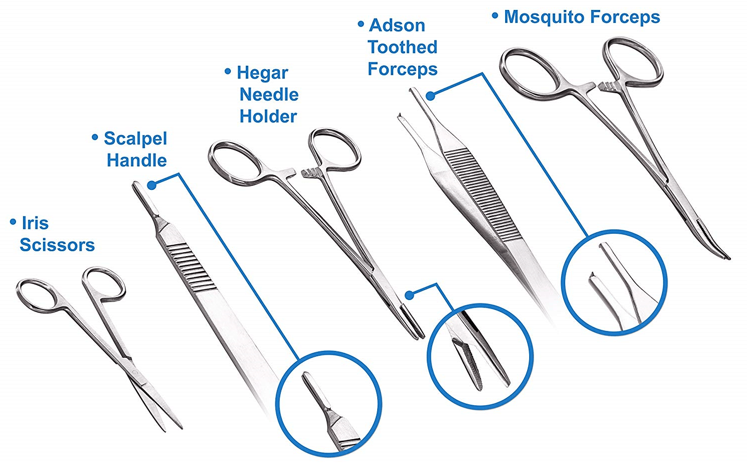
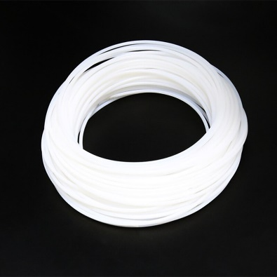

Bandages
