The Five-Step Dutch Hoof Trimming Method

General Indications-
- Steps 1 to 3 are indicated for functional trimming and lameness prevention. Here, excess horn is removed and the hoof is prepped for inspection prior to therapeutic trimming.
- Steps 4 & 5 are indicated for therapeutic trimming and is used when there is an issue in the hoof, including abscesses. Here, the functional shape of the hoof must be conserved.
- The measurements indicated may vary depending on age and breed of cattle, as well as specific animal features, environmental conditions and disease present.
- If lameness is suspected, begin with the normal hoof.

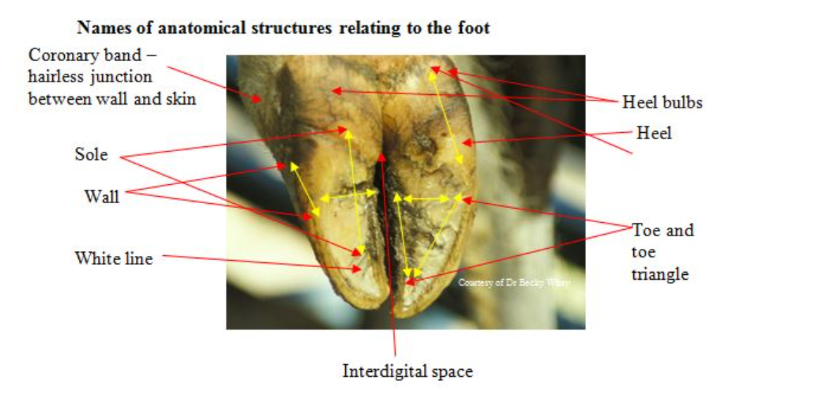
Figure showing anatomical markers to use as reference for the terminology mentioned in the following procedure

Functional Trimming-
Step 1:
Measuring and Trimming the first Digit
Indications:
- Hindlimb- begin with medial digit
- Forelimb- begin with lateral digit

(Starting with hindlimb medial digit)
- Correcting toe length:

Measurement
- Measure approximately 7.5cm from the top of the coronary band to the front of the digit. In larger breeds, the approximated length may be 8-8.5cm.
- OR wrap a hand around the digit, placing fingers in the interdigital space. The cut length can be adjusted here according to how your hand measures wider or shorter than 7.5-8.5cm.
- If toe length is correct and is without the need for trimming, then proceed to step 2.
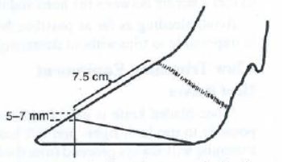
Figure showing measurements and its markers

Trimming
- Trim toe by cutting perpendicular to the sole.
- Cut in increments as to avoid removing excessive horny tissue and ensure the cut is straight. (See attached video)
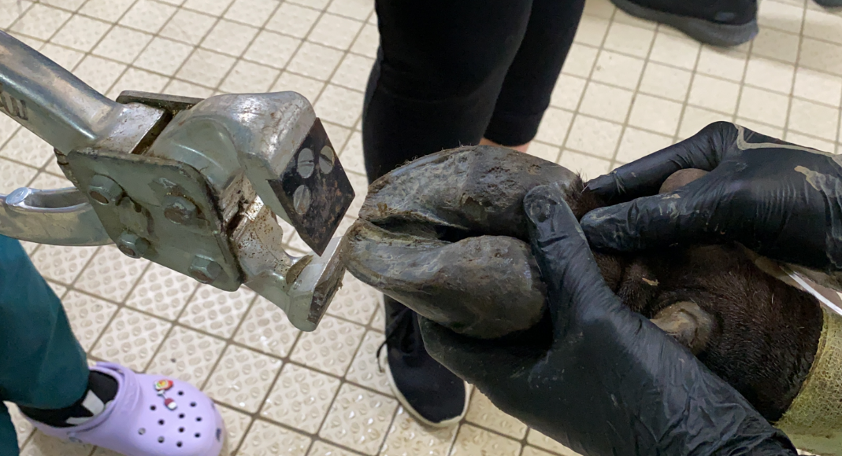
Figure showing toe trimming

- Trimming sole:
- Grade excess sole at the toe from the ground surface to outside of the wall, ensuring the heel, the side and inside wall are not trimmed. For the hindlegs, removing heel horn can reduce hoof angle.
- An indication that sufficient sole has been removed and the sole is of proper thickness is when the white line appears around the inside of the sole, re-joining at the tip of the toe and leaving approximately a 5-7mm step at the tip.
- A properly trimmed sole is also parallel to a flat surface and has an even weight-bearing surface from the toe to the heel.

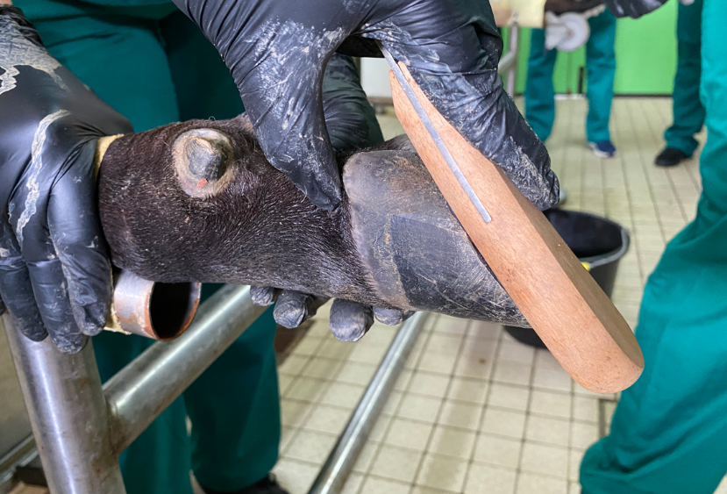

Figure showing trimmed hoof being parallel to a flat surface (hoof trimming knife)

Step 2:
Measuring and Trimming the opposing Digit
- Correct toe length of opposing digit by matching toe length of outer digit to that of the trimmed inner digit and repeat the trimming process, cutting perpendicular to the sole and in a straight line.

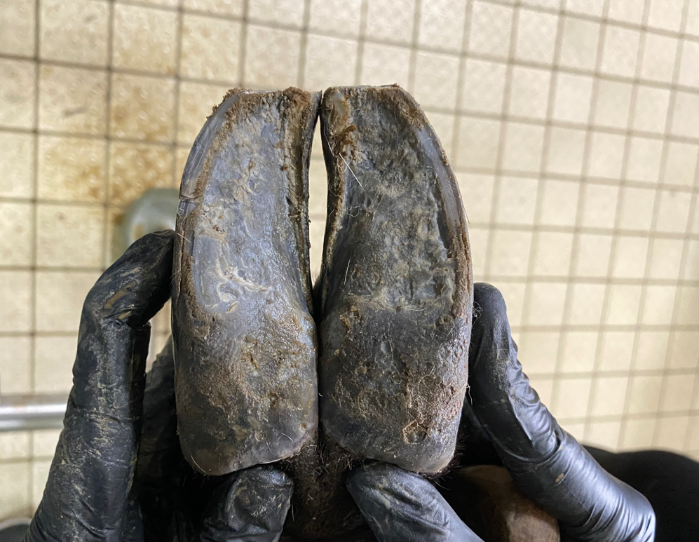

Figure showing even toe correction between inner digit and outer digit

- Balance opposing digit by using the level that was graded from the stable toe triangle of the trimmed inner digit. Trimming digits to the same height allows for even weight distribution across the entire hoof.
- An indication of even weight distribution across the hoof can be assessed by placing the flat handle of a hoof knife within the digit and in the interdigital space.

Note:
- Since the outer digit is slightly larger in size than the inner digit and is susceptible to bony change around the coronary band, this digit is balanced with the correctly trimmed inner digit.
- Typically, more horn is removed from the outer digit and less horn is removed from the inner digit in order to gain even weight-distribution.
- In sound animals, the heel rarely requires trimming.
- Ensure that the axial white line weight-bearing horn is not removed. This typically stretches from the toe to 1/3 along the axial wall.

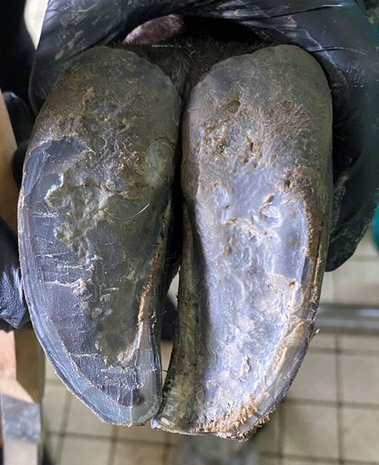
Figure showing white line in abaxial and axial wall

Step 3:
Modelling the soles/ ‘Dishing’ out the ulcer site
- Enables the transfer of weight from the centre of the sole onto the toe triangle, the harder wall and the cushioned heel.
- ‘Dishing’ out on the inner hind digit is performed slightly in order to prevent manure, mud and faeces from remaining in the interdigital space. ‘Dishing’ on the outer digit is greater but shallower in order to relieve pressure off the sole, which is the ulcer site of the under hoof.
- A ‘dishing’ ratio of 2:1 for the outer hind digit to the inner hind digit is required to achieve proper function of the anatomical aspects of the hoof. This is where the heel is able to absorb concussive forces when the hoof makes contact with the ground and when the outer wall is able to withstand wear and tear from hard surfaces.
Note:
- Ensure that modelling does not extend into the toe triangle as this can reduce weight-bearing in axial wall.
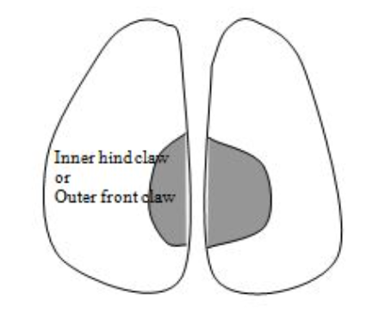
Figure showing the anatomical locations at which ‘dishing’ out is done
Therapeutic Trimming-
Step 4:
Identify and therapeutically trim lesions

- Identification of lesions:

- Painful lesions are identified by:
- Application of pressure by using a hoof tester/pincers where pain is evident in areas of the claw (along white line, toe and interdigital space). The cow may tense if digit is painful or attempt to pull away.
- Observing grossly for abscesses, foul odour, haemorrhaging or heat in one or more digits.

- Trimming lesions:

- The intention is to relieve the painful digit by reducing its weight-bearing capacity in order to allow for recovery. This is done in either of two ways:
- Provided there is sufficient depth of the heel in the healthy digit, the heel of the painful digit is trimmed in order to create a height difference. A rubber/plastic or wooden block is placed in the health digit for 4-8 weeks, depending on the lesion and its severity.

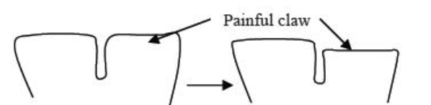

Figure showing the height difference between a painful digit and a healthy digit following trimming

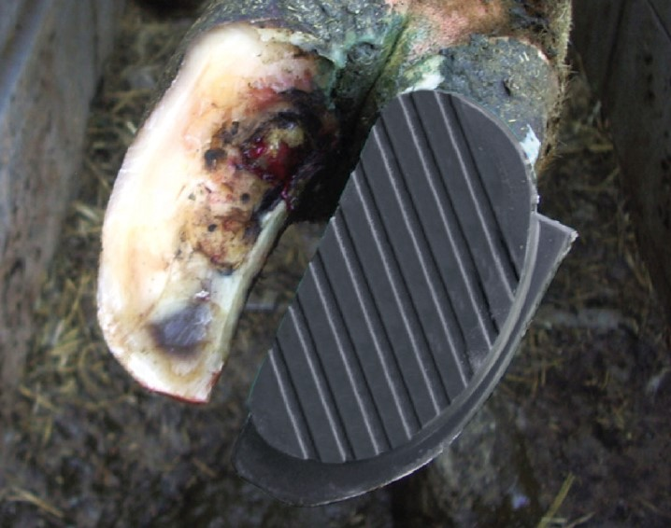

Figure showing block and its placement in cattle

Reference video that displays bio-degradable block placement for 8 weeks, following ulcer identification in the corium:
https://www.youtube.com/watch?v=4KZ36f41IBM&list=RDCMUCo4S-ThBT3KDDHAMvKw2SQg&index=16

- If there is disease present or bruising of the healthier digit, then blocking is unsuitable and another method is required. Here, a nursing paddock is required for the animal’s recovery period.
Anti-inflammatory drugs may also be required for either way.

Note:
- Horn in inner hind digit is always conserved to provide weight-bearing.

Step 5:
Trimming loose horn
- Any loose horn from around the white line, the sole and the heel is removed.
- Assess interdigital space and heel for digital dermatitis.
- The final step involves ensuring that no sharp ridges protrude from the digits as this can injure legs or teats. This is assessed by passing a hand over the under hoof to ensure it is smooth.
Note:
- Avoid removing excessive horn from the bulbs of the heel as this can affect weight-bearing.
- Avoid cutting into the ‘quick’ in order to prevent unnecessary pain and further spread of infections into deeper tissues.
