Disarticulation of P1 and P2
Purpose | Used to treat:  - Sole ulcer  - Sole abscess  - Foot-rot  - Digital dermatitis  - Interdigital dermatitis
Anatomy | Distal interphalangeal joint
Equipment | - Scalpel and scalpel blade  - Haemostat  - Rat tooth forceps  - Hypodermic needle  - Suture material (twine)  - Tubing
Restraints | - Ideally in a live cow, the animal will be in a standing in a trimming chute  Anaesthetic options: lidocaine IV or a 4-point digital block
Procedure | - The digits were scrubbed clean to remove any debris  - The skin surrounding the medial digit was retracted via an incision distally on both the medial and lateral side of the digit  - Once the skin was retracted, the distal interphalangeal joint was identified  - The soft tissue structures surround the joint were removed  - Then the connective tissue attaching the 1st Phalanx to the 2nd Phalanx were severe -> the removal of the digit  - The deep digital flexor tendon was removed  - A tube was inserted in the space which previously held the DDFT to drain the area  - The skin was then sutured closed
Post operative Care | In a live animal:  - Antibiotic and analgesics will be required to avoid infection and the animal from being in pain  - The wound site, should be kept clean and dry, so the animal should be moved to a separate pen from the rest of the herd
Considerations and Complications | - The animal will now be putting most of it’s weight on the lateral digit  - This procedure is used to treat infection, however if the infection has spread beyond the joint and to the other phalanx, then amputation will be required to be done above the affected area

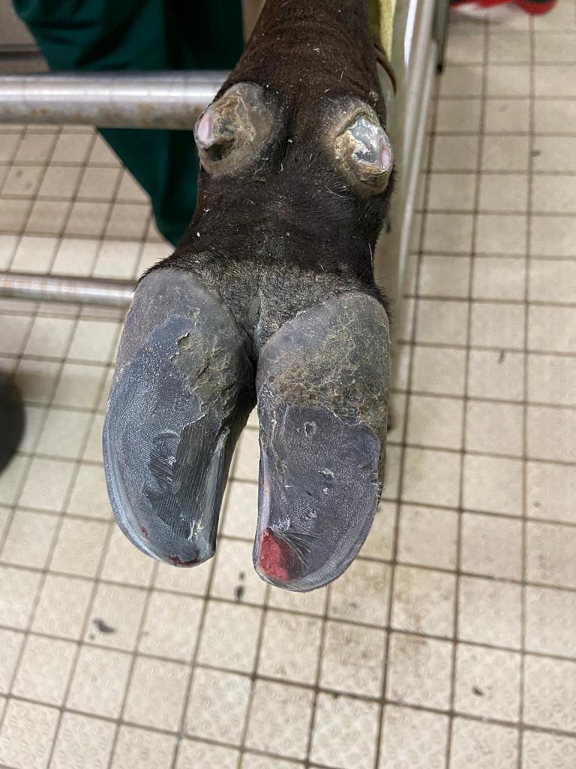
Our limb before the disarticulation
- The hooves were trimmed and smoothen

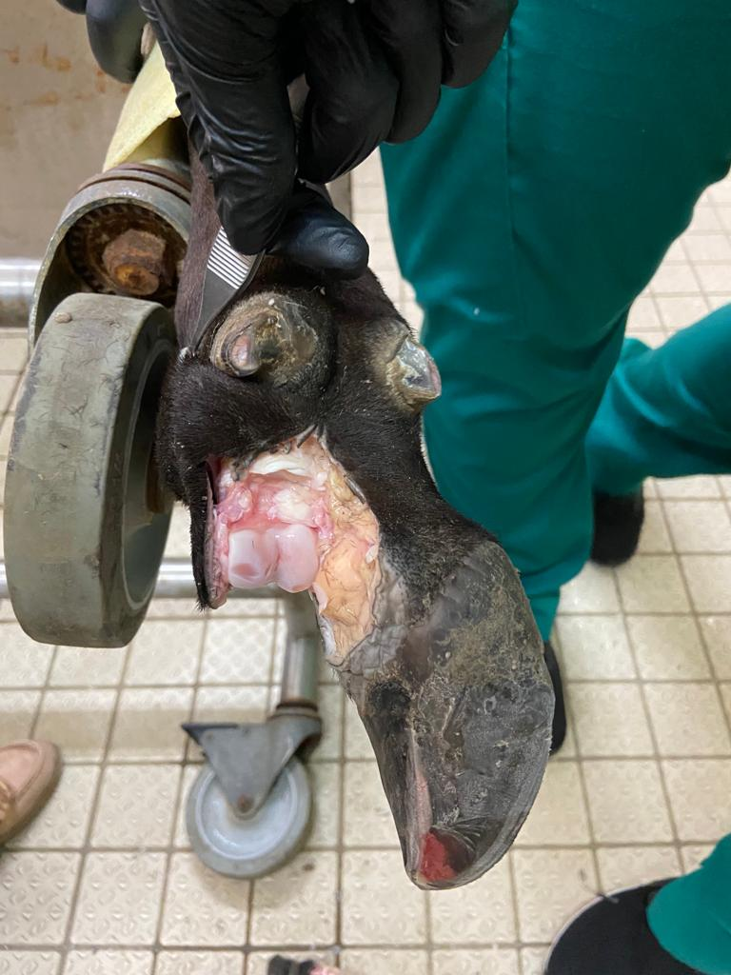
- The skin surrounding the digit was retracted
- Then the soft tissue surrounding the joint were removed
- The connective tissue was severed that held the two digits together
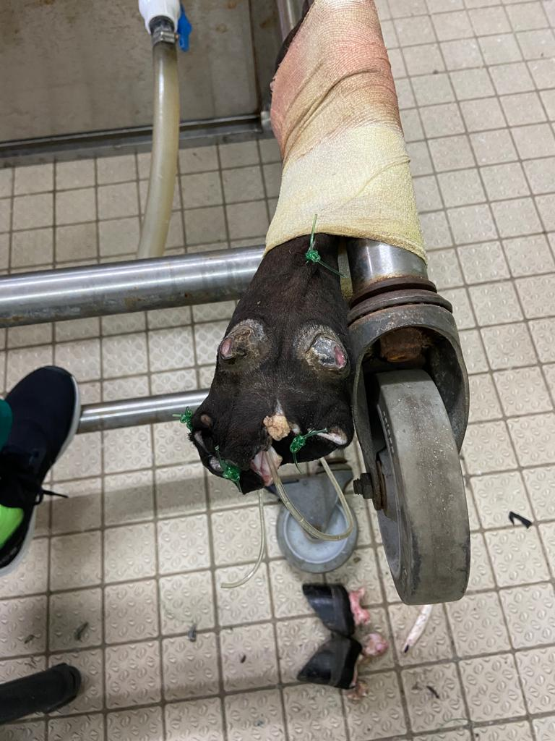
- A piece of tubing was placed in the area that once held the DDFT
- The skin was then sutured closed

