TYPES OF TEAT LACERATIONS

Type of Laceration | Description | Prognosis
Simple | 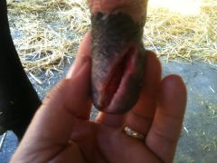  Only first layer of skin affected | Fair to good.  Risk of environmental mastitis
Complex | 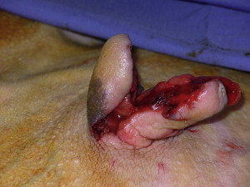  Inverted “Y” or “U”  Irregular cut. Often 2 or more layers. Can involve teat canal. Creative and logical suturing required for tissue apposition | Guarded  High risk of complications depending on teat involvement, blood supply involvement, and tissue apposition.
Longitudinal | 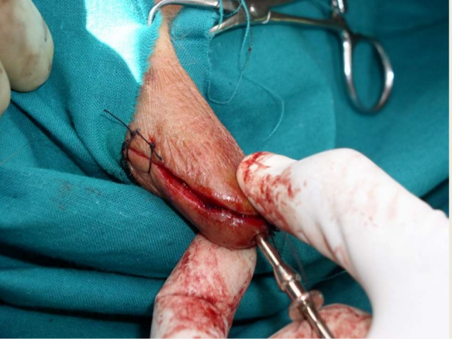  Can involve all layers/teat canal. Straightfoward suturing. In the same direction of blood supply | Good to poor  Good : if only first layer of skin involved and blood supply unaffected  Poor : If teat canal was involved
Transverse | 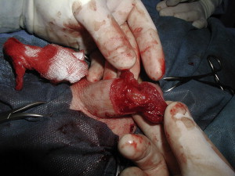  Can involve all layers. Potential for blood supply involvement | Fair to poor  Greater risk for severing blood supply
Proximal | 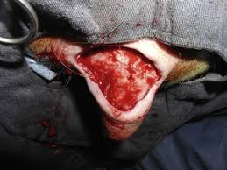  Usually not near teat but all layers and blood supply can be involved | Fair to guarded  Depends on orientation and layers involved.
Distal | 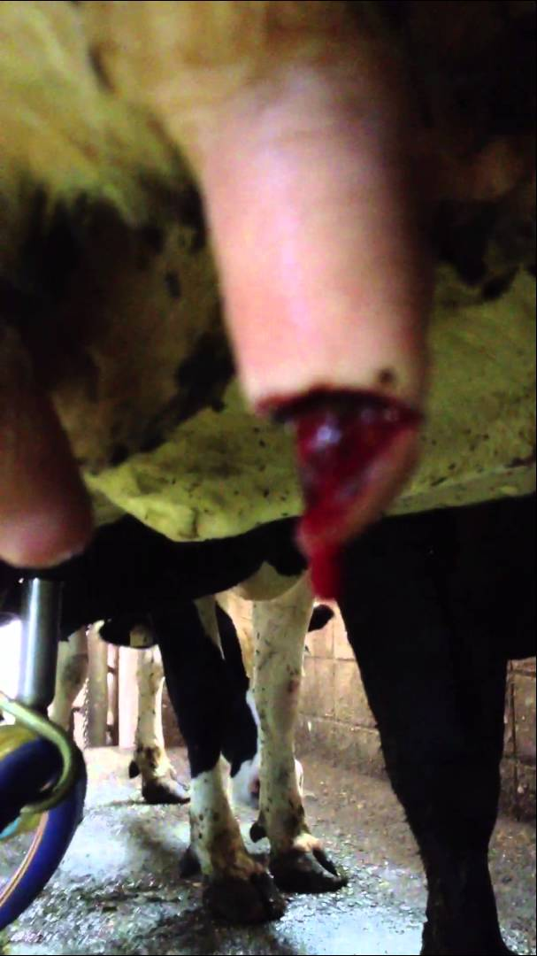 | Guarded to poor  This part of the teat is the main defense mechanism to mastitis
Partial thickness | 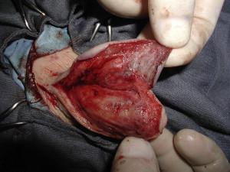 | Good to guarded  Consideration of blood supply involvement
Chronic | 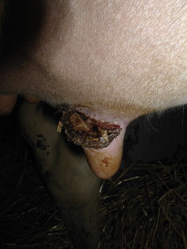 | Fair  If teat canal not involved and blood supply not affected.  or Guarded  Potential for gangrene and sloughing if severely infected.
Full Thickness | 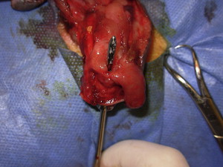 | Guarded to poor  Teat involvement and blood supply involvement .  Regaining patency can be a challenge depending on position and orientation of laceration.

