RELEVANT ANATOMY OF THE HOOF FOR DIGIT AMPUTATION
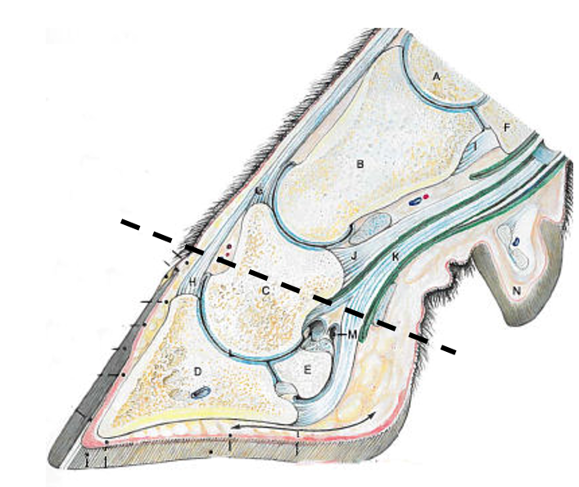

Important structures:
- P1 bone (long pastern bone)
- P2 bone (short pastern bone)
- P3 bone (coffin bone)
- Deep flexor tendon
- Extensor tendon
The dashed line indicates where the gigli wire should be placed and where it should cut through.

