INDICATIONS FOR PERIOSTEAL TRANSECTION IN FOALS
Can be used in combination with Transphyseal bridging to treat severe deformities in foals
- To treat mild to moderate cases of angular limb deformities
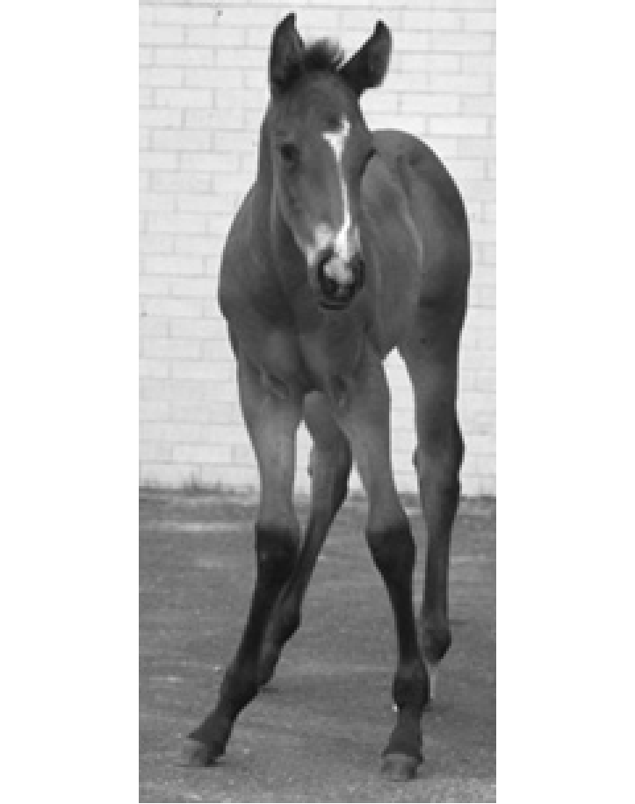

- To treat carpal valgus and tarsal valgus
Carpal valgus:
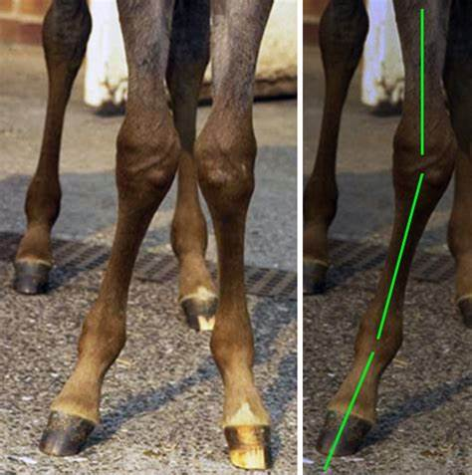

Tarsal valgus:
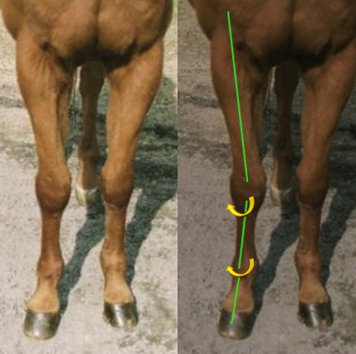
- Varus or valgus deformities of metacarpophalangeal or metatarsophalangeal joints.

