PROCEDURE FOR PERIOSTEAL TRANSECTION

- This procedure is performed on the lateral aspect of the limb for valgus deformities, and on the medial aspect for varus deformities.
- A vertical incision is made about 3-4cm in the skin, parallel to the long axis of the bone beginning 1-2cm proximal to the physis (incision ending proximally). The incision is carried to the periosteum level.
- Curved haemostatic forceps are then used to dissect between the periosteum and soft tissues, extending from the distal aspect of the incision site in the cranial and caudal planes.
- Tissues and tendons are elevated with the curved forceps, and the scalpel blade is then used to transect the periosteum along the lateral hemi-circumference of the bone.
- The periosteum is then incised longitudinally, extending proximally about 3-4cm and then connects with the horizontal periosteal transection.
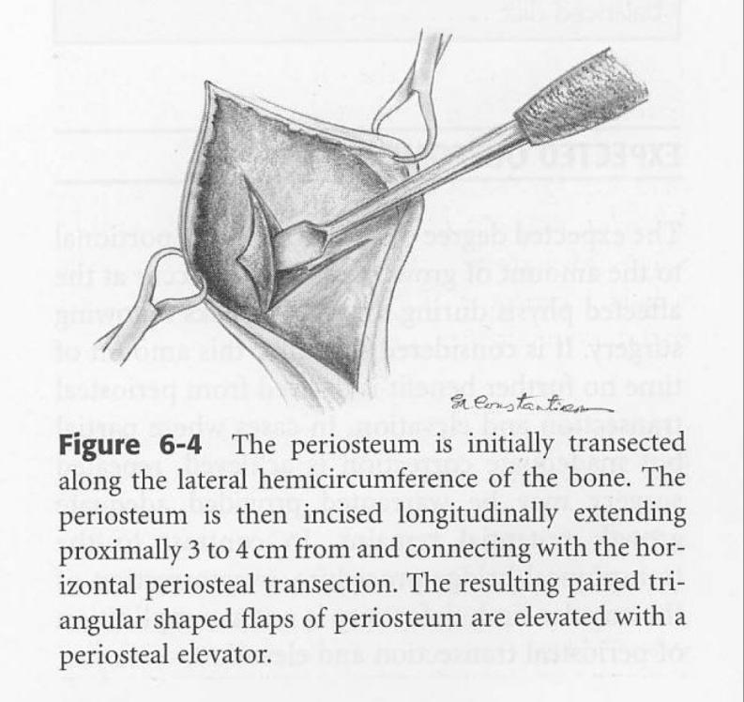
(Picture taken from Equine Manual of Field Surgery- Keith Branson, David Wilson and Joanne Kramer)
- The resulting paired triangular shaped flaps of the periosteum are then elevated with the periosteal elevator.
- The subcutaneous tissues are then sutured with absorbable material in a simple continuous pattern; the skin is then sutured closed with intra-dermal sutures or a simple interrupted suture pattern using non-absorbable non-filament suture material.
- The wound is lastly bandaged using routine bandaging.

