RELEVANT ANATOMY FOR PERIOSTEAL TRANSECTION
(All pictures taken from the “Manual of Equine Field Surgery- Keith Branson, David Wilson and Joanne Kramer)
For treatment of carpal valgus:
The procedure is performed over the distolateral aspect of the radius, proximal to the distal radial physis. A vertical skin incision is made between the common and lateral digital extensor tendons.
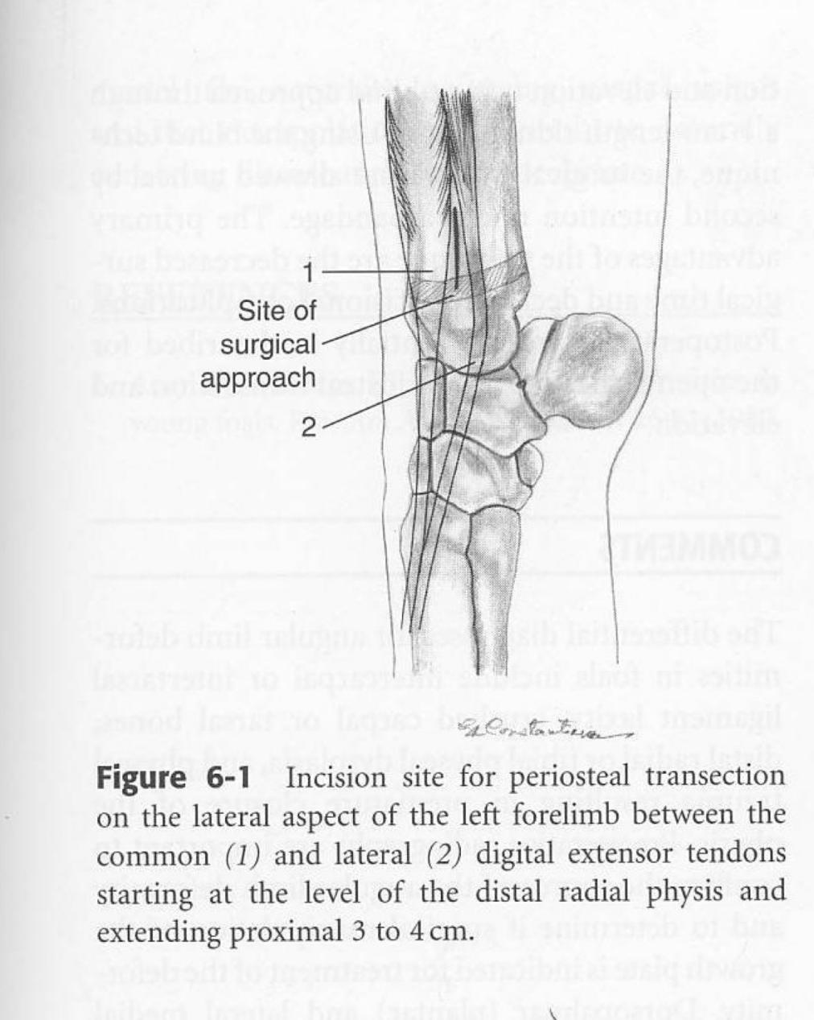

For this procedure, the rudimentary cartilaginous ulna is also transected.
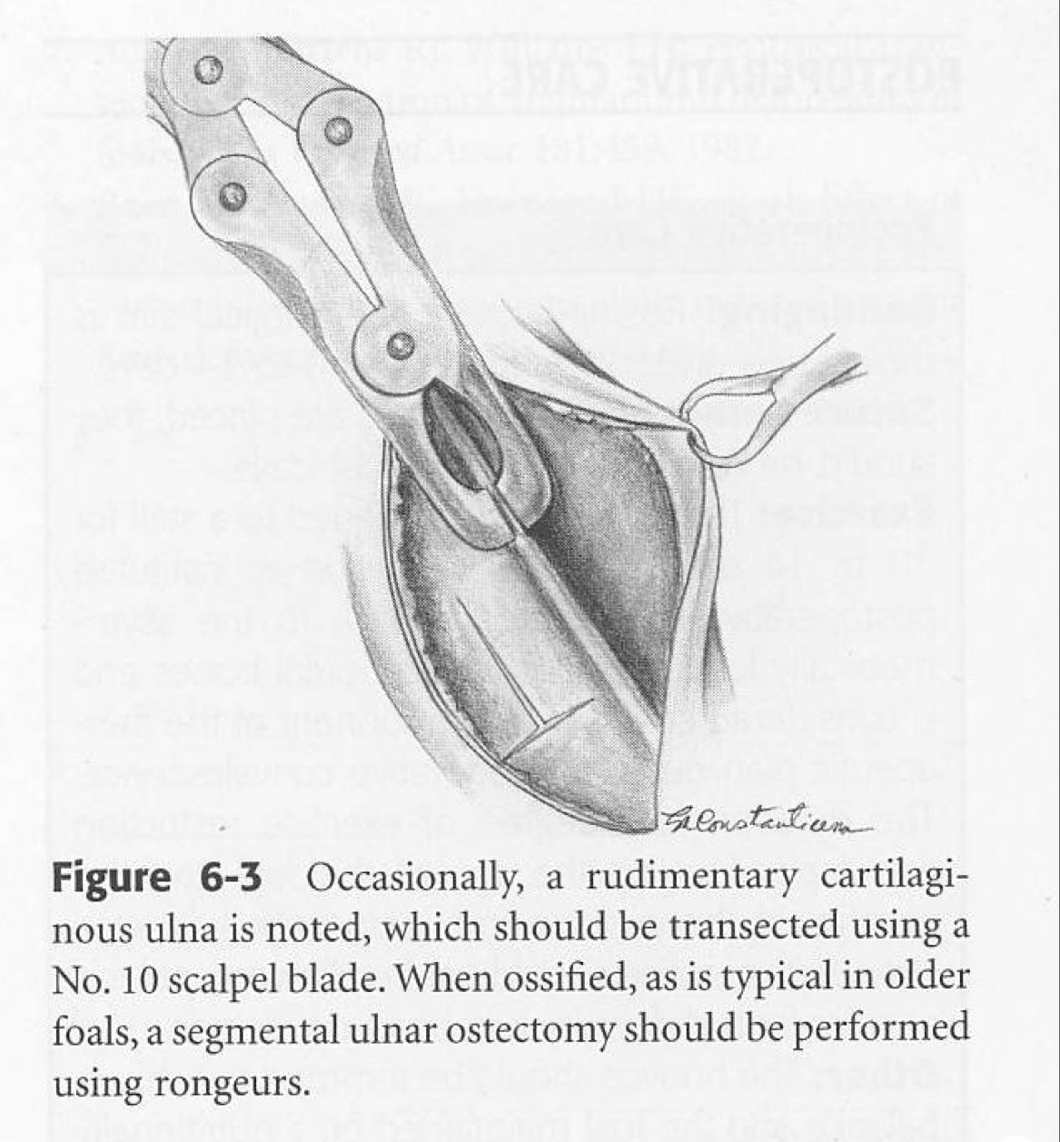

For treatment of tarsal valgus:
The procedure is performed over the lateral malleolus of the tibia, proximal to the distal tibial physis. A vertical skin incision is made either cranial or caudal to the lateral digital extensor tendon.
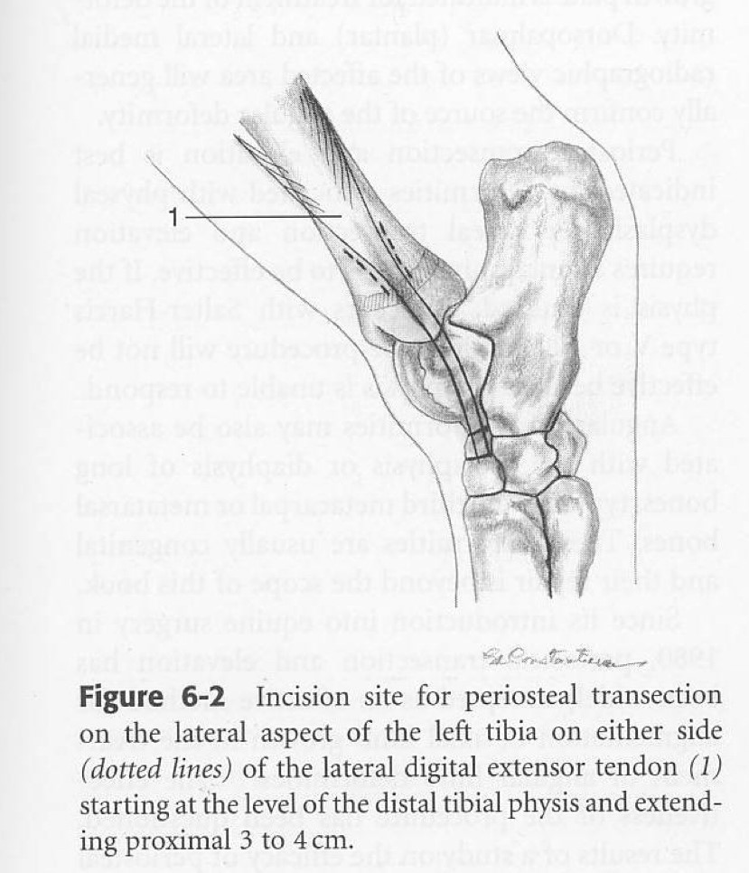

Treatment of metatarsophalangeal and metacarpophalangeal angular limb deformities
This is performed over the concave side of the limb using an approach proximal to the distal physis of the 3rd metacarpal and 3rd metatarsal bone.

