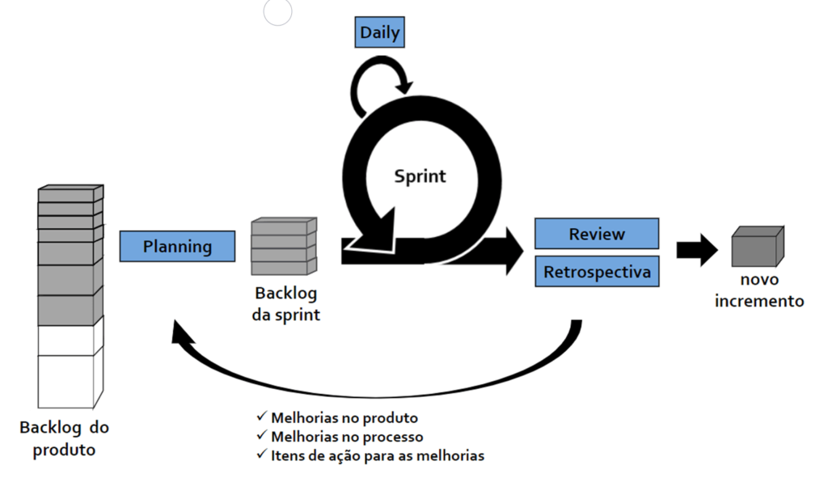
Fonte: https://thomazribas.com/agile/scrum

