**ALTERNATIVE METHOD: USING RECTAL PROLAPSE RINGS**

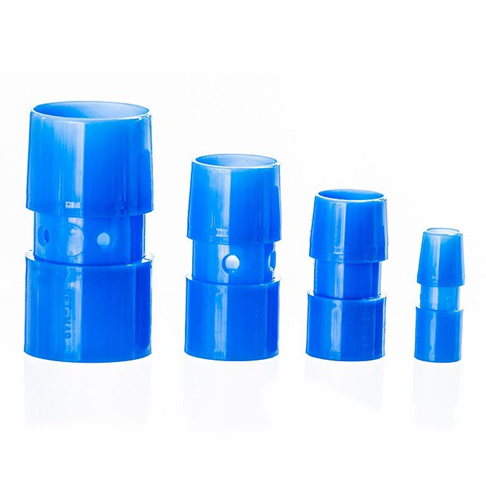

Rectal prolapse ring were designed for rectal prolapse repair. Rectal prolapse rings come in many sized and most have a waist for anchoring the prolapsed rectum to the ring. The emasculator and band can be used to secure the prolapsed rectum to the ring in smaller livestock and for larger livestock the callicrate bander could be used.

Technique:

* The animal is appropriately restrained and prepped for the procedure.
* The appropriate size ring is chosen
* The tube is inserted into the rectum
* The prolapse is tied off next to the body with an elastrator ring or umbilical tape securing it onto the ring ensuring it is tied off atleast 1cm proximal to the healthy margin of tissue.
* Do not tie off necrotic tissue !
* The damaged prolapse section should then slough-off in 4-5 days.