**SUBMUCOSAL RESECTION AND AMPUTATION**

This technique is performed if the prolapse mucosa is necrotic, ulcerated or traumatized, but the underlying tissue is healthy. It involves the removal of the affected area and salvage of the healthy underlying tissue.

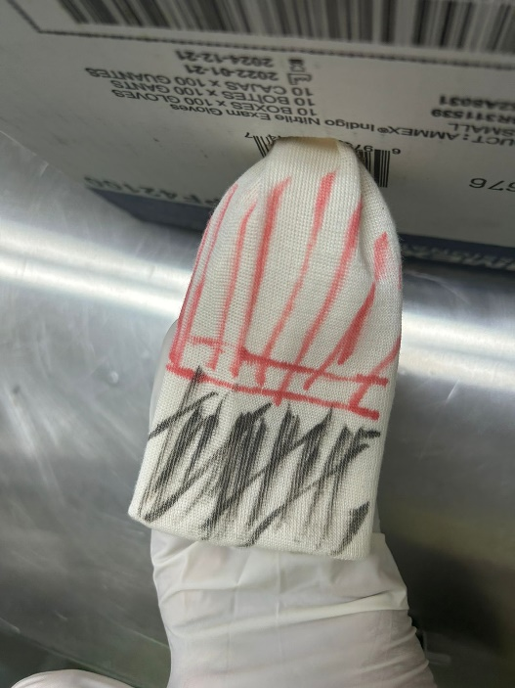 This picture shows an illustration of a Type III rectal prolapse. The red area is the healthy salvageable mucosa and the black area is the necrotic mucosa to be removed.

Technique:

* After caudal epidural is performed, the mucosa is cleaned and edema is reduced by temporary topical application of a hyperosmotic solution (50% dextrose, 70% mannitol).
* A final preoperative evaluation is performed.
* A syringe casing of appropriate diameter is inserted into the lumen of the prolapse.
* A cross pin fixation is performed to control the movement of the prolapse during surgery. This is achieved by using spinal needles inserted at 12 o’clock and 3 o’clock positions close to the opening across the prolapse and syringe casing.

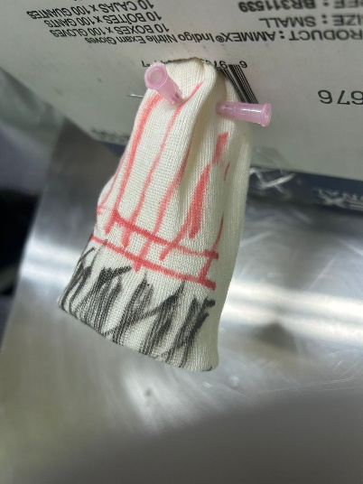 Picture showing the cross-pin fixation of the prolapse using 18 gauge needles.

* The needles prevent the prolapse from retracting into the abdomen when being incised.
* The necrotic mucosa is removed by making a full thickness incision distally to the needles placed, cutting down to the syringe case.
* The mucosa is sutured in a continuous pattern. Stop part way and tie a knot to avoid a purse-string effect.
* Hemorrhage may be controlled by ligature of individual blood vessels. Working in sections to minimize hemorrhage during procedure.
* The mucosa is aligned with four simple continuous suture pattern for each quadrant around the circumference of the prolapse.
* Remove the needles and syringe case and return to the rectum.

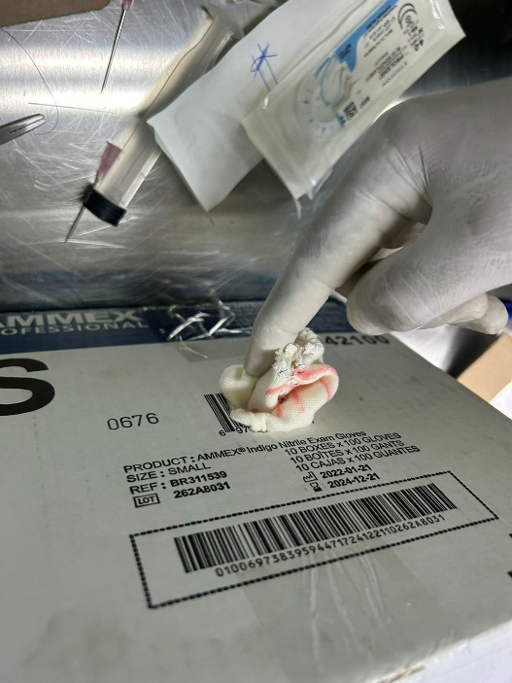 Returning the prolapse into the rectum.

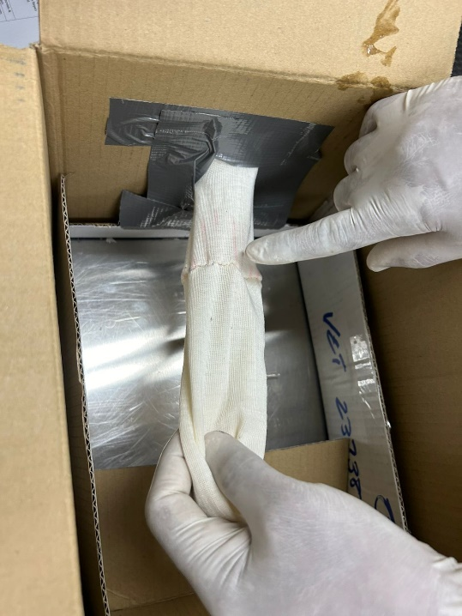

Advantages of this technique compared to amputation:

* not exposing the serosal lining minimizes the possibility of peritonitis or perirectal abscess formation
* not transecting the main blood supply minimizes the danger of postoperative hemorrhage
* less postoperative straining occurs
* the lumen in only minimally constricted
* healthy tissue is not sacrificed
* healing is faster.