**Cobalt in Biology**

***Vitamin B12*** – Cobalt is widespread in biology, except for land plants and fungi, as the metal center of the corrin ring in Vitamin B12 (also referred to as cobalamin; Kräutler, 2005; Okamoto and Eltis, 2011; Helliwell et al., 2011; Cracan and Banerjee, 2013). Cobalt is also present in various non-corrinoid metalloenzymes, but the vast majority of its biological abundance is found in cobalamin (Cbl). In the structure of Cbl, four nitrogens from the corrin macrocycle act as the equatorial ligands, and a component of the corrin ring known as the nucleotide loop ending in a dimethylbenzimidazole base provides the lower axial or -ligand to the cobalt (Fig. 1, adapted from Kräutler, 2005). The upper axial or -ligand can change yielding different Cbl derivatives: methylcobalamin (MeCbl), adenosylcobalamin (AdoCbl), cyanocobalamin (CNCbl), or hydroxocobalamin (OHCbl). The tetrapyrrole corrin macrocycle serves as an electron sink to stabilize various oxidations states of the coordinated Co ion (Okamoto and Eltis, 2011; Dereven’kov et al., 2015).

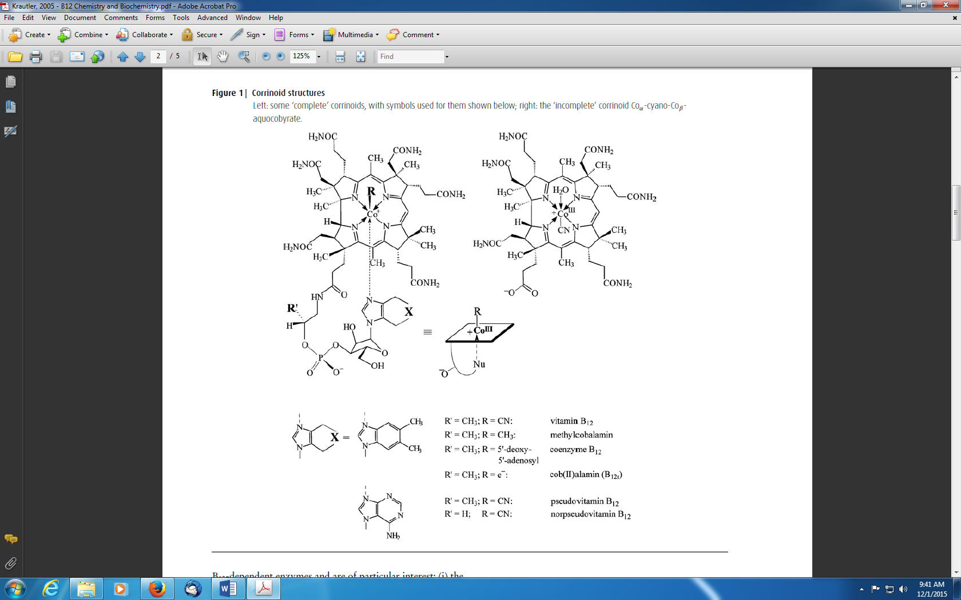



Under physiological conditions Cbl-derivatives are known to exist in three different oxidation states [Co(III), Co(II), or Co(I)], making redox processes central to the biology of Cbl. As a rule, the number of axial ligands decreases in parallel with the cobalt oxidation state (Kräutler, 2005). In thermodynamically predominating forms of cobalt corrins, two axial ligands are bound to the Co(III)-center, one axial ligand is bound to the Co(II)-center, and it is assumed that no axial ligands are bound to the Co(I)-center. The four equatorial nitrogen ligands of the corrin macrocycle are bound in each of the three oxidation states, therefore electron transfer reactions involving Cbl derivatives are linked with changes in the number and nature of axial ligands. The reduction of alkyl-Co(III) corrins typically takes place at more negative potentials than Co(II)/Co(I)-redox pairs (Krautler, 1993). Two functions are critical to the reactions catalyzed by most Cbl-dependent enzymes: First, Cbl is an efficient radical trap and considered a reversible carrier of an alkyl radical (one e- reduction/oxidation of Co); Second, methyl-transfer reactions by the alkylation of the supernucleophilic Co(I)-center and nucleophile-induced demethylation of methyl-Co(III)-corrins (two e- reduction/oxidation of Co) (Halpern, 1985; Finke, 1998; Kräutler and Ostermann, 2003; Fig. 2 adapted from Kräutler, 2005).

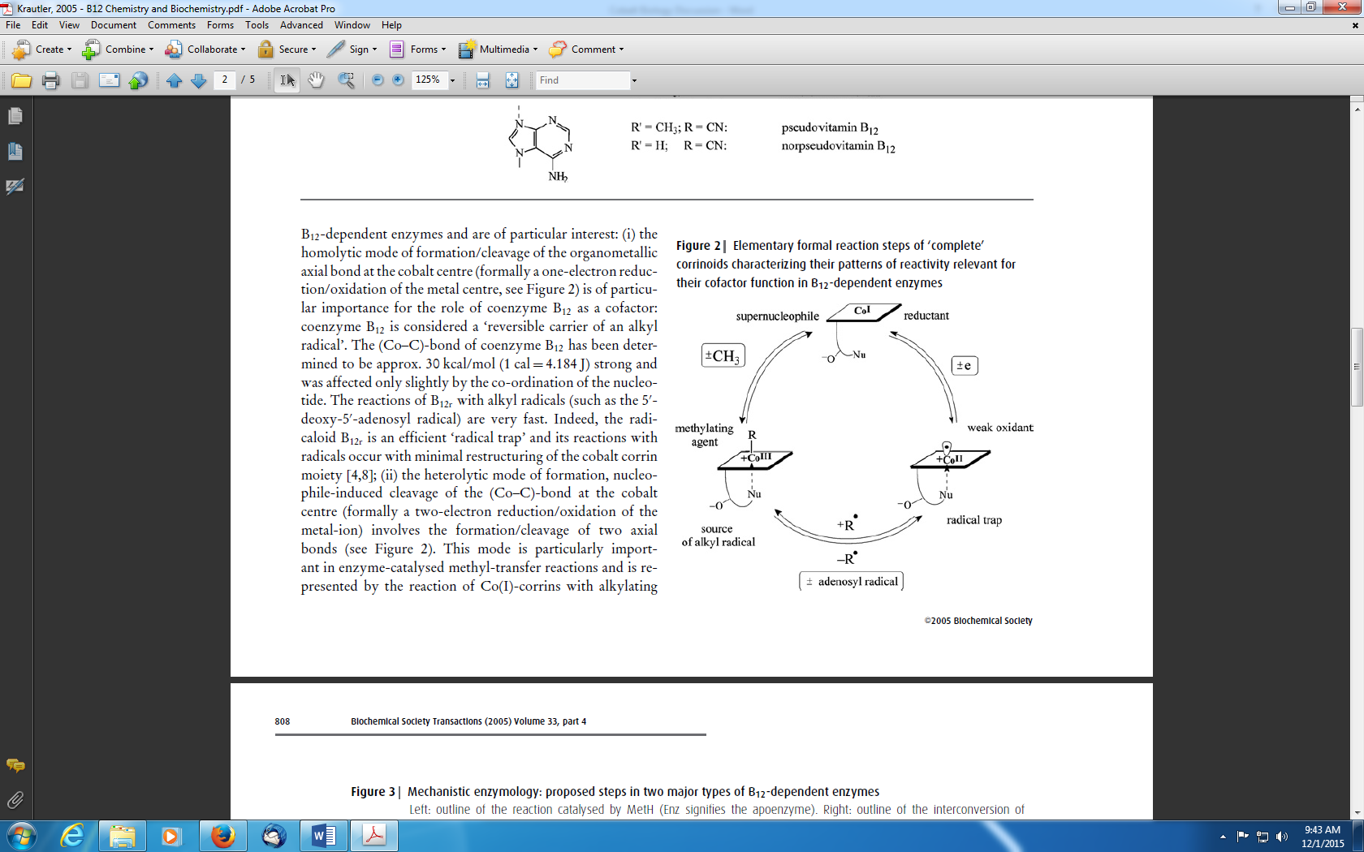

In Prokarya and Archaea, a wide variety of corrinoid-dependent methyltransferases play central roles in metabolism, particularly in organisms which grow under anaerobic conditions (Kräutler, 2005; Matthews, 2009). Anaerobic acetogenesis, methanogenesis, and catabolism of acetic acid to methane and carbon dioxide depend on Cbl-catalyzed enzymatic methyl transfer reactions (Kräutler, 2005; Matthews, 2009). Methionine synthases catalyze the transfer of a methyl group from CH3-H4folate to L-homocysteine, the terminal step in biosynthesis of methionine (cobalamin-dependent methionine synthase, MetH; cobalamin-independent methionine synthase, MetE; Ludwig and Matthews, 1997; Peariso et al., 2001; Evans et al., 2004; Pejchal and Ludwig, 2005). Microorganisms are the only natural sources of Cbl and its derivatives, however, land plants, fungi, and various microbes possess the Cbl-independent MetE pathway (Brown, 2005; Giovannoni et al., 2005; Kräutler, 2005; Helliwell, 2011; Cracan and Banerjee, 2013).

Other microorganisms acquire Cbl through a symbiotic relationship with bacteria, and some have both the MetH and MetE pathways allowing them to use MetH if Cbl is available (Foster et al., 1961; Gonzalez et al., 1992; Croft et al., 2005; Helliwell, 2011). Likewise, there are Cbl-dependent and Cbl-independent forms of ribonucleotide reductase involved in the synthesis of deoxyribose and DNA, allowing some microbes which contain both pathways to switch between them depending on Cbl availability (Hamilton, 1974; Carell and Seeger, 1980). Recently, an experimental evolution approach with the Cbl-independent model green alga *Chlamydomonas reinhardtii* demonstrated in fewer than 500 generations of growth in the presence of vitamin B12, a Cbl-dependent clone rapidly displaced its ancestor (Helliwell et al., 2015). This illustrates how rapid microbial evolution can respond to vitamin availability.

Studies have shown that Cbl availability can have an impact on marine phytoplankton growth and community composition (Droop, 1957; Panzeca et al., 2006; Bertrand et al., 2007; Koch et al., 2011). Various eukaryotic algae have only the Cbl-dependent methionine synthase MetH pathway and have absolute vitamin B12 requirement for growth (Guillard and Ryther, 1962; Croft et al., 2005; Bertrand et al., 2012). Other algae encode both the MetH and MetE genes, such as *Phaeodactylum tricornutum*, allowing for both the Cbl-dependent and Cbl independent pathways. However, no eukaryotic marine microbes have been identified that have only the MetE Cbl-independent gene, suggesting that it is unfavorable for marine microbial eukaryotes to lose the ability to use Cbl for methionine synthase activity (Bertrand et al., 2013). The eukaryotic strategy of substituting Co for a majority of Zn requirements (Price and Morel, 1990; Sunda and Huntsman, 1995) may be remnant capabilities from the high sulfide low Zn Proterozoic (Saito et al., 2003). Cbl requirements do not follow phylogenetic lines suggesting that Cbl auxotrophy has arisen multiple times throughout algal evolutionary history (Croft et al., 2006; Helliwell et al., 2011). In *P. tricornutum* growth experiments it was found that under low Cbl availability MetE expression resulted in 30-fold increase in nitrogen and 40-fold increase in zinc allocated to methionine synthase activity (Bertrand et al., 2013). This study indicates that retention of Cbl utilization by phytoplankton results in resource conservation under conditions of high Cbl availability.

***Non-corrinoid Co proteins and Co transport*** – The occurrence of cobalt in non-corrinoid metalloenzymes is relatively rare, at present only eight non-corrin cobalt-containing enzymes have been characterized (Kobayashi and Shimizu, 1999; Okamoto and Eltis, 2011). [1] Methionine aminopeptidase is a ubiquitous enzyme that cleaves the N-terminal methionine from many newly translated polypeptide chains in both prokaryotes and eukaryotes (Roderick and Matthews, 1993; Bazan et al., 1994). [2] Prolidase is widespread in nature, has been isolated from bacteria, and specifically cleaves Xaa-Pro dipeptides (Ghosh et al., 1998). [3] Nitrile hydratase catalyzes hydration of nitriles to amides, and is a key enzyme involved in the metabolism of toxic compounds (Kobayashi et al., 1992). [4] Glucose isomerase catalyzes the reversible isomeration of D-glucose to D-fructose and is one of the most highly used enzymes in industry (Bhosale et al., 1996). [5] Methylmalonyl-CoA caboxytransferase contains biotin and three types of subunits that catalyze the transfer of a carboxyl group from methylmalonyl-CoA to pyruvate to form propionyl-CoA and oxaloacetate (Harmon et al., 1982). [6] Aldehyde decarbonylase converts a fatty aldehyde to a hydrocarbon and CO, and is responsible for a key step in the biosynthesis of hydrocarbon compounds (Dennis and Kolattukudy, 1992). [7] Lysine 2,3-aminomutase catalyzes the reversible isomerization of L-lysine into L--lysine (Reed and Ballinger, 1995) and seems to contain one or two Co2+ atoms per dimer of subunits (Petrovich et al., 1991). [8] Bromoperoxidase from *Pseudomonas putida* catalyzes the formation of a carbon-bromine bond in the presence of peroxides and is activated by incubation with cobalt ions (Itoh et al., 1994).

Cobalt can also be used as a substitute for zinc in various proteins such as RNA polymerase of *E. coli* (Speckhard et al., 1977) carbonic anhydrase of a marine diatom (Yee and Morel, 1996), the zinc finger derived from the DNA repair protein XPA (Kopera et al., 2004), or the active site of thermolysin (Holland et al., 1995). The cobalt transporter protein COT1 from *Saccharomyces cerevisiae* participates in both cobalt and zinc uptake (Conklin et al., 1994), which may be related to the interchangeability of the two metals in certain protein structures. COT1 also functions as a suppressor of cobalt toxicity by sequestration or compartmentalization (Conklin et al., 1992). The protein GRR1 is also involved in cobalt and zinc uptake in *S. cerevisiae* cells (Conklin et al., 1994). Protein J1 in *Rhodococcus rhodochrous* has both a nonspecific low-affinity magnesium transporter and a high-affinity system for cobalt transport (Komeda et al., 1997; Kobayashi and Shimizu, 1999). Various other proteins are involved in acquiring cobalt and managing cobalt toxicity, and are described in detail by Kobayashi and Shimizu, (1999) and Okamoto and Eltis, (2011).

***Origin of Co in biology*** – Co requirements in biology have been described as remnants from early life (da Silva and Williams, 1991). It has been speculated that the Co-containing biomolecule vitamin B12 (cobalamin) evolved 2.7-3.5 Ga due to its presence in primitive anaerobes, biosynthesis without an oxidative step (unlike the similar tetrapyrrole containing molecules heme and chlorophyll), and redundancy in function with respect to more recently evolved pathways (Jeter et al., 1984; Eschenmoser, 1988; Cameron et al., 1989; Benner et al., 1989; Scott, 1990). Modeling studies and geochemical analyses have shown that Co was more abundant in the Archean ocean than present and thus more bioavailable leading to the speculation that Cbl-independent pathways evolved as a response to lower Co bioavailability (Saito et al., 2003; Zerkle et al., 2005; Swanner et al., 2014).

Reducing conditions of the anoxic Archean ocean would have favored the Co(II) oxidation state. Co falls somewhere in the middle of the stability series for divalent metal ions binding to an organic agent Mg2+ (Ca2+) < Mn2+ < Fe2+ < Co2+ < Ni2+ < Cu2+ > Zn2+, but becomes much more stable in the trivalent form Al3+ << Cr3+ < Fe3+ Mn3+ < Co3+ (Williams, 1981). These trivalent ions, except Al3+ can form very strong complexes to N/O- side chain groups of proteins, but this is not observed for Co likely due to its low availability in the environment. The most stable binding of metals occurs when the chelating agent is conformationally constrained as in a rigid ring such as corrin in the case of Co (Williams, 1981). It has been shown that the structural elements of Cbl-resembling corrinoids are found to self-assemble under structurally appropriate preconditions, including the A/D-ring junction and arrangement of double bonds of the corrin ring (Eschenmoser, 1988). A primitive structure of corrin stabilized by hydrogen instead of methyl substitution has been speculated to have existed prebiotically and formed an imprint for the evolution of enzymes which synthesized a more robust form of Cbl (Decker et al., 1970; Eschenmoser, 1988; Benner et al., 1989; Scott, 1990).

Photo-reactivity may have also played a role in selection of Co in biology. Cobalamin-derivatives are known to undergo two types of light induced reactions: loss of an axial ligand, or sensitization of reactions with singlet oxygen (Krautler, 1991). Loss of axial ligands allows the production of alkyl radicals by photolysis which are then available for subsequent reactions (Halpern, 1985; Retey, 1990). The photoinduced carbonylation of methylcorrin presumably operates by way of the intermediate free methyl radical and Cbl(II) where carbon monoxide functions as a non-oxidative trap for the free methyl radical (Fig. 4 adapted from Krautler, 1984; 1991). This carbonylation pathway has potential relevance with respect to acetate biosynthesis in anaerobic bacteria (Krautler, 1984; Thauer, 1988) and could be a potential precursor to early metabolism. Acylation of activated olefin carbon double bonds catalyzed by B12 involving photoinduced cleavage of acetylcobalamin has also been performed (Walder and Orlinski, 1987), again demonstrating that cobalamin can be involved in light-activated abiological carbon fixation processes.

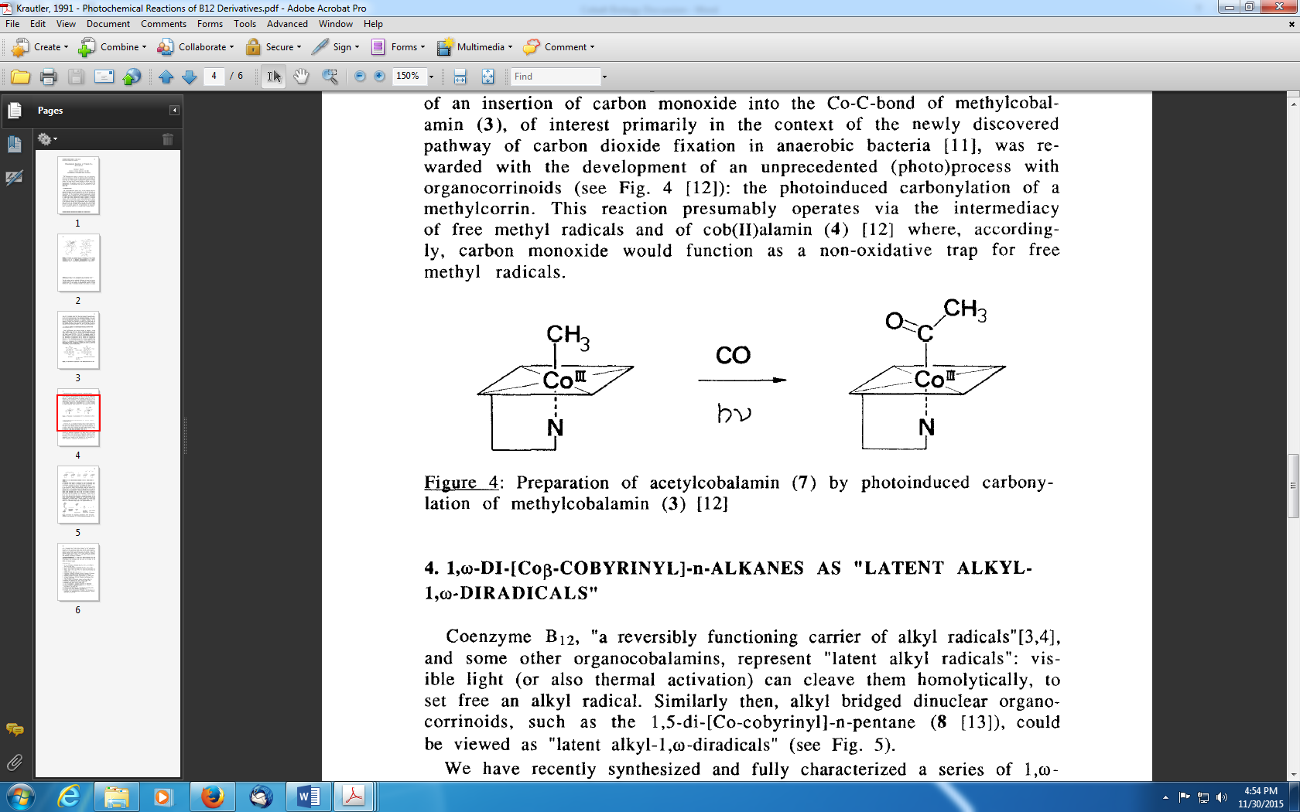

Despite the speculated anoxic origin of Cbl, there also appears to be oxic evolutionary selection of cobalamin in biology. The 5’-Deoxyadenosyl radical serves important biochemical functions as a powerful single-electron oxidant that can remove a hydrogen atom from very unreactive molecules and reversibly abstracting a hydrogen atom from a substrate (Wang and Frey, 2007; Brown, 2005). There are two biological mechanisms for generating 5’-deoxyadenosyl radical involving either: adenosylcobalamin (AdoCbl), or S-adenosylmethionine (AdoMet) complexed to a reduced iron-sulfur cluster. Reactive oxygen species destroy the iron-sulfur clusters of AdoMet enzymes which may have provided evolutionary pressure towards selection of AdoCbl-dependent enzymes for relevant biochemical reactions under oxic conditions (Marsh et al., 2010). Despite the low relative abundance of Co in the environment, its apparent utility under a range of conditions throughout Earth’s history have made it an important micronutrient to a diverse range of primitive and recently evolved organisms.

**REFERENCES**

Bazan JF, Weaver LH, Roderick SL, Huber R, Matthews BW. **1994**. Sequence and structure comparison suggest that methionine aminopeptidase, prolidase, aminopeptidase P, and creatinase share a common fold. *PNAS*, 91, 2473-2477.

Benner SA, Ellington AD, Tauer A. **1989**. Modern Metabolism as a Palimpsest of the RNA World. *PNAS*, 86, 18, 7054-7058.

Bertrand EM, Saito MA, Rose JM, Riesselman CR, Lohan MC, Noble AE, Lee PA, Ditullio GR. **2007**. Vitamin B12 and iron colimitation of phytoplankton growth in the Ross Sea. *Limnology & Oceanography*, 52, 1079-1096.

Bertrand EM, Allen AE. **2012**. Influence of vitamin B auxotrophy on nitrogen metabolism in eukaryotic phytoplankton.  *Frontiers in Microbiology*, 3, 375.

Bertrand EM, Moran DM, McIlvin MR, Hoffman JM, Allen AE, Saito MA. **2013**. Methionine synthase interreplacement in diatom cultures and communities: Implcations for the persistence of B12 use by eukaryotic phytoplankton. *Limnology & Oceanography*, 58, 1431-1450.

Bhosale SH, Rao MB, Deshpande VV. **1996**. Molecular and industrial aspects of glucose isomerase. *Microbiol. Rev.*, 60, 280-300.

Brown KL. **2005**. Chemistry and Enzymology of Vitamin B12. *Chemical Reviews*, 105, 6, 2075-2149.

Cameron B, Briggs K, Pridmore S, Brefort G, Crouzet J. **1989**. Cloning and Analysis of Genes Involved in Coenzyme B12 Biosynthesis in *Pseudomonas denitrificans*. *Journal of Bacteriology*, 171, 1, 547-557.

Conklin DS, McMaster JA, Culbertson MR, Kung C. **1992**. COT1, a gene involved in cobalt accumulation in *Saccharomyces cerevisiae*. *Mol. Cell. Biol.*, 12, 3678-3688.

Conklin DS, Culbertson MR, Kung C. **1994**. Interactions between gene products involved in divalent cation transport in *Saccharomyces cerevisiae*., 244, 303-311.

Cracan V, Banerjee R. **2013**. Cobalt and Corrinoid Transport and Biochemistry. In: *Metallomics and the Cell*, Metal Ions in Life Sciences 12. Springer Science+Business, Dordrecht, Netherlands.

Croft MT, Lawrence AD, Raux-Deery E, Warren MJ, Smith AG. **2005**. Algae acquire vitamin B12 through a symbiotic relationship with bacteria. *Nature*, 438, 90–93.

Croft MT, Warren MJ, Smith AG. **2006**. Algae need their vitamins. *Eukaryotic Cell*, 5, 1175-1183.

da Silva JJRF, Williams RJP. **1991**. The Biological Chemistry of the Elements: The Inorganic Chemistry of Life. Oxford University Press, Oxford.

Decker K, Jungermann K, Thauer RK. **1970**. Energy Production in Anaerobic Organisms. Angewandte Chemie International Edition, 9, 2, 138-158.

Dennis M, Kolattukudy PE. **1992**. A cobalt-porphyrin enzyme converts a fatty aldehyde to a hydrocarbon and CO. *PNAS*, 89, 5306-5310.

Dereven’kov IA, Salnikov DS, Silaghi-Dumitrescu R, Marakov SV, Koifman OI. **2015**. Redox chemistry of cobalamin and its derivatives. *Coordination Chemistry Reviews*, XX.

Droop MR. **1957**. Vitamin B12 in marine ecology. *Nature*, 180, 1041-1042.

Eschenmoser A. **1988**. Vitamin B12: Experiments Concerning the Origins of Its Molecular Structure. *Angewandte Chemie-International Edition in English*, 27, 1, 5-39.

Evans JC, Huddler DP, Hilgers MT, Romanchuk G, Matthews RG. **2004**. Structures of the N-terminal modules imply large domain motions during catalysis by methionine synthase. *PNAS*, 101, 3729–3736.

Finke RG. **1998**. In: *Vitamin B12 and B12-Proteins*. Eds: Kräutler B, Arigoni D, Golding BT., 383–402, Wiley–VCH, Weinheim, Germany.

Foster MA, Tejerina G, Woods, DD, et al. **1961**. 2 enzymatic mechanisms for methylation of homocystein by *Escherichia coli*. *Biochemical Journal*, 81, 1, P1-&.

Ghosh M, Grunden AM, Dunn DM, Weiss R, Adams MW. **1998**. Characterization of native and recombinant forms of an unusual cobalt-dependent proline dipeptidase (prolidase) from the hyperthermophilic archaeon *Pyrococcus furiosus*. *J. Bacteriol.,* 180, 4781-4789.

Giovannoni SJ, Tripp HJ, Givan S, et al. **2005**. Genome streamlining in a cosmopolitan oceanic bacterium. *Science*, 309, 1242.

González JC, Banerjee RV, Huang S, Sumner JS, Matthews RG. **1992**. Comparison of Cobalamin-Independent and Cobalamin-Dependent Methionine Synthases from *Escherichia coli*: Two Solutions to the Same Chemical Problem. *Biochemistry*, 31, 6045-6056.

Guillard RR, RYther JH. **1962**. Studies of marine planktonic diatoms: I. Cyclotella Nana Hustedt, and Detonula Confervacea (Cleve) Gran. *Canadian Journal of Microbiology*, 8, 229-239.

Halpern J. **1985**. Mechanisms of Coenzyme B12-Dependent Rearrangements. *Science*, 227, 869-875.

Hamilton FD. **1974**. Ribonucleotide reductase from *Euglena gracilis*. a 5 deoxyadenoslycobalamin-dependent enzyme. *J Biol Chem*. 249, 4428–4434.

Harmon FR, Goss NH, Wood HG. **1982**. Stabilization of the quaternary structure of transcarboxylase by cobalt (II) ions. *Biochemistry*, 21, 2847-2852.

Helliwell KE, Wheeler GL, Leptos KC, Goldstein RE, Smith AG. **2011**. Insights into the Evolution of Vitamin B12 Auxotrophy from Sequenced Algal Genomes. *Molecular Biology and Evolution*, 28, 10, 2921-2933.

Helliwell KE, Collins S, Kazamia E, Purton S, Wheeler GL, Smith AG. **2015**. Fundamental shift in vitamin B-12 eco-physiology of a model alga demonstrated by experimental evolution. *ISME Journal*, 9, 6, 1446-1455.

Holland DR, Hausrath AC, Juers D, Matthews B. **1995**. Structural analysis of zinc substitutions in the active site of thermolysin. *Protein Sci.*, 4, 10, 1955-1965.

Itoh N, Morinaga N, Kouzai T. **1994**. Purification and characterization of a novel metal-containing nonheme bromoperoxidase from *Pseudomonas putida*. *Biochim. Biophys. Acta*, 1207, 208-216.

Jeter RM, Olivera BM, Roth JR. **1984**. *Salmonella typhimurium* Synthesizes Cobalamin (Vitamin B12) De Novo Under Anaerobic Growth Conditions. *Journal of Bacteriology*, 159, 1, 206-213.

Kobayashi M, Nagasawa T, Yamada H. **1992**. Enzymatic synthesis of acrylamide: a success story not yet over. *Trends Biotechnol.*, 10, 402-408.

Kobayashi M, Shimizu S. **1999**. Cobalt proteins. *Eur. J. Biochem.*, 261, 1-9.

Koch F, Marcoval MA, Panzeca C, Bruland KW, Sanudo-Wilhelmy SA, Gobler CJ. **2011**. The effect of vitamin B12 on phytoplankton growth and community structure in the Gulf of Alaska. *Limnology & Oceanography*, 56, 1023-1034.

Komeda H, Kobayashi M, Shimizu S. **1997**. A novel transporter involved in cobalt uptake. *PNAS*, 94, 36-41.

Kopera E, Schwerdtle T, Hartwig A, Bal W. **2004**. Co(II) and Cd(II) substitute for Zn(II) in the zinc finger derived from the DNA repair protein XPA, demonstrating a variety of potential mechanisms of toxicity. *Chem. Res. Toxicol.*, 17, 11, 1452-1458.

Kräutler B. **1984**. Acetyl-cobalamin from Photoinduced Carbonylation of Methyl-cobalamin. *Helvetica Chimica Acta*, 67, 4, 1053-1059.

Kräutler B. **1991**. Photochemical Reactions of Vitamin B12 Derivatives. *Coordination Chemistry Reviews*, 111, 215-220.

Kräutler B. **1999**. In: *Chemistry and Biochemistry of B12*. Ed: Banerjee R., 315–339, John Wiley, New York, NY.

Kräutler B, Ostermann S. **2003**. In: *The Porphyrin Handbook, vol. 11*. Eds: Kadish KM, Smith KM, Guilard R., 227–274, Elsevier Science, San Diego, CA.

Kräutler B. **2005**. Vitamin B12: chemistry and biochemistry. *Biochemical Society Transactions*, 33, 4, 806-10.

Ludwig ML, Matthews RG. **1997**. Structure-based perspectives on B12-dependent enzymes. *Annual Review of Biochemistry*, 66, 269-313.

Marsh ENG, Patterson DP, Li L. **2010**. Adenosyl Radical: Reagent and Catalyst in Enzyme Reactions. *ChemBioChem*, 11, 5, 604-621.

Matthews RG. **2009**. Cobalamin- and Corrinoid-Dependent Enzymes. *Met Ions Life Sci.*, 6, 53-114.

Okamoto S, Eltis LD. **2011**. The biological occurrence and trafficking of cobalt. *Metallomics*, 3, 963-970.

Panzeca C, Tovar-Sanchez A, Agustí S, Reche I, Duarte CM, Taylor GT, Sañudo-Wilhelmy SA. **2006**. B vitamins as regulators of phytoplankton dynamics. *EOS*, 87, 593-596.

Peariso K, Zhou ZS, Smith AE, Matthews RG, Penner-Hahn JE. **2001**. Characterization of the zinc sites in cobalamin-independent and cobalamin-dependent methionine synthase using zinc and selenium x-ray absorption spectroscopy. *Biochemistry*, 40, 987–993.

Pejchal R, Ludwig ML. **2005**. Cobalamin-Independent Methionine Synthase (MetE): A Face-to-Face Double Barrel That Evolved by Gene Duplication. *PLoS Biology*, 3, 2, e31.

Petrovich RM, Ruzicka FJ, Reed GH, Frey PA. **1991**. Metal cofactors of lysine-2,3-aminomutase. *J. Biol. Chem.* 266, 7656-7660.

Price NM, Morel FMM. **1990**. Cadmium and cobalt substitution for zinc in a marine diatom. *Nature*, 344, 658-660.

Reed GH, Ballinger MD. **1995**. Characterization of a radical intermediate in the lysine 2,3-aminomutase reaction. *Meth. Enzymol.*, 258, 362-379.

Retey J. **1990**. Enzymatic Reaction Selectivity by Negative Catalysis or How Do Enzymes Deal with Highly Reactive Intermediates? *Angewandte Chemie-International Edition in English*, 29, 4, 355-361.

Roderick SL, Matthews BW. **1993**. Structure of the cobalt-dependent methionine aminopeptidase from *Escherichia coli*: a new type of proteolytic enzyme. *Biochemistry*, 32, 3907-3912.

Saito MA, Sigman DM, Morel FMM. **2003**. The bioinorganic chemistry of the ancient ocean: the co-evolution of cyanobacterial metal requirements and biogeochemical cycles at the Archean-Proterozoic boundary? *Inorganica Chimica Acta*, 356, 308-318.

Scott AI. **1990**. Mechanistic and Evolutionary Aspects of Vitamin B12 Biosynthesis. *Accounts of Chemical Research*, 23, 9, 308-317.

Speckhard DC, Wu FYH, Wu CW. **1977**. Role of the intrinsic metal in RNA polymerase from *Escherichia coli*. In vivo substitution of tightly bound zinc with cobalt. *Biochemistry*, 16, 5228-5234.

Sunda WG, Huntsman SA. **1995**. Co and Zn interreplacement in marine phytoplankton: Evolutionary and ecological implications. *Limnology & Oceanography*, 40, 1404-1417.

Swanner ED, Planavsky NJ, Lalonde SV, Robbins LJ, Bekker A, Rouxel OJ, Saito MA, Kappler A, Mojzsis J, Konhauser KO. **2014**. Cobalt and marine redox evolution. *Earth and Planetary Science Letters*, 390, 253-263.

Thauer RK. **1988**. Carbonylierung in anaeroben Bakterien. *Nachrichten aus Chemie Technik und Laboratorium*, 36, 9, 993-997.

Wang SC, Frey PA. **2007**. S-adenosylmethionine as an oxidant: the radical SAM superfamily. *Trends in Biochemical Sciences*, 32, 3, 101-110.

Williams RJP. **1981**. The Bakerian Lecture, 1981: Natural Selection of the Chemical Elements. *Proceedings of the Royal Society of London. Series B, Biological Sciences*, 213, 1193, 361-397.

Yee D, Morel FMM. **1996**. In vivo substitution of zinc by cobalt in carbonic anhydrase of a marine diatom. *Limnology and Oceanography*, 41, 3, 573-577.

Zerkle AL, House CH, Brantley SL. **2005**. Biogeochemical signatures through time as inferred from whole microbial genomes. *American Journal of Science*, 305, 6-8, 467-502.