DRUG | TRADE NAME | ACTIVE INGREDIENT | INDICATIONS | DOSAGE | CONTRAINDICATION | WITHDRAWAL
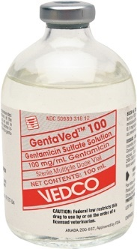 | Gentamycin 100 | Gentamicin Sulfate | For the control of bacterial infections of the uterus (metritis) in horses and as an aid in improving conception in mares with uterine infections caused by bacteria sensitive to gentamicin. | Horses: 6.6mg/kg, IV/IM Foals: 11-15 mg/kg  Pigs: 5mg/kg, PO/IM in neonates; 1.1mg/kg in weanlings PO. 2.2mg/kg to treat swine dysentery  Sheep: 5mg/kg IM | Hypersensitivity to gentamycin.  Administration to animals with a serious impaired hepatic and/or renal function.  Concurrent administration of nephrotoxic substances. | Pigs: 40 days for slaughter in piglets, 14 in neonatal swine, 10 days for weanlings and adults
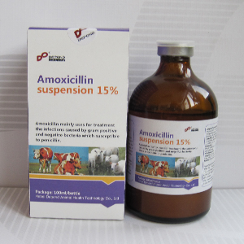 | Amoxicillin | Amoxicillin base | Gastrointestinal, respiratory and urinary tract infections caused by amoxicillin sensitive micro-organisms in calves, cattle, goats, sheep and swine. | Cattle: 6-10mg/kg  Calves: 7mg/kg PO  Horses: 20-30mg/ kg PO,  Foals: 15-30mg/ kg IV/IM, | Hypersensitivity to amoxicillin.  Administration to animals with a seriously impaired renal function. | Meat: 21 days.  Milk: 3 days.  Not for sheep producing milk for human production.
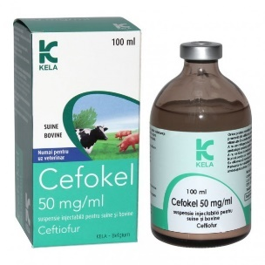 | Cefokel 50mg/ml suspension for injection | Ceftiofur HCL | Pigs: Treatment of bacterial respiratory disease.  Cattle: Treatment of bacterial resp. disease and footrot.  For the treatment of the bacterial component of acute post-partum (puerperal) metritis within 10 days after calving | Pigs: 3mg/kg, IM or 1 ml/16kg at each injection.  Cattle: Respiratory disease: 1mg /kg, SC.  Footrot: 1mg/kg SC injection.  Acute post-partum metritis within 10 days of calving: 1mg/kg for 5 consecutive days SC  Sheep: 1.1mg - 2.2mg/kg IM | Do not administer to an animal previously found to be hypersensitive to ceftiofur and other β -lactam antibiotics. Do not inject intravenously. | Pigs: Meat and offal: 5 days.  Cattle: Meat and offal: 8 days. Milk: zero hours
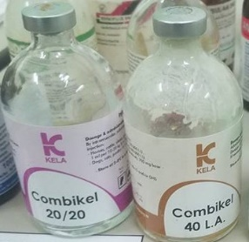 | Combikel  (available in 20 & 40 L.A) | Procaine Benzyl- penicillin, Dihydrostreptomycin | Respiratory tract infections | 40 LA: Cattle: 5-10 ml/kg. Horses, Pigs: 0.1ml/kg. IM or SC routes may be used in both.  20LA: Horses, cattle, pigs 12.5ml/2kg b.w | Hypersensitivity and renal insufficiency in patients | Slaughter 30 days  Milk: 5 days after last application.
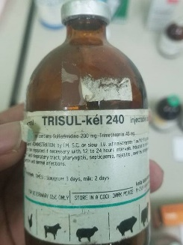 | Trisul-kel 240 | Trimethoprim/ Sulfa-methoxazole | Used when a single antibiotic is not effective. Treats prostate infections and infections caused by methicillin-resistant staphylococci | Horses: 15-30 mg/kg, PO  Swine: 48mg/kg, IM  Cattle: 25mg/kg, IV, IM, Calves: 48mg/kg IV/IM | Not to be used in horses with liver parenchymal damage, blood dyscrasis, or history of sulfonamide sensitivity. Not to be used in animals intended for food | Cattle: Slaughter – 10days, Milking – 96hours.
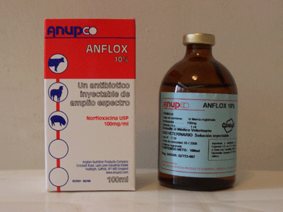 | Anflox 10% | Norfloxacin | Active against Gram-positive and Gram-negative bacteria and mycoplasma | Cattle:10mg/kg/b.w | Do not use in case of hypersensitivity to the product and with other quinolone antibiotics group. | Meat: 4 days  Milk: 4 days
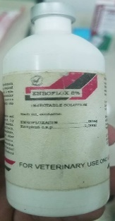 | Enroflox 8% | Enrofloxacin | Gastrointestinal and respiratory infections caused by enrofloxacin sensitive micro-organisms, like Campylobacter, E. coli, Haemophilus, Mycoplasma, Pasteurella and Salmonella spp. in calves, cattle, sheep, goats and swine. | Calves, cattle, sheep and goats: 1 ml per 20 - 40 kg body weight for 3 - 5 days IM,SC Swine: 1 ml per 20 - 40 kg body weight for 3 - 5 days. | Hypersensitivity to enrofloxacin. Administration to animals with a seriously impaired hepatic and/or renal function. Concurrent administration of tetracyclines, chloramphenicol, macrolides and lincosamides. | Meat: Calves, cattle, sheep and goat: 21 days. Swine: 14 days  Milk: 4 days.
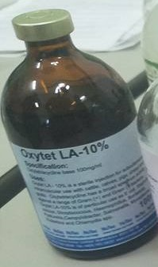 | Oxytet 19% L.A | Oxytetracycline | A sterile injection for subcutaneous or  intramuscular use with cattle, calves, pigs,  sheep and goats. It has a broad spectrum  activity against a range of Gram (+) and  Gram (-) bacteria. | 1ml per 1 0 kg bodyweight  Cattle: 20 ml Pigs: 1 0 ml  Calves: 5 ml | Hypersensitivity reactions to tetracycline. Pregnant animals. Liver and renal insufficient patients. Lactating animals | 7 days for slaughter
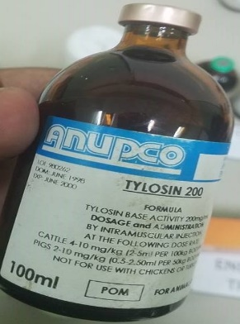 | Tylosin 200 | Tylosin Tartrate | For use in the treatment of bovine respiratory complex (shipping fever, pneumonia) usually associated with Pasteurella spp and Actinomyces pyogenes in beef cattle and nonlactating dairy cattle.  Swine: used in the treatment of swine arthritis caused by Mycoplasma spp. | Cattle: 17.6mg/kg IM daily. Bronchonpneumonia – 4mg/kg  Swine: 8.8mg/kg IM q12  Sheep & goats: 10mg/kg SC | Do not mix with other injectable solutions as this may cause precipitation of the active ingredients.  Fatal in horses. | Cattle: Meat: 21days for slaughter  Milk: 72hours cattle  48hours (goats)  Swine: 14 days for slaughter
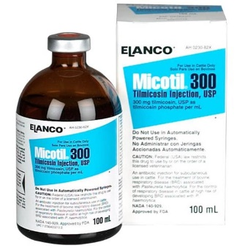 | Micotil 300mg | Tilmicosin | For use in treatment of bovine and ovine respiratory disease caused by Mannheimia haemolytica | 10mg/kg SC | Do not administer intravenously to cattle or sheep. Intravenous injection in cattle or sheep will be fatal. Do not use in lambs less than 15 kg body weight. Administer to cattle and sheep only. | 7 days for slaughter
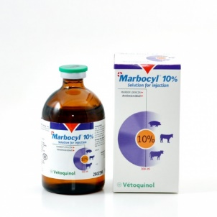 | Marcobyl 10% | Marbofloxacin | In cattle: Indicated in the treatment of respiratory infections and the treatment of acute E.coli mastitis.  In pigs: Indicated in the treatment of Metritis Mastitis Agalactia syndrome caused by susceptible strains of organisms. | Cattle:2mg/kg/day (1ml/50kg) in a single daily injection IM,SC,IV  Pigs: IM | Avoid using in young animals. | Milk: 36hrs  Meat: Cattle 6 days  Pigs 4days
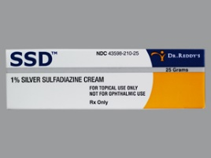 | Thermazene | Silver Sulfadiazine | A thick topical antibacterial cream most commonly used for treatment of burn wounds | Apply cream over a sterile wound. | _____ | ___
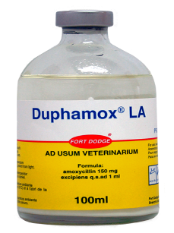 | Duphamox | Amoxicillin Trihydrate | A broad-spectrum semi-synthetic penicillin bactericidal in action. In vitro it is effective against a wide range of Gram-positive and Gram-negative bacteria which include in cattle, sheep, pigs. | Cattle and Pigs: 1ml/10kg IM | Not for use in known cases of hypersensitivity to penicillin or cephalosporins. | Cattle: Meat – 23 days, Milking – 84 hours  Pigs: 16 days for slaughter
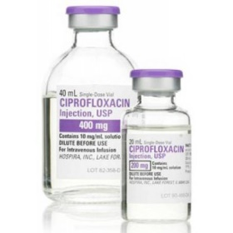 | Cifran | Ciprofloxacin | An alternative to Enrofloxacin as a post antibiotic resort against both Gram-positive and Gram- negative cocci and bacilli, in small animals. | Cattle:7.5- 12.5mg/kg single dose or 2.5- 5mg/kg | Not indicated for food animals or horses | ______

