DRUG | TRADE NAME | ACTIVE INGREDIENT | INDICATION | DOSAGE | CONTRAINDICATION | WITHDRAWAL
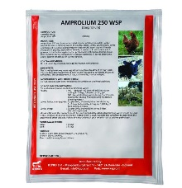 | Amprolium | Amprolium HCL | It is effective against other protozoal infections like Histomoniasis (Blackhead) in turkeys and poultry; against coccidiosis in calves, sheep and goats; against amaebiasis in various species. | Calves, lambs, kids: 3 g per 20 kg/b.w as drench  Cattle, sheep: 3g/20 kg b.w during 5 days (via drinking water) | _____ | Meat:3 days  Milk:3 days
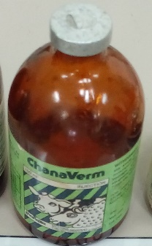 | ChanaVerm | Levamisole | Used for the treatment of GIT nematodes. SC,IM or orally | Cattle, sheep, pigs, goats:5mg/kg IM.  Horses: 5-10 mg/kg SC | Should not be used with Chloramphenicol. | Withdrawal period depends on route of administration.
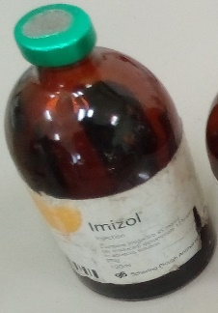 | Imizol | Imidocarb diproprionate | For the treatment of dogs with clinical signs of babesiosis and/or demonstrated Babesia organisms in the blood. | SC 6.6 mg/kg (3 mg/lb) b.w Repeat the dose in two (2) weeks, for a total of two (2) treatments. | Should be administered IM/IV | Cattle: Meat 213 days.  Milk: 21 days
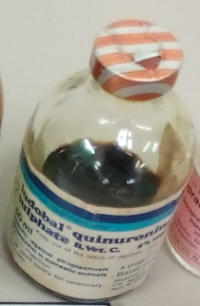 | _ | Quinuronium sulphate | Quinuronium sulphate is used against Babesia cabali, B. bouis, B. ouis, B. molasi. The drug is used in febrile stages in 24 - 48hrs a second treatment might be necessary. | 0.3-0.5mg/kg birth weight for cattle, sheep, pigs | The drug should not be used for a long duration. This might cause animal susceptibility to piroplasms.

