POST-OPERATIVE PAIN MANAGEMENT
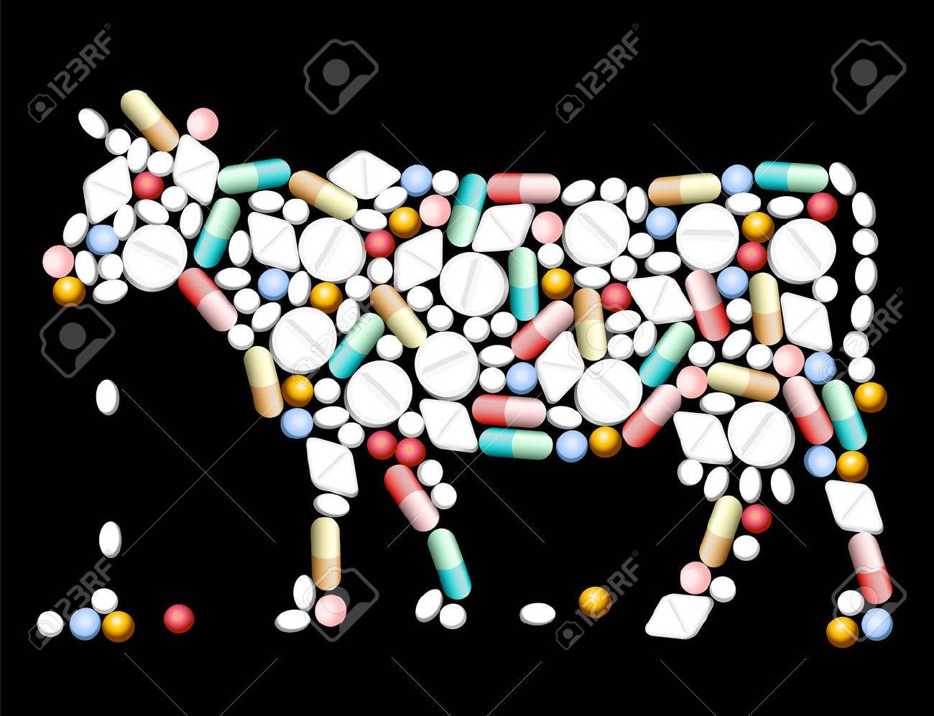
In order to manage post dehorning pain, Non-Steroidal Anti-Inflammatory can be used.
- Meloxicam: a NSAID (Nonsteroidal Anti-Inflammatory Drug) that has been shown to be effective in alleviating pain and distress following dehorning. Meloxicam has a longer period of pain relief with a single dose (48hrs), ease of administration, and low cost. While not approved specifically for alleviation of pain in livestock, veterinarians may prescribe Meloxicam to alleviate pain and stress and enhance animal well-being following dehorning. (Dose = 1mg/kg or 0.45mg/kg)
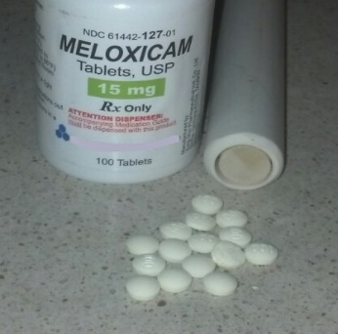

- Flunixin meglumine: a Non-Steroidal Anti-Inflammatory Drug (NSAID). It is used to treat pain and reduce inflammation in cows after they have been dehorned.

