RESTRAINT TECHNIQUES FOR DEHORNING AND DISBUDDING

Restraint is a very important step when dehorning or disbudding ruminants.
Why is it important?
- Ensures the handler has good control over the animal while conducting the procedure.
- Ensures the safety of both the animal and the handler and reduces the risk of injuries.
Types:
The two main types of restraint are physical and chemical.
- Physical restraint:
This type of restraint involves the use of certain tools and equipment such as: squeeze chute with mechanical head restraint apparatus, holding or disbudding box, head catch that allows access to both horns, lead ropes, head chain and halter.

Another important aspect to have, is the skills and knowledge associated with handling these animals. It may also be safer to have an assistant accompanying the veterinarian when conduction dehorning or disbudding procedures.

Some of the most significant tools and equipment are displayed in the following images below.

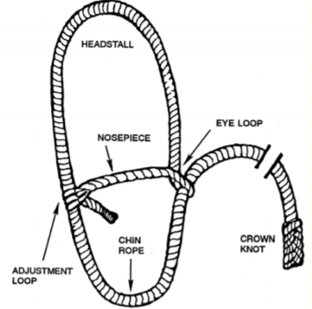
Figure 1: The various structures of a typical halter
How to apply a halter: https://www.youtube.com/watch?v=OBo4mZLtSfM&app=desktop
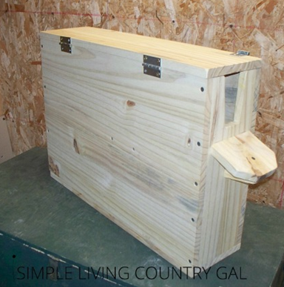
Figure 2: A typical holding/disbudding box for younger animals

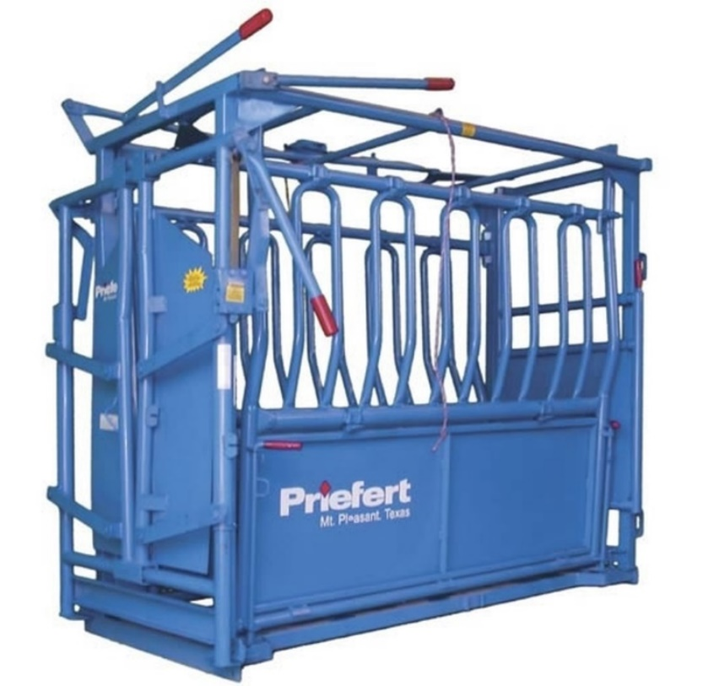
Figure 3: A typical squeeze chute used to restrain cattle
- Chemical restraint:
This method of restraint involves the use of drugs such as sedatives (examples: low dose xylazine (0.01-0.4mg/kg) or combination of butorphanol (0.01 mg/kg), xylazine (0.02 mg/kg), and ketamine (0.04 mg/kg))). These drugs help to calm the animal and allows the handler and veterinarian to gain control over aggressive patients.

Another very important aspect when restraining animals with this method is the knowledge on the use and dosages of these drugs.

