RESTRAINT TECHNIQUES FOR THREE SCENARIOS

SCENARIO 1:
Restraint in a 2-week-old Saanen goat kid
A holding box is very useful for young kids. The holding box is narrow with a U-shaped space for the kid’s head to fit through. While the kid’s head is through the slot, the board should be on top covering the box with the kid inside and the assistant should hold the kid’s head firmly with the ears folded back.
Video demonstrating disbudding with goat kid in holding box: https://youtu.be/myuHZ2rLULo

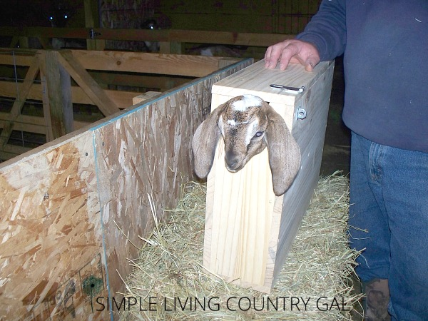
Figure 1: A kid being restrained in a holding/disbudding box

SCENARIO 2:
Restraint in a 6-month-old Holstein calf
- Place the calf in the squeeze chute and head catch that allows access to both horns.
- Contain the calf with a halter and lead rope tied to a ring, a post, or the head gate of the chute for additional restraint. Ensure the halter is secured properly on the calf’s head and tied tightly to avoid movement. If a mechanical head restraint apparatus is available with the squeeze chute, this avoids the need to reposition the patient throughout the procedure.
- The calf should be sedated using an appropriate dose of a sedative and a non-steroidal anti-inflammatory drug as per label directions. Typically, low doses of intravenous xylazine (0.01-0.04mg/kg) are given to induce standing sedation.
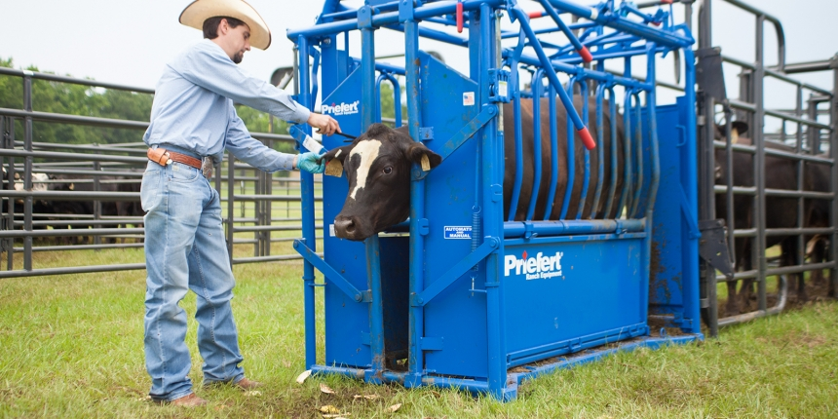
Figure 2: A cow in a squeeze chute
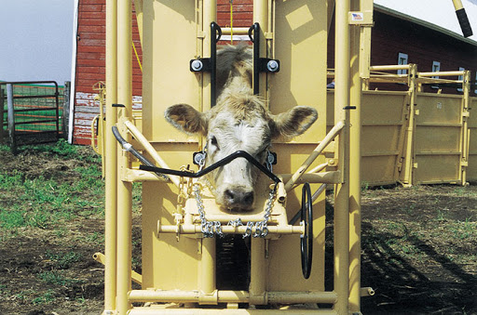
Figure 3: A calf in a typical squeeze chute with its head restrained.

Video demonstrating how to use a squeeze chute: https://www.youtube.com/watch?v=4353QzNWXVY
Website:
http://www.omafra.gov.on.ca/english/livestock/dairy/facts/09-003.htm#welfare

SCENARIO 3
Restraint in a 2-year-old breeding Boer ram that is aggressive
This procedure is more difficult than disbudding a young kid. When the goat is aggressive, chemical restraint is exercised, followed by physical restraint.
- Firstly, the animal should be carefully handled as to prevent any injury as horns could be potentially dangerous.
- A halter should be applied to the head to have more control over the ram while restricting movement.
- The restraint technique may be similar to that of a cow or calf. A chute system may be utilized, and the halter tied with a rope to the side for additional restraint.
- A sedative such as xylazine or ketamine (dosage discussed in drugs) should be administered IV to the aggressive goat to calm him.
- An assistant can help further restrain the ram by firmly holding the head while pressing the ears back to avoid accidental injury to the ears.

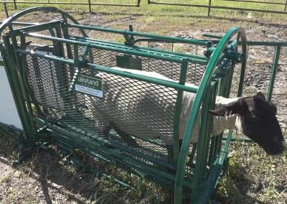
Figure 4: An adult goat in a squeeze chute system

