Case Two: Dehorning of a 6 month Holstein Calf
Signalment- 6 month Holstein Calf

Indications
Increase safety of farmer, and other cows.
Decrease injuries during fights

Aseptic techniques-
- A wide surgical field should be clipped around each horn, across the forehead, and behind the pole. A surgical prep with povidone iodine or chlorhexidine and isopropyl alcohol should be performed.
- Instruments should be disinfected between each calf. A bucket can be used to soak the instruments. Iodine can be used on the skin, but may be corrosive on the instruments
- Rinse blood off instruments with cold water
- Place the equipment into an antiseptic such as cholorhexidine after the calf is dehorned.
- Change the antiseptic solution frequently
- Store the equipment only after cleaning and disinfecting.

Precautions
- Precision is key therefore restraints are essential for success. A
- cattle crush, halter and nose pliers may be able to assist you. General anesthesia can also be use, the tail vein may be used for this. The cattle should be released into a bedded holding pen after the procedure.
- Adhere to the withdrawal time of the drugs used.
- Aseptic techniques should be used to prevent bacterial infection and prevention of ectoparasites (fly strike) should be performed.
- Used disinfectants such as Good disinfectants are chlorohexidine to wash instruments Bloodborne pathogens such as Anaplasma, Babesia, or bovine leukemia virus can be transmitted with way.
- Welfare issue- Monitor for stress. Cortisol is release however Increases in concentrations of cortisol in plasma of calves that were handled or dehorned were short term, lasting no longer than one to two hours

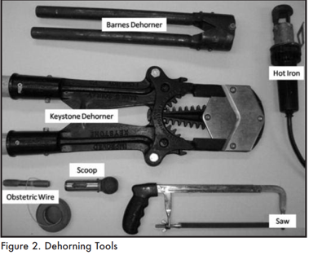
Material and Equipment/Instruments
- Local and general anesthetic- 2% Lidocaine
- Needles-18g
- Syringes-10ml
- Aseptic solutions, Isopropyl Alcohol and Iodine.
- Animal Clippers
- General Surgical Kit
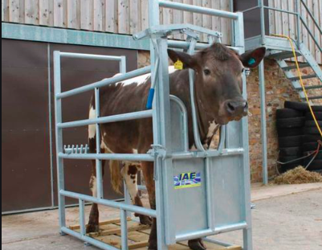
- Barnes dehorner and (optional Obstetric Wire and Handle)
- Cattle crush

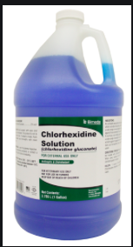

Method of Dehorning
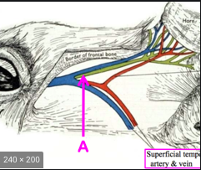
- Scoop/Gouge Barnes-type Dehorner Scoop Can be used on calves from 3 months to a year or more. The small size for 2- to 8-month old calves and The larger size is for yearlings or older cattle
An elliptical cut is made which removes the horn and exposes the cornual arteries. These arteries can be pulled out until they snap. As a result the remain artery is allowed to clot under the skin. These arteries can also be cauterized. There may be an opening into the sinus which can be left open, or covered with a thin piece of gauze to keep it clean.

Benefits
- Fast
- can be used after the horn bud attaches to the skull
Possible Complications
- hemorrhage
- risk of infection because of open wounds
- opens the frontal sinus in older calves
- fly strike

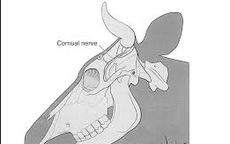
Method
- Clean and disinfect tool before each calf.
- Administer sedation, analgesia and local anaesthetic. (this is further discussed in Pre-op) Ears should be retracted or alternatively, wrapped drape material.
- Clip and clean the area
- Close the handles together.
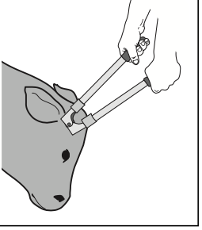
- Place the jaws of the dehorner over the horn bud. adjust the opening to remove 1cm of skin
- With pressure and quickly spread the handles apart removing the skin and horn bud
- Pull the arteries or using a hot iron to cauterize them.

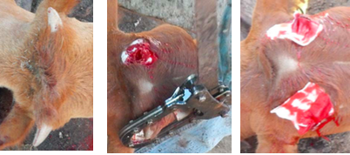

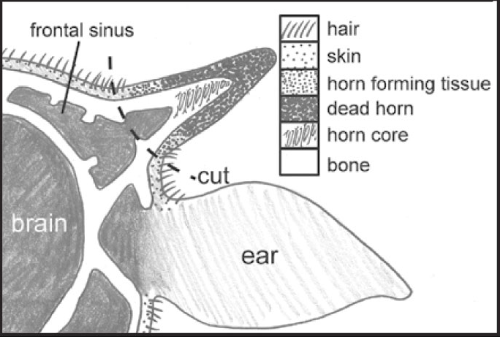
Cosmetic dehorning
Animal is secured in crush with its head tied to one side with a halter to reduce movement.
Hair from the poll, base of the each and a portion of the face (to the eyes) is clipped.
The area is scrubbed with Iodine and alcohol alternatively. The last swab of alcohol should be free of debris..
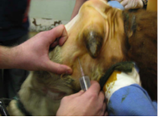
A cornual block is perform by inserting the needle into the skin (18g 4-5cm; 8cm in larger breeds) between the lateral cantus and the base of the horn. Advance the needle into upper 1/3 the temporal ridge and frontalis muscle. 5ml of Lidocaine is administer right behind the ridge approximately 2.5 cm below the base of the horn and about 1.0 cm deep. Another 2ml is administer at the point of insertion as the needle is removed.
At the base of the horn another 2-3ml of local lidocaine is administer subcutaneously.
Massage these areas to encourage distribution of the anesthetic. Repeat on the other horn

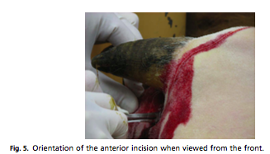
Wait 5-10 minutes for anesthetic to take effect.
An incision is made from the lateral limit of the nuchal eminence moving laterally towards the base of the horn. Moving rostroventrally the incision curves around the base of the horn and along the frontal crest for about 5–7 cm to. The incision is about 1cm away from the base of the horn. About 5–8 cm from the first incision, a second incision is made and carried around the caudal aspect of the horn, to unite it with the first incision ventrally. The incisions are deep enough so that bone is encountered, and the edges of the incision are undermined using sharp dissection. The rostral incision is undermined a bit and the caudal incision is undermined just enough to allow placement of the wire saw ventrally and deep to the base of the horn on the frontal crest. You should avoid incision into the auricular muscles The stump is then removed using either an obstetric wire as a saw, a dehorning saw, or a Barnes dehorner. 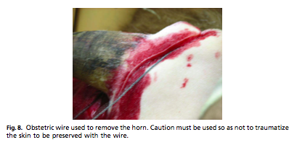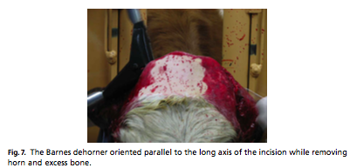
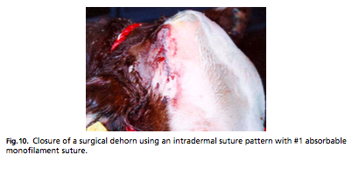
Rinse surgical site with Ringer’s solution to remove debris. Skin closure is usually performed with nonabsorbable material in a simple continuous or continuous interlocking pattern. If tension exists, a near-far- far-near suture can be used The sutures can be remove in approximately 3 weeks. Animal should be allowed to recover in a dry bedded area. Antibiotics should be given which will be discussed further in post op.

Possible complications
- Removal of too much skin at the base of the horn. improper seating of the wire saw leaving a stump of bone; and failure to undermine the skin edges adequately.
- Fracture of the skull due to dull blades
- Sinusitis secondary to bone fragments left in the sinus.
- Hemorrhage. It has suggested that mold from sweet clover hay can interfere with. Cautery, powders, astringent, flour and corn starch have been used to arrest hemorrhage. Dressings in the sinus delay healing.
- Cows that are febrile, lethargic, and in appetent, may suffer from infection. A foul smell and discharge from the sinus may also indicate infection. Sinuses are drained and flushed until resolved. Chronic drainage may suggest osteomyelitis or a bone sequestrum Surgical curettage is performed to correct this.

References
Cosmetic dehorning
https://research.uq.edu.au/files/17501/sop_aht_57_surgical_dehorning_in_cattle.pdf
Dehorning calves https://extension.tennessee.edu/publications/documents/pb1684.pdf
Dehorning of cattle https://www.researchgate.net/publication/294581420_DEHORNING_OF_CATTLE/link/56c2271b08aee5caccf9b1b1/download
Bovine surgery of the Skin https://www.vetfood.theclinics.com/article/S0749-0720(08)00052-2/pdf
Disbudding/dehorning Dairy calves https://outagamie.extension.wisc.edu/files/2010/12/Dehorning-Debudding-Dairy-Calves-Factsheet.pdf
Dehorning of Calve Fact sheet- http://www.omafra.gov.on.ca/english/livestock/dairy/facts/09-003.htm#hot
http://www.dehorning.com/disbudding-and-dehorning
Dehorning Methods- https://animart.com/files/Dehorning%20Tech%20Bulletin_0.pdf
Surgical dehorning in Cattle https://research.uq.edu.au/files/17501/sop_aht_57_surgical_dehorning_in_cattle.pdf
Dehorning, castrating and branding- http://animalscience.tamu.edu/wp-content/uploads/sites/14/2012/04/beef-dehorning-castrating-branding.pdf
Dehorning of Dairy Animals https://www.google.com/url?sa=t&rct=j&q=&esrc=s&source=web&cd=&ved=2ahUKEwiblO7_uILsAhWCo1kKHTo5B14QFjABegQIAhAB&url=https%3A%2F%2Fnjaes.rutgers.edu%2Fpubs%2Fdownload.php%3FstrPubID%3DFS769&usg=AOvVaw0zww4llMr7XaVFaqQf38qV
Beef Calf preconditioning programs- http://extension.msstate.edu/sites/default/files/publications/publications/p2578.pdf
Videos
- AGam in Kansas - Options for Dehorning -https://www.youtube.com/watch?v=Fg4qCwq58nQ

Dehorning for calves with Dr Naylor's paste- https://www.youtube.com/watch?v=m-MilnAfo04

Calf Management Tips: Dehorning with Caustic Paste- https://www.youtube.com/watch?v=3u-1E_eLXDg

Calf Management Tips: Lidocaine Blocking & Dehorning-https://www.youtube.com/watch?v=bH9l4RB6r-4

Surgical cow dehorning https://www.youtube.com/watch?v=tTzGQROv-78

Hereford cattle dehorning- https://www.youtube.com/watch?v=zcGLugBR438&t=181s

Books
- Techniques in large animal surgery
- Farm Animal Surgery

